Modeling of Wind Energy Conversion System and Power Quality Analysis

A. Djellad#1, P.O. Logerais*2, A. Omeiri#3, O. Riou*4, J.F. Durastanti*5, A. Khelfi#6

# *Electrical Engineering Department, Badji Mokhtar-Annaba University,*

*P.O. Box 12, Annaba 23000, Algeria*

1djellad.abdelhak@gmail.com

3[.amar.omeiri@univ-annaba.dz](mailto:omeiri.amar@univ-annaba.org)

6[khelfirezak@yahoo.fr](mailto:khelfirezak@yahoo.fr)

* CERTES, Université Paris-Est  
IUT de Sénart, rue Georges Charpak, 77567 Lieusaint, France

2pierre-olivier.logerais@u-pec.fr

4olivier.riou@u-pec.fr

5durastanti@u-pec.fr

***Abstract* – With growing electrical energy demand, wind power capacity has experienced tremendous surge in the past decade, thanks to wind power environmental benefits. Direct driven permanent magnet synchronous generator (PMSG) with a full size back-to-back converter set is one of the promising technologies employed with wind power generation. Wind grid integration brings the problems of voltage fluctuation and harmonic pollution. In the present study, a filter is placed between the wind system and the network to reduce the total harmonic distortion (THD) and enhance power quality during disturbances. The models of wind turbine, PMSG, power electronic converters and the filter are implemented in Matlab/Simulink environment.**

**Keywords** – wind energy conversion system, PMSG, PWM, THD, power quality, passive filter.

I. Introduction

Worldwide concern about environment has led to increasing interest in technologies for generation of renewable electrical energy. The ever-rising demand for conventional energy sources has driven society towards the need for research and development of alternative energy sources. Several new forms of renewable resources such as wind power generation systems (WPGS) and photovoltaic systems (PV) to supplement fossil fuels have been developed and globally integrated. However, the photovoltaic generation has low energy conversion efficiency and is very costly compared to the wind power. In recent years, wind energy has been regarded as one of the most significant renewable energy sources. Wind energy can be captured and transformed to electric energy by using a wind turbine and an electric generator [1].

Many generators of research interests and for practical use in wind generation are induction machines with wound-rotor or cage type rotor. Recently, the interest in permanent magnet synchronous generators (PMSG) is becoming significant. The desirable features of the PMSG are its compact structure, high air-gap flux density, high power density, high torque-to-inertia and high torque capability. Moreover, compared with an induction generator, a PMSG has the advantage of a higher efficiency due to the absence of rotor losses and lower no-load current below the rated speed, and its decoupling control performance is much less sensitive to the parameter variations of the generator. Therefore, a high performance variable speed generator including high efficiency and high controllability is expected by using a PMSG for a wind generator system [2].

Power quality has also been a growing concern in recent years with many researches done in this area. Harmonic emissions are recognized as a power quality problem [3,4]. For this reason relevant standards require the measurement of harmonics [5]. In this paper, the wind energy conversion system with passive filter capable of reducing Total Harmonic Distortion (THD) noticeably during disturbances is modeled [6].

II. System description

The wind turbine with PMSG is connected to the AC grid through two back-to-back full converters, which consist of an uncontrolled diode rectifier, an internal DC-Link modeled as a capacitor and a PWM (Pulse Width Modulation) voltage-source inverter (VSI) [7]. The filter is connected between the inverter and the grid. The layout of the electrical part is depicted in Fig. 1.

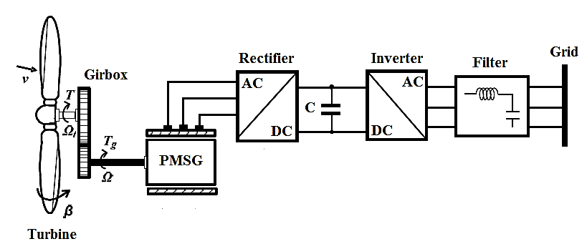

Fig. 1 Structure of direct driven PMSG.

I. Modeling of conversion chain

*A. Modeling of wind turbine*

The proposed model is based on the steady-state aerodynamic power characteristics of the wind turbine. The wind turbine analyzed is a classic three-bladed horizontal-axis (main shaft) wind turbine design with the corresponding pitch controller [1,8].

The output mechanical power available from a variable speed wind turbine can be expressed in the following way [8]:

$$P_{wt}=\frac{1}{2}ρSV_{w}^{3}C_{p}\left(β,λ\right) (1)$$

where Pwt is the wind power, 𝜌 is the air density, S is the effective rotor swept area, Vw is the wind speed, Cp is the power coefficient, 𝛽 is the pitch angle, and 𝜆 is the tip-speed ratio given by (2) in which, 𝜔 and R are rotational speed and radius of the rotor respectively [9].

$$λ=\frac{ωR}{V_{ω}} (2)$$

In expression (1), *Cp* depends on 𝛽 and 𝜆, representing the aerodynamic characteristic of the turbine. If 𝜆 is kept constant, *Cp* gets larger when 𝛽 gets less. Similarly, given 𝛽 constant, there is a value of 𝜆 making *Cp* maximum [9]. The curve family of Cp versus 𝛽 and 𝜆 is illustrated in Fig. 2 where 𝛽0=0<𝛽1<𝛽2<𝛽3<𝛽4.



Fig. 2 Curve family of Cp versus 𝛽 and 𝜆.

In terms of wind speed, the operation range of the turbine can be divided into maximum power point tracking (MPPT) mode and nominal power mode. When the wind speed is between cut-in and nominal speeds, the turbine will operate in MPPT mode requiring the power conversion coefficient to be the maximum Cpmax. As illustrated in Fig. 3 the pitch angle and the tip-speed ratio should be 𝛽0 and 𝜆opt respectively [9]. The optimal rotor speed at different wind speeds can be calculated by:

$$ω_{opt}=λ_{opt}V_{ω} (3)$$

When the wind speed exceeds nominal speed, the turbine will operate in nominal power mode. In this case, the pitch angle is regulated to control the wind power captured by the turbine. Fig. 3 presents the characteristic of the wind speed *V𝜔*. Between V1 and V8, it operates in nominal power mode, where V1<V2<V3<V4………<V7.



Fig. 3 Maximum power in function of rotor speed.

B. Gearbox model

The role of gearbox is to transform the mechanical speed of the turbine to the generating speed, and the aerodynamic torque to the gearbox torque according to the following mathematical formulas:

$$G=\frac{C_{aer}}{C_{g}} (4)$$

$$G=\frac{Ω_{mec}}{Ω_{tur}} (5)$$

The fundamental equation of dynamics permits to determine the mechanical speed evolution from the total mechanical torque applied to the rotor which is the sum of all torques applied on the rotor [7]:

$$J\frac{dΩ_{mec}}{dt}=C_{g}-C_{em}-C_{f} (6)$$

*Ωtur*: Mechanical speed of the turbine

*Ωmec*: Generator speed

*Caer*: Torque applied on the shaft of turbine

*Cg*: Torque applied on the shaft of the generator

*Cem*: Electromagnetic torque

*Cf*: Resistant torque due to frictions

$$C_{f}=fΩ_{mec} (7)$$

*J*: total inertia brought back on the generator shaft, containing inertia of the turbine, the generator, the two shafts, and the gearbox.

*f*: the total friction coefficient of the mechanical coupling.

C. Modeling of PMSG

In order to get a dynamical model for the electrical generator that easily allows us to define the generator control system, the equations of the generator are projected on a reference coordinate system rotating synchronously with the magnet flux in Fig. 4.

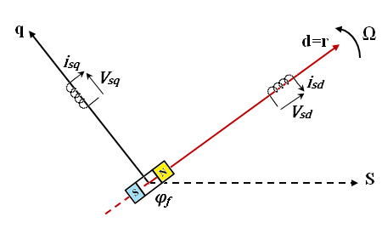

Fig. 4 Park model for PMSG.

In the synchronous machines with sinusoidal distribution of conductors, flux *φd* and *φq* are linear functions of currents *id* and *iq* situated on the rotor [10]. And they are given by the equations:

$$\left\{\begin{matrix}φ_{d}=L_{d}i_{d}+φ_{f} \\ φ_{q}=L_{q}i_{q} \end{matrix}\right. \left(8\right)$$

where:

*Ld*: stator inductance in d-axis

*Lq*: stator inductance in q-axis

*Lq* and *Ld* are supposed independent of 𝜃 (angle of Park transformation)

𝜑f: magnet flux

The wind turbine driven PMSG can be represented in the rotor reference frame as [10]:

$$\left\{\begin{matrix}V_{d}=-R_{s}I_{d}-L_{d}\frac{d}{dt}I_{d}+ωL_{q}I_{q} \\ V_{q}=-R_{s}I_{q}-L_{q}\frac{d}{dt}I_{q}-ωL_{d}I_{d}+ωφ_{f}\end{matrix}\right. (9)$$

The electromagnetic torque is expressed by:

$$C_{em}=\frac{3}{2}p\left(φ_{d}i_{q}-φ_{q}i_{d}\right) (10)$$

After affectation of the expressions of 𝜑d and 𝜑q.   
The expression of the electromagnetic torque becomes [10]:

$$C_{em}=\frac{3}{2}p\left[\left(L_{q}-L_{d}\right)i_{d}i_{q}+i_{q}φ_{f}\right] (11)$$

D. Output voltage control of grid-side inverter

The schematic diagram of the converter is shown in Fig. 5 [11]:

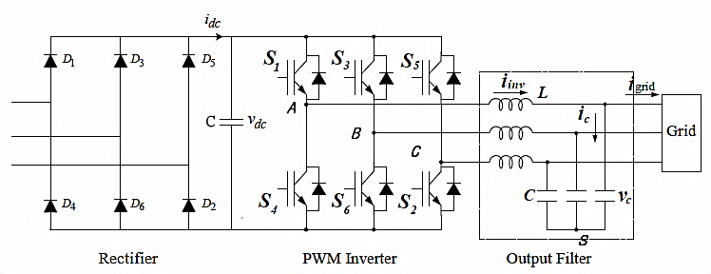

Fig. 5 Schematic diagram of the converter.

The power conditioning system (PCS) used for connecting renewable energy sources to the distribution utility grid requires the generation of high electric power quality. The proposed system includes a wind turbine (WT), a permanent magnet synchronous generator, a three-phase diode rectifier bridge, a DC bus with a capacitor and a current regulated PWM voltage source inverter. A three-phase uncontrolled full-wave rectifier bridge for performing the AC-DC conversion is a device which has the benefit of being simple, robust, cheap and needs no control system. A three-phase DC-AC voltage source inverter using IGBTs is employed for connecting to the grid through sinusoidal PWM techniques. As the high frequency harmonics produced by the inverter as result of the PWM control techniques employed are filtered by the filter, the VSI can be seen as an ideal sinusoidal voltage source. Since the wind power fluctuates with wind velocity, the generator output voltage and frequency vary continuously. The varying AC voltage is rectified into DC using a diode bridge and the DC-link voltage is then filtered to obtain constant voltage and the DC voltage is inverted to get the desired AC voltage employing a PWM inverter [1].

The output voltage of three-phase PWM inverter can be determined from the following space vectors:

* line to line voltage vector *[Vab Vbc Vca]t*

Where switching variable vector is *[a b c]t*

* line to neutral (phase) voltage vector   
  *[Van Vbn Vcn]t*

A LC filter has been used to eliminate the harmonics caused by switching of the IGBTs. Regarding the input and output of the system, the inverter circuit equations are expressed in differential forms as:

$$C\frac{d{\overline{V}}_{c}}{dt}={\overline{i}}_{inv}-{\overline{i}}_{Gd} (12)$$

$$L\frac{d{\overline{i}}_{inv}}{dt}={\overline{V}}_{i}-{\overline{V}}_{c} (13)$$

${\overline{V}}_{c}=\left[\begin{matrix}V_{ca} \\ V_{cb} \\ V_{cc}\end{matrix}\right]$, ${\overline{V}}_{i}=\left[\begin{matrix}V_{a} \\ V_{b} \\ V_{c}\end{matrix}\right]$, ${\overline{i}}_{inv}=\left[\begin{matrix}i_{a} \\ i_{b} \\ i_{c}\end{matrix}\right]$, ${\overline{i}}_{Grid}=\left[\begin{matrix}i_{Ga} \\ i_{Gb} \\ i_{Gc}\end{matrix}\right]$

where ${\overline{V}}_{c} , {\overline{V}}_{i} , {\overline{V}}_{inv}$ and ${\overline{i}}_{Gd}$ are the capacitor voltage, inverter output voltage, inverter output current and grid current vectors, respectively. L and C are the filter inductance and capacitance, respectively [12].

Expressing (12) and (13) in a synchronously rotating reference frame, the d-q axis equations are given by:

$${\dot{v}}_{cq}=\frac{1}{C}i_{q}-ωv_{cd}-\frac{1}{C}i_{Gq} (14)$$

$${\dot{v}}_{cd}=\frac{1}{C}i_{d}+ωv_{cq}-\frac{1}{C}i_{Gd} (15)$$

$${\dot{i}}_{q}=\frac{1}{L}v_{q}-ωi_{d}-\frac{1}{L}v_{cq} (16)$$

$${\dot{i}}_{d}=\frac{1}{L}v_{d}+ωi_{q}-\frac{1}{L}v_{cd} (17)$$

where *vcd* and *vcq* are the capacitor d-q voltage, *vd* and vq are the inverter output d-q voltages, *id* and *iq* are the inverter d-q currents, *iGd* and *iGq* are the grid d-q currents, and 𝜔 is the angular frequency of the output voltage [12].

Assuming that the input power in the DC link supplies instantaneously the grid power required, then the power balance between the filter input and output terminals can be achieved as:

$$V_{dc}I_{dc}=\frac{3}{2}\left(V_{cq}I_{Gq}+V_{cd}I_{Gd}\right) (18)$$

where *Vdc* and *Idc* are the DC link voltage and current.

For the balanced three-phase source voltage system, *Vcd* = 0 can be set arbitrarily. The voltage terms due to the coordinate transformation such as 𝜔Lid, 𝜔*Liq*, 𝜔*CVcd*, and 𝜔*CVcq* can compensated in feed forward-fashion, so that these terms can be excluded from the differential equation (9).

Then, from (14), the q-axis grid current can be expressed as:

$$i_{Gq}=i_{q}-CV_{cq} (19)$$

Substituting (19) into (18):

$$V_{cq}=\frac{2V_{dc}I_{dc}}{3CV_{cd}}+\frac{i_{q}}{C} (20)$$

Thus, from (16) and (20) a nonlinear system model can be expressed as:

$$\left[\begin{matrix}i_{q} \\ V_{cq}\end{matrix}\right]=\left[\begin{matrix}-\frac{1}{L}V_{cq} \\ -\frac{2V_{dc}I_{dc}}{3CV_{cq}}+\frac{i_{q}}{C}\end{matrix}\right]+\left[\begin{matrix}\frac{V_{q}}{L} \\ 0\end{matrix}\right] (21)$$

If the nonlinear system in (21) is expressed in a general form of (22)

$$\dot{x}=f\left(x\right)+g\left(x\right)u (22)$$

Then:

$$\left[\begin{matrix}{\dot{x}}_{1} \\ {\dot{x}}_{2}\end{matrix}\right]=\left[\begin{matrix}-\frac{1}{L}x_{2} \\ -\frac{2V_{dc}I_{dc}}{3Cx_{2}}+\frac{1}{C}x_{1}\end{matrix}\right]+\left[\begin{matrix}\frac{u}{L} \\ 0\end{matrix}\right] (23)$$

where, the state variables are *x1 = iq* and *x*2 = *Vcq*, and the control input is *u=Vq*.

IV. Results and discussion

In this section the simulated results in the Matlab/Simulink environment for the grid connection of three-phase harmonic filter described above are presented. The simulation results are considered to investigate the impact of harmonic filter on power grid connected with wind energy system. The wind speed is taken at 9 m/s. The inductance and capacitance of the filter are L=800.10-6 H and C=400.10-6 F respectively.

*A. Transient evolution of PMSG*

Fig. 6 and Fig. 7 show the tip-speed ratio and power coefficient of wind turbine.

Fig. 6 Tip-speed ratio 𝜆.

Fig. 7 Power coefficient Cp of wind turbine.

It is obvious from these Fig. 6 and Fig. 7 that 𝜆 and Cp are almost constant for the simulating period except for the jump start time at 0 s, while Fig. 8 shows the electromagnetic torque of PMSG.

Fig. 8 Electromagnetic torque of PMSG in N.m.

Fig. 9 shows the PMSG speed. The output voltage and current of PMSG at Phase (A) are presented in Fig. 10 and Fig. 11.



Fig. 9 Measured speed of PMSG in rad/s.



Fig. 10 PMSG output voltage Phase (A).

Fig. 11 PMSG output current Phase (A).

Fig. 12 depicts that the DC-link voltage with a constant value is equal to 430V.

Fig. 12 DC-Link voltage in volts.

*B. Before filtering*

Fig. 13 and Fig. 14 illustrate the inverter output voltage and current in Phase (A) before harmonic filter.



Fig. 13 Inverter output current Phase (A).



Fig. 14 Inverter output voltage Phase (A).

The FFT tool of powergui is used to display the harmonic spectrum of voltage waveforms before and after harmonic filter. Fast Fourier Transform (FFT) analysis of voltage is shown in Fig. 15. Harmonics are quantified in percentage of the fundamental component.

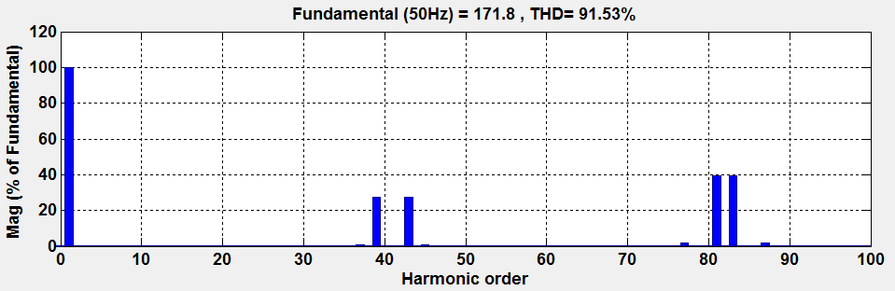

Fig. 15 Harmonic Spectrum before filtering.

*C. After filtering*

After harmonic filtering, the grid voltage and current at Phase (A) are depicted in Fig. 16 and Fig. 17. Fig. 18 shows the corresponding harmonic spectrum obtained by FFT.

Fig. 16 Grid current Phase (A).

Fig. 17 Grid voltage Phase (A).

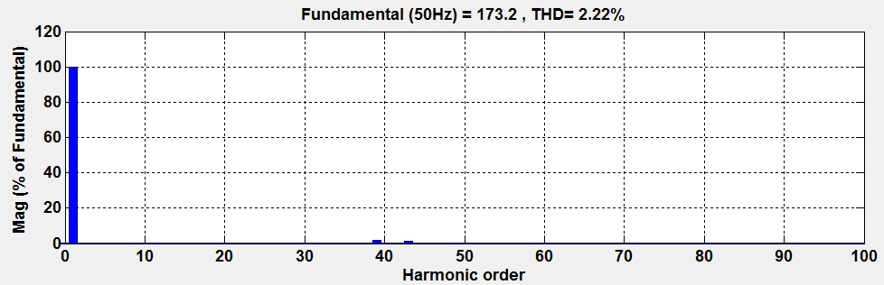Fig. 18 Harmonic Spectrum after filtering.

It is observed that the THD voltage is equal to 91.53% before filtering (Fig. 15). It is reduced to 2.22% after filtering (Fig. 18) which is less than the 5% limit imposed by IEEE-519 standard [5]. This is because the LC filter has been used to eliminate the harmonics pollution, which diminishes the total harmonic distortion and enhances the power quality distributed to the grid connection.

V. Conclusion

Modeling and simulation results of a grid-connected PMSG based on wind turbine system are analyzed and presented in this paper using Matlab/Simulink tool. Results show that turbine tip-speed ratio and power coefficient can be controlled at a constant value for different wind speeds. The output of the PMSG is converted to constant DC voltage. Detailed modeling and control strategy of a DC/AC converter connected to utility grid have been proposed. A three-phase inverter model was developed with a passive filter to eliminate inverter output harmonics. The proposed PWM inverter model enables substantial reduction of the harmonics while using polarized capacitors. The total harmonic content presents in the grid voltage and current is also reduced to a reasonable value.

The results have clearly demonstrated the ability of harmonic filter to decrease transients and harmonic distortion in power system. It has been concluded that with the inclusion of harmonic filter, THD runs down noticeably and hence power quality improves significantly.

VI. References

[1] N. S. Jayalakshmi, D.N. Gaonkar, K. Sai Kiran Kumar "Dynamic Modeling and Performance Analysis of Grid Connected PMSG based Variable Speed Wind Turbines With Simple Power Conditioning System", *2012 IEEE International Conference on Power Electronics, Drives and Energy Systems December16-19, 2012,* Bengaluru, India.

[2] W.M Lin, C.M. Hong, T.C. Ou, T.M. Chiu, "Hybrid intelligent control of PMSG wind generation system using pitch angle control with RBFN", *Energy Conversion and Management*, 52 (2011) 1244–1251.

[3] M. Seixas, R. Melício, V.M.F. Mendes, "Fifth harmonic and sag impact on PMSG wind turbines with a balancing new strategy for capacitor voltages", *Energy Conversion and Management, 79 (2014) 721–730*.

[4] A. Hoseinpour, S.M. Barakati, R. Ghazi, "Harmonic reduction in wind turbine generators using a Shunt Active Filter based on the proposed modulation technique", *Electrical Power and Energy Systems,* 43 (2012) 1401–1412.

[5] IEEE Guide for Harmonic Control and Reactive Compensation of Static Power Converters, IEEE Standard 519-1992, 1992.

[6] L. Gidwani, H. Tiwari, R.C. Bansal, "Improving power quality of wind energy conversion system with unconventional power electronic interface", *Electrical Power and Energy Systems*, 44 (2013) 445–453.

[7] W. Biao, D. Li-jie, Z. Hua, M. Peng, Q. Xiao-yan, "Study of the Directly Driven Type of Permanent Magnet Synchronous Wind Turbine Containing the Dynamic Characteristics", *IEEE. Electric Power Corporation*, (No.11H0892), 2012.

[8] A.G. Sanchez, M.G. Molina, A.M. Rizzato Lede, "Dynamic model of wind energy conversion systems with PMSG-based variable-speed wind turbines for power system studies", *International journal of hydrogen energy*, 37 (2012) 10064-10069.

[9] Z. Qiu, K. Zhou, Y. Li, "Modeling and Control of Diode Rectifier Fed PMSG Based Wind Turbine ", *IEEE. The National Natural Science Foundation of China under Grant No. 50977013,* 2011.

[10] M. Messaoud, R. Abdessamed, "Modeling and Optimization of Wind Turbine Driving Permanent Magnet Synchronous Generator", *Jordan Journal of Mechanical and Industrial Engineering*, Vol. 5, No. 6, Dec. 2011, pp. 489 – 494.

[11] A. Jamehbozorg, W. Gao, "A New Controller Design for a Synchronous Generator-Based Variable-Speed Wind Turbine", NSF Grant 0844707.

[12] D. C. Lee, J.I. Jang, "Output Voltage Control of PWM Inverters for Stand-Alone Wind Power Generation Systems Using Feedback Linearization", *IAS 2005*, pp. 7803-9208.