Maximum Power Point Tracking of a photovoltaic pumping system with PSO controller design
Marwen Bjaoui¹, Brahim Khiari², Ridha Benadli³ ,Mouad Memni⁴, Anis Sellami⁵
^{1,3,4}LANSER Laboratory, National Higher Engineering School of Tunis,
EED, BP 56, Montfleury 1008, Tunis, Tunisia
¹bjaouimarwen@yahoo.fr
³ridhabenadly@gmail.com
⁴memnimouad@hotmail.fr
²LANSER Laboratory, CRTEn, B.P.95 Hammam-Lif 2050, Tunis-Tunisia
²brahim.khiari@crten.rnrt.tn
⁵Research unit: C3S, National Higher Engineering School of Tunis,
EED, BP 56, Montfleury 1008, Tunis, Tunisia
⁵anis.sellami@esstt.rnu.tn

Abstract— This article allows us to evaluate the use of control strategy based on the optimization by particle swarm (PSO) to extract the maximum power from photovoltaic generator. This involves identifying the performance of a photovoltaic pumping system and the quality of robustness and dynamic response of the regulator. The results obtained under different operating conditions show a clear improvement in the MPPT control performance by the PSO method of the photovoltaic system.
Keywords—Photovoltaic pumping system, PSO, MPPT
- Introduction
Photovoltaic is being used around the whole world in most recent years. It is frequently used in many applications such as remote areas. Using photovoltaic as the power supply for water pumping is considered as one of the most promising areas of PV application. The main parts of PV water pumping systems are PV array, controller, converter, motor, pump and water storage tank.
Photovoltaic water pumping systems are particularly suitable for water supply in remote areas where the electricity is not available. Water can be pumped during the day and stored in tanks, making water available also at night or when it is cloudy. The pumped water has various uses such as domestic use, water for irrigation and village water supplies. The advantages of using water pumps powered by photovoltaic systems include little maintenance, easy installation, great reliability and the matching between the powers generated and the water usage requirements. In addition, water tanks can be used instead of batteries in photovoltaic pumping systems [8] [6].

- STUDIED STRUCTURE
The photovoltaic plant is essentially composed of a photovoltaic generator, a boost converter and motor load as indicated by the following figure.2:

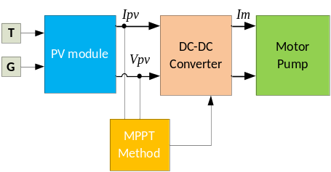
Fig 1. Diagram of MPPT in PV system

- PV Array
This generator consists of 6 TANIT modules of 50WC. The combination of these modules is done in parallel. The characteristic of a module is given below:

TABLE I
Electrical characteristics at 1KW/m², 25°C.
Parameters | Name | Value
R_{s} | Series resistance | 0.8Ω
n | Ideality factor | 1.62
I_{sc} | Schort circuit current | 3.35A
V_{oc} | Open circuit voltage | 19.8V
V_{mp} | Voltage at Pmax | 15.9V
I_{mp} | Current at Pmax | 3.15A

- DC Motor-pump characteristics
The motor pump consists of a permanent magnet DC motor and a centrifugal type pump. The nominal characteristics of this motor pump are:
U_{an}=24 V, I_{an}=12A, P_{um}= 0.36CV, N=2000rpm, f_{r}=1.5m³/h for a manometric height of h =10 m.
- DC-DC boost converter
The DC-DC Converter is an essential part of a PV system. The duty cycle of DC-DC converter is used as a control variable to regulate the V_{pv} of the array.
Therefore, once the algorithm estimates the reference voltage (V_{ref}) of global maximum, the duty cycle is modulated to adjust V_{pv} at V_{ref}. The DC-DC converter is shown Fig.3, has been used in this work. The relationship between the output voltage (Vs) and the duty cycle (d) is provided in Eq. (1).

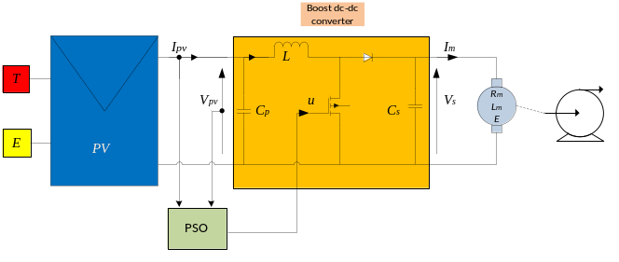
Fig 2. DC-DC Boost converter

The duty cycle is modulated between 0 and 1 at a speciﬁc frequency as depicted in eq.(2),
Where 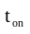is the on-time and 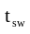is the total switching-time. The required output voltage and current is typically achieved by the appropriate values of the capacitors and indicators.
The values of C_{p}, L and C_{s} are calculated using Eqs.(3),(4) and (5) respectively [9]. Where V_{pv} is the photovoltaic array voltage, fsw is the switching frequency, ΔV_{pv} is the ripple voltage of the PV array, ΔV_{s} is the ripple voltage at the load, ΔI_{L} is the ripple current of the inductor and V_{s} is the output voltage of the boost converter [9].

(1)
(2)
(3)
(4)
(5)
- Modeling the structure adopted
  - Modeling of photovoltaic cell
Photovoltaic converts the arrays into electricity. It can be used for making electric generators. The equivalent model of a PV cell is shown in Fig.4.
The solar cell terminal current can be expressed as a function of photo-generated current, diode current and shunt current.

I_{p}=I_{ph} - I_{d} - I_{sh} (6)

Where:
I_{ph} is the current generated by the incident light (proportional to the sun irradiation).
I_{d} is the current through the diode.
I_{sh} is the current through the parallel resistor Rsh.

c
Fig 3. Simplified equivalent circuit of a photovoltaic cell.

The output current of PV array is given by following equation:
(7)
Where:
is cell reverse saturation current.
is the electron charge (q = 1,602.10⁻¹⁹ C).
k is the Boltzman constant (k = 1,38.10⁻²³Jk⁻¹)
n is the diode ideality constant.
is cell output voltage.
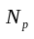is the number of PV cells connected parallel.
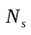is the number of PV cells connected in series.
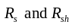are the series and shunt resistors of the cell, respectively.

The generated photocurrent 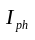 is related to the solar irradiation by the following equation:
(8)

Where:
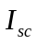is cell short circuit current at reference temperature and irradiation .
is short-circuit current temperature coefficient.
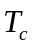 is cell reference temperature.
 is solar irradiation in W/m².

A typical P-V-I characteristics of a PV module at solar irradiation E=1000W/m2 and temperature T_{c}=25°C are shown in Figure.4.

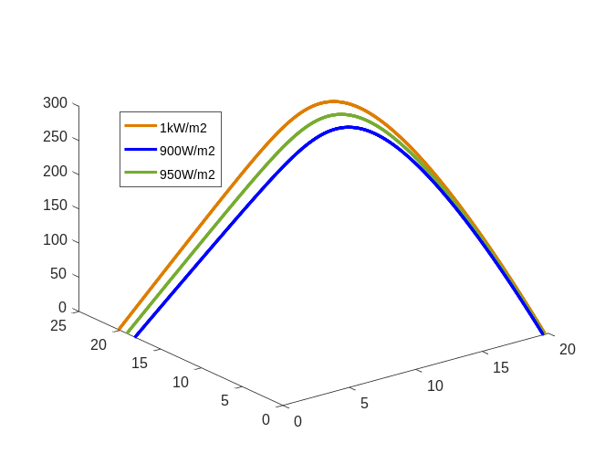
Fig 4. P-V-I output characteristics of PV array.
  - PV pumping systems models
The photovoltaic system studied is consists of a PV generator coupled to a DC motor with permanent magnet through a booster chopper. The model of the system set is as follows [8]:
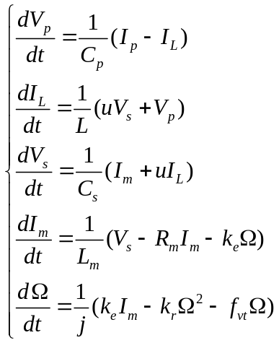 (9)

- MPPT controller
The proposed MPPT method is based on the fact that the slope of the PV module power versus voltage curves 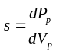 equal to zero at the maximum power point (MPP) [10][11]. The proposed algorithm invokes particle swarm optimization. PSO is stochastic, evolutionary computation algorithm which is developed based on the observations of the social behavior of animals such as bird ﬂocking, ﬁsh schooling and swarm theory [1] [2]. It maintains a population of individuals called particles. Each particle representing a candidate solution, is assigned with randomized velocity are then ﬂown through the search space [5]. Each particle shares the information gained by its own and its neighbor's ﬂying experience and updates its position [3]. In this manner, each particle progress to the global optimum point. The sequential steps of the algorithm are given below [4][7]:
- The duty ratio of the DC-DC converter is represented by the initialize of particles (duty ratio) with ﬁxed positions which cover the search space [u_{min} , u_{max}] with equal distance where u_{min} and u_{max} .
- The activation of the DC-DC converter using digital controller corresponding to the position of each particle and compute its ﬁtness value is after the allowable converter settling time of 0.2s.
- The position with lowest ﬁtness value found by particle i is known as its personal best (pbesti). Each time compare the ﬁtness value of particle i with pbesti. If the current position has lower ﬁtness value, replace the pbesti with its current position.
- The position of the particle with lowest ﬁtness value in the swarm is known as global best (gbest). For the entire swarm there is one gbest to which all particles tend to move. Compare the ﬁtness value of particle i with gbest. If ﬁtness value of particle i is smaller than gbest, replace gbest with position of particle i.
- Compute the velocity and position of ith particle in the kth iteration using equations (10) and (11) given below.
- The program ended when the displacements between gbest and all other pbests become lower than 0.001.

(10)

Where:
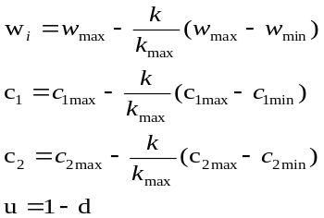

The velocity of the particle is varied according to the position of pbest and gbest as schown in the equation (10). The new velocity is scaled by the factor wi and increased in the direction of pbest and gbest. c₁ is a constant that determines the the amount by which the particle is inﬂuenced by pbest referred to as cognitive rate .c₂ is a constant which determines how much the particle is inﬂuenced by rest of population referred to as social rate. r₁ and r₂ are random numbers in the range (0,1). The particle is moved to new position using the updated velocity as given in equation (11).
(11)

The ﬂow chart of PSO algorithm is shown in Fig.6. The value of parameters used in velocity update equation is given in Table 2.

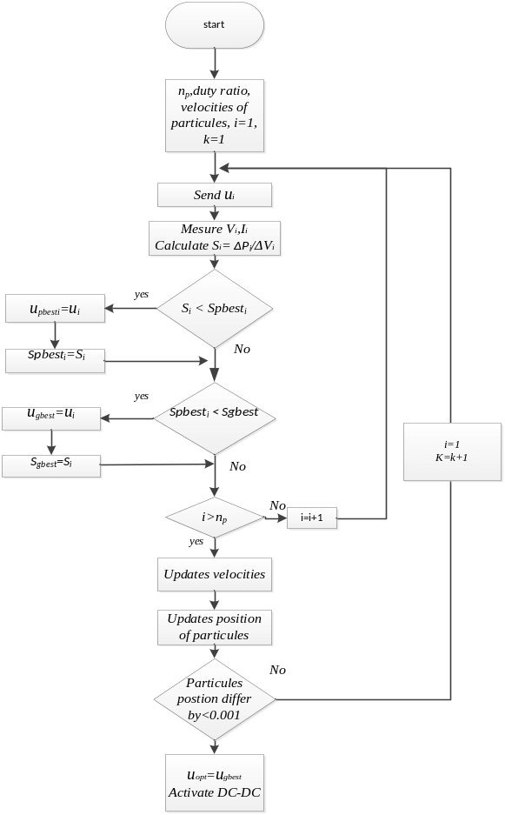

Fig 5. Flow chart of PSO algorithm.

TABLE III
Parameters of PSO.
Parameters | Value
Number of particule | 7
C_{1max} | 2
C_{1min} | 1
C_{2max} | 2
C_{2min} | 1
W_{max} | 1
W_{min} | 0.1

- Simulation results
This section presents us the results of the whole system (see ﬁg.3) using PSO control techniques to track the maximum power point under variation of the irradiance. All the following results were implemented in Matlab/ Simulink environment.

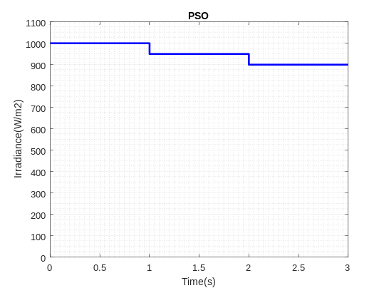

Fig 6. Irradiance variation

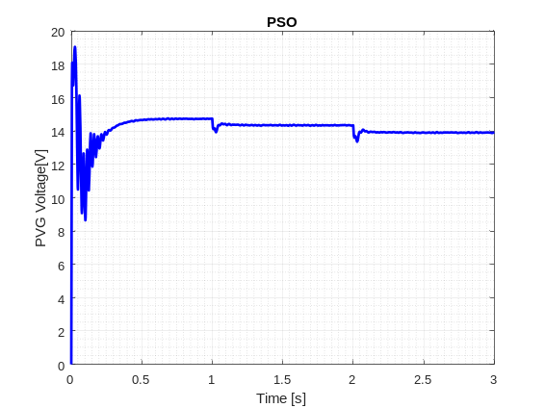

Fig 7. Variation of the PVG voltage

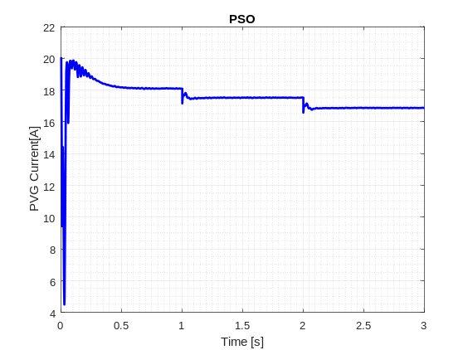

Fig 8. Variation of the PVG current

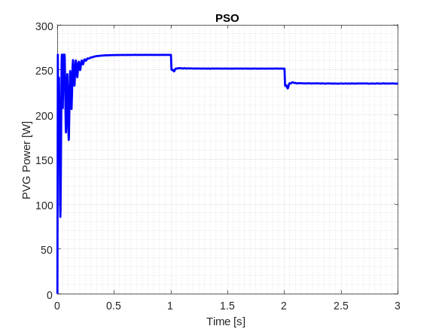

Fig 9. Variation of the PVG power.

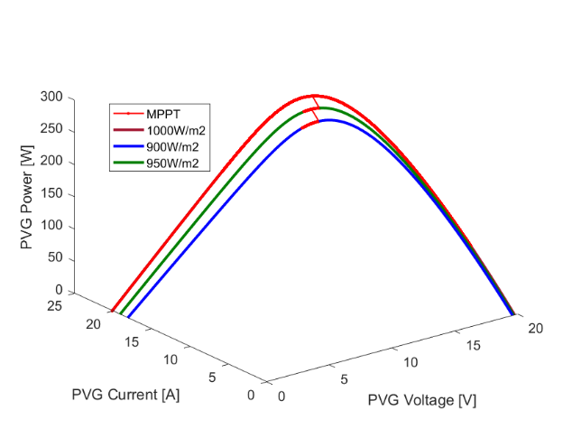

Fig 10. PSO MPPT method

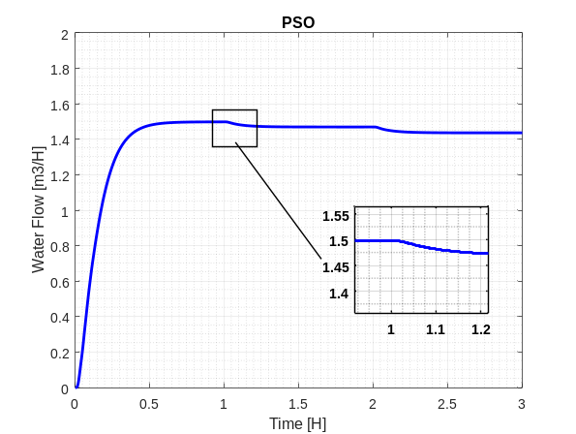

Fig 11. Variation of the water ﬂow rate.

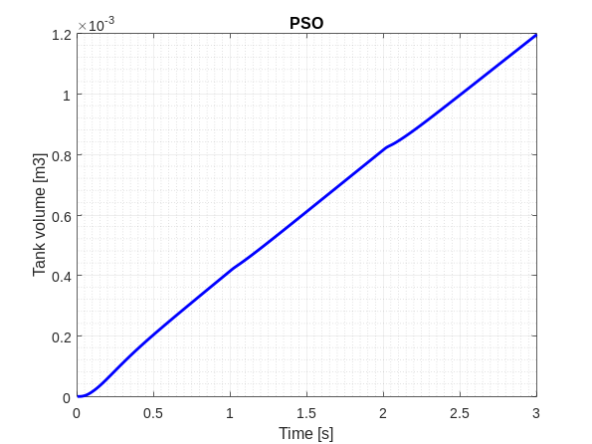

Fig 12. Progress of the tank volume

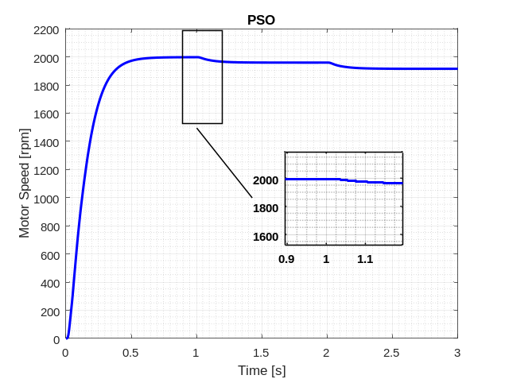

Fig 13. Variation of the moto-pump speed

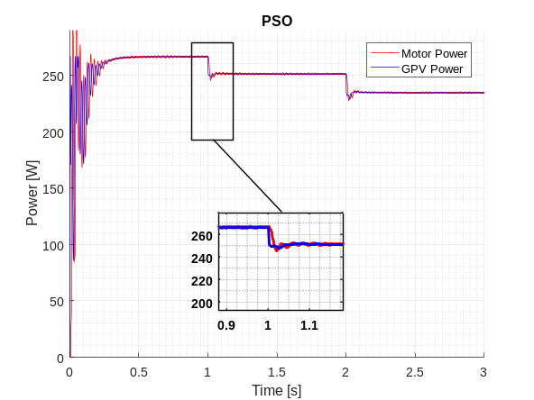
Fig 14. Variation of the PVG power and Motor power (W)
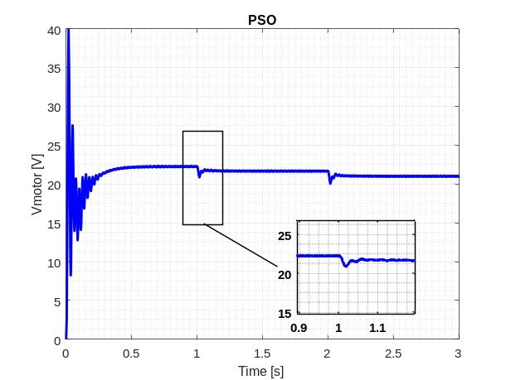
Fig 15. Variation of motor voltage (V).

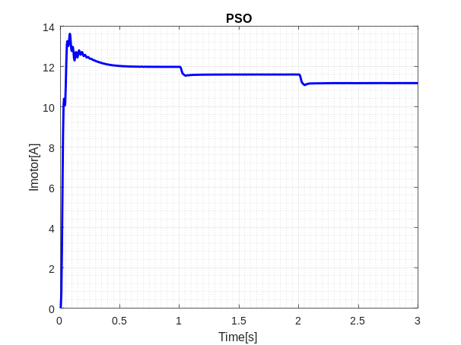
Fig 16. Variation of the motopump current.

- Discussion
The following results are obtained under variable irradiance (ﬁg.6) with a temperature of 25◦C. As illustrated in ﬁgures 7, 8 and 9, the current, voltage and power of the PVG, respectively, have the same shape as the irradiance curve. This means that they are directly proportional to the irradiance.
Figure 13 shows the speed of the moto-pump, which depends directly to the PVG voltage.
In ﬁgure 12, the water ﬂow starts when the moto-pump reaches a speciﬁc speed, around 2000 rpm, and then varies according to its variation.
The transient response curve of power tracking is delineated in Fig.9. The curve show that PSO based algorithm is capable of reaching the GMPP but takes 0.49 s for convergence. Further the PSO based algorithm produces oscillations in PV output power.

The PSO method proved its benefit in the extraction of maximum power from the photovoltaic panel. In fact, for the Irradiance value of 1000 W/m², the maximum power is of the order of 266.65 W. The efficiency of this method is of the order 99%.
In figure14, the Motor voltage is around 22V for the irradiance value of 1000 W/m² and it changes according to the irradiation’s variation.

- Conclusion
In this study, an improved maximum power point tracking (MPPT) method based of Particle swarm optimization algorithm for solar panel is proposed which has the ability to track the MPP for the environmental condition of irradiation and temperature.
PSO Approaches is considered to select and generate an optimal duty cycle which varies with photovoltaic parameters in order to extract the maximum Power. The proposed approach shows us that we can reach the maximum power point and can improve the performance of the system according to simulation results.

references

[1] Miyatake M, Veerachary M, Toriumi F, Fujii N, Ko H. Maximum power point tracking of multiple photovoltaic arrays: a PSO approach. IEEE Trans Aerosp Electron Syst Jan. 2011;47(1):367-80.

[2] Liu Yi-Hwu, Huang Shyh-Ching, Huang Jia-Wei, Liang Wen-Cheng. A particle swarm optimization-based maximum power point tracking algorithm for PV systems operating under partially shaded conditions. IEEE Trans Energy Conv Dec. 2012;27(4):1027-35

[3] Ishaque Kashif, Salam Zainal. A deterministic particle swarm optimization maximum power point tracker for photovoltaic system under partial shading condition. IEEE Trans Ind Elec Aug. 2013; 60(8):3195-206.

[4] K. Sundareswaran , V. Vignesh kumar , S. Palan. Application of a combined particle swarm optimization and perturb and observe method for MPPT in PV systems under partial shading conditions. Renewable Energy 75 (2015) 308-317.

[5] Youcef Souﬁ, Mohcene Bechouat , Sami Kahla. Fuzzy-PSO controller design for maximum power point tracking in photovoltaic system. International journal of hydrogen energy xxx (2016) 1-9.

[6] Dhiaa Halboot Muhsena, Abu Bakar Ghazalia, Tamer Khatib. Multiobjective differential evolution algorithm-based sizing of a standalone photovoltaic water pumping system. Energy Conversion and Management 118 (2016) 32–43.

[7] Chen Cheng P, Rei Peng B, Yi, Liu Hua, Cheng Yu Shan, Huang Jia Wei. Optimization of a Fuzzy-Logic-Control-Based MPPT Algorithm Using the Particle Swarm Optimization Technique. Energies 2015; 8:5338-60.

[8] A. Hadjaissa∗ S.M. Ait cheikh∗ K. Ameur∗ N. Essounboul. A GA-based optimization of a fuzzy-based MPPT controller for a photovoltaic pumping system, Case study for Laghouat, Algeria. IFAC-PapersOnLine 49-12 (2016) 692–697.

[9] M. Yaqoob Javeda,∗, Ali Faisal Murtazab, Qiang Linga,∗, Shahid Qamara, M.Majid Gulza. A novel MPPT design using generalized pattern search for partial shading. Energy and Buildings 133 (2016) 59–69.

[10] Paula Andrea Ortiz Valencia 1, Carlos Andres Ramos-Paj. Sliding-Mode Controller for Maximum Power Point Tracking in Grid-Connected Photovoltaic Systems. Published: 2 November 2015 Academic Editor: Tapas Mallick

[11] Siew-Chong Tan, Y.M0Lai, and Ch k.Tse,”General Design Issues of Sliding-Mode controllers in DC-DC converters”, IEEE Transactions on Industrial Electronics, vol.55, pp.1160-1174 March 2008.

