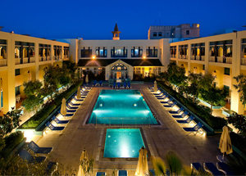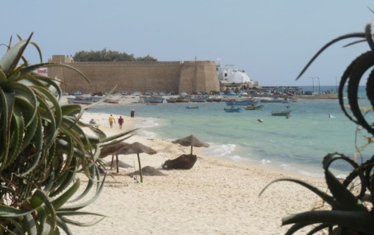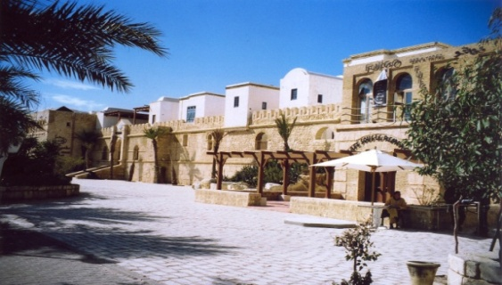

**3rd International Conference on**

**Automation, Control Engineering & Computer Science**



|  |  |  |  |
| --- | --- | --- | --- |
| **Computer Science & Information Technology**   * Algorithms and Bioinformatics * Artificial Intelligence * Computer Graphics & Visualization * Database & Data Fusion and Mining * Pattern Recognition/Multimedia * Internet & Cloud Computing * Multimedia systems & services * Probabilistic Methods * Queuing Methods * Security, Information Assurance * Web and internet computing | **Renewable Energy**   * Biomass, Geothermal, Hydraulic * Energy storage & management * Fuel cell, biogas * Heat transfer & Thermal Energy * Materials, semiconductors * Photovoltaic & Solar Energy * Wind Energy   **Signal Processing & Communication**   * Coding, transmitting, estimating * High Speed Communication * Hyper Network Communication * Image processing & communication | **Electrical Engineering & Automation**   * AC-DC/DC-AC/ DC-DC converters * Automated guided vehicles * Autonomous devices, Sensors * Cooperative Signal Algorithms * Digital and analog communication * Electric machines design * High voltage DC transmission * Industrial electronics * Monitoring and diagnostics * Power electronic Systems * Power systems * Radio wave, RFID, RF MEMS | **Control & Instrumentation**   * Algorithms & complexity * Biomedical instrumentation * Chaos and control applications * Control & Intelligent Sensors * Computational Science * Discrete-time control systems * Linear & nonlinear control * Neuro-fuzzy control * Robust and optimal control * Robot Dynamic and Control * System Modelling & Identification * Stochastic control and filtering |
| **Special session on Innovation & Engineering Management (IEM - 2016)** | | | |

**Publication & Indexing**

**All Registered and presented** papers will be published in indexed **Numeric proceedings** "Proceedings Engineering & Technology" Vol.12 & Vol.13

**Selected papers will be extended then published in several journals (Scopus and else) - Confirmed:**

|  |  |
| --- | --- |
| 1- International Journal of Hydrogen Energy (**ISI Thomson IF: 3.313**) | (10 papers) |
| 2- International Journal of ChemTech Research (**SCOPUS**) | (15 papers) |
| 3- International Journal of Simulation and Process Modelling (**SCOPUS-EiCompendex**); | (12 papers) |
| 4- International Journal of Signal and Imaging Systems Engineering (**SCOPUS**); | (20 papers) |
| 5- International Journal of Alternative Propulsion (**SCOPUS**)  6- International Journal of Control Theory and Applications (**SCOPUS**)  7- International Journal of Intelligent Engineering Informatics (**SCOPUS**); | (15 papers)  (15 papers)  (24 papers) |

|  |  |  |
| --- | --- | --- |
| **Submission Deadline**  **February 10, 2016** | **Authors Notification**  **10 Days after Submission** | **Final Manuscript due**  **February 28, 2016** |

***!!!!* Best paper award: Amount of 1000 TND Cash**

**Post Conference Program: Two MATLAB Workshops on 23 & 24 March 2016, Hammamet – Tunisia**

|  |  |  |  |
| --- | --- | --- | --- |
| **Steering Committee & Conference Chairs**  Ahmed Rhif, ***Tunisia***  Amer Zerek, ***Libya***  Feng Qiao, ***UK***  Minyar Sassi Hidri, ***Tunisia***  Nidhal Bouaynaya, ***USA***  Sundarapandian Vaidyanathan, ***India***  Youcef Soufi, ***Algeria***  **Publication Chairs**  Ahmad Tahar Azar, ***Egypt***  Ahmed Rhif, ***Tunisia***  Sundarapandian Vaidyanathan, ***India***  **Advisory Committee Chairs**  Abdeldjebar Hazzab, ***Algeria***  Ali Haddi, ***Morocco***  Ameen El-Sinawi, ***United Arab Emirates***  Ahmed El Oualkadi, ***Morocco***  Chalee Vorakulpipat, ***Thailand***  Dongguang Li, ***China***  Jalel Chebil, ***Tunisia*** | Linsen Xie, ***China***  Lijie Jiang, ***China***  Mohsen Guizani, ***USA***  Mohamed El Fituri, ***Libya***  Mohammed Sidki, ***Morocco***  Natheer K.Gharaibeh, ***Jordan***  Özlem Senvar, ***Turkey***  Quanmin Zhu,***United Kingdom***  Qing Zhu, ***USA***  Sofia Lebbar, ***Morocco***  Tahar Bahi, **Algeria**  Ved Ram Singh, ***India***  Yan Gao, ***China***  Yue Ma, ***China***  Zhengjie Wang, ***China***  **Technical Committee Chairs**  **Control & Instrumentation Chairs**  Beisenbia Mamirbek, ***Kazakhstan***  Bojana Milosevic, ***Serbia***  Burcu (Hudaverdi) Ucer, ***Turkey***  Deniz Türsel Eliiyi,***Turkey*** | Huseyin Hacihabiboglu, ***Turkey***  Laura Giarré, ***Italy***  Lamamra Kheireddine, ***Algeria***  Maria Letizia Corradini, ***Italy***  Mourad Kchaou, ***Saudi Arabia***  Ozlem Defterli, ***Turkey***  Yasemin Çelik, ***Turkey***  Saliha Durmus Tekir, ***Turkey***  **Automation & Engineering Chairs**  Antun Pintaric, ***Croatia***  Gulser Koksal, ***Turkey***  Gurkan Ozturk, ***Turkey***  Marina Ivasic-Kos, ***Croatia***  Merve Er Kara, ***Turkey***  Mirta Baranovic, ***Croatia***  Metin Turkay, ***Turkey*** | Yar M. Mughal, ***Estonia***  Ozlem Ozgun, ***Turkey***  Syedah Sadaf Zehra, ***Pakistan***  **Signal processing &Communication Chairs**  Afef Fekih, ***USA***  Ana (Kaic) Mestrovic, ***Croatia***  Amir Nakib, ***France***  Ali Mohammad-Djafari, ***France***  Fatma Sbiaa, ***Tunisia***  Greg Ditzler , ***USA***  Hassan Fathallah-Shaykh, ***USA***  Kenz A.Bozed, ***Libya***  Lucia Nacinovic Prskalo, ***Croatia***  Mohamed El Fituri, ***Libya***  Matjaz B. Juric, ***Slovenia***  Nilay Papila, ***Turkey***  Zhiqiang Du, ***China***  Rahmita Wirza, ***Malaysia***  Xinping YI, ***France*** |

**20-22 March 2016 - Hammamet, Tunisia**

**ACECS-2016**

Authors are invited to submit their papers in English in the following areas, but are not limited to:

**Website:**

[**http://ipco-co.com/ACECS.html**](http://ipco-co.com/ACECS.html)

**Email: acecs.conf@gmail.com**