INVOICE LETTER FOR AFRICAINS

Registration Fees | Africans Participant (€)
Full Registration | 490
Registration Co-author / Visitor  (without paper) | 420
2nd paper if any | 300
Transport Carthage Airport<>Conference | 30
Paper Publication | Free
Night Meeting | Free
Total | …..

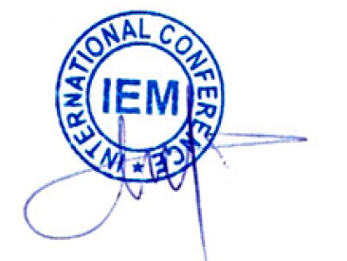
This registration form has to be made before 30 October

If you have any query please write to us on
iem.confe@gmail.com
Payment Procedure:

- Payment could be made by Cash on the conference desk or by Bank Transfer or by purchased order forms:
Tax Number: 1285992 / M / N / C / 000
Account Holder: Rahma Abdallah “INT.PUB & CO”
Bank Name: ZITOUNA BANK, SOUSSE SENGHOR
International Bank Account Number (IBAN): TN59 25 005 000 0000110235 40
Bank Identification Code (BIC): BZITTNTTXXX

Please clearly indicate your name, the paper ID and the announcement: “IEM-2017″ on the payment receipt.

