A novel method for the determination of cadmium ions based on the quenching of the fluorescence of CdSe quantum dots

Nassim Ben Brahim^{a,b,}*, Naim Bel Haj Mohamedª, Rafik Ben Chaâbaneª, Mohamed Haouariª, Hafedh Ben Ouadaª
ªLaboratoire des Interfaces et Matériaux Avancés, Faculté des Sciences de Monastir, Bd. de l’Environnement, 5019 Monastir, Tunisia.
E-mail: nassim.benbrahim.fsm@gmail.com.

Michel Negrerie^{b}
^{b}Laboratoire d'Optique et Biosciences, INSERM U1182, CNRS UMR7645, Ecole Polytechnique, 91128 Palaiseau, France.
E-mail: michel.negrerie@polytechnique.fr.

Abstract: A novel method for the determination of Cd²⁺ has been developed based on quenching of the fluorescence of thioglycerol-capped CdSe quantum dots (TG-CdSe QDs) by Cd²⁺ in aqueous solutions. Under optimum conditions, the relative fluorescence intensity was linearly proportional to the concentration of Cd²⁺ between 1.0 and 20 µM with a detection limit of 0.32 µM. The detection mechanism between the TG-CdSe QDs and Cd²⁺ ions was discussed using various experimental techniques such as TEM, UV–vis and fluorescence spectroscopy. Based on their optical properties, the TG-CdSe QDs could be used as a highly selective probe for the detection of Cd²⁺ ions in aqueous solutions, a species very toxic for cells.

Keywords: CdSe quantum dots synthesis; Quenching of the fluorescence; Electronic microscopy; Cadmium detection; Cation binding selectivity.

- Introduction
Heavy metal contamination is a serious concern to human health due to of their toxicity and their accumulation in ecological systems. Cadmium is one of the most hazardous heavy metal elements and has been extensively studied because its high toxicity as a cumulative poison in humans and animals. Due to the biological and environmental concerns of metal ions, there is an ongoing need to develop sensitive strategies for tracing heavy metal ions in living systems and the whole environment, so that a large number of organic dye-based metal ion probes have been studied so far [1-5]. Up to now, a variety of methods have been developed for the determination of metal ions, including atomic absorption spectrometry [6,7], anodic stripping voltammetry [8], spectrophotometry [9], and gas chromatography-mass spectrometry [10]. However, these methods all have limits, such as high cost, robust sample handling, etc., and it is crucial to develop simple, accurate and sensitive methods for the detection of Cd2+. Therefore, the development of simple analytical instruments, methods and procedures with high selectivity and low detection limits are actively investigated for these cadmium ions. Organic dyes have been developed for the determination of heavy metal ions based on fluorescence quenching [11] and measurement of variation of the intensity of the fluorescence emission. However, for many dyes, disadvantages are their narrow excitation spectra, broad emission spectra and photobleaching. Alternatively, quantum dots (QDs) are well-dispersed semiconductor nanocrystals which have attracted increasing attention since their discovery in the early 1980's [12, 13]. Compared with organic dyes, QDs have a broad excitation spectrum, narrow and tunable emission spectrum, good photostability, chemical stability, and high brightness [14, 15]. Moreover, their absorption spetrum can be tuned as a function of their size. Since CdS QDs were firstly reported as selective ion probes in aqueous samples [16, 17], many functionally capped luminescent QDs, such as CdS, CdSe and CdTe QDs, also showed a response to copper, silver and mercury ions [18-22]. Besides, thiol-capped CdTe QDs have been exploited in numerous applications, such as light-emitting devices [23], photonic [24] and biological labels [25]. However, to the best of our knowledge, no study of CdSe QDs used as Cd probes has been performed.
In this paper, a new approach is proposed for the determination of Cd²⁺ based on fluorescence quenching of thioglycerol-capped CdSe QDs. Some influencing factors, such as temperature, pH and time reaction, were studied in detail. Under optimum conditions, the fluorescence quenching as a response to Cd²⁺ binding was linear in the range of 1 to 20 µM of Cd²⁺ concentration, with a detection limit of 0.34 µM. The detection mechanism between the thioglycerol capped CdSe QDs and Cd²⁺ ions was discussed using various experimental techniques such as TEM, UV–vis absorption and fluorescence spectroscopy.

Experimental
1. Instrumentation
X-ray diffraction (XRD) powder spectra were taken by XPERT PRO MPD PANalytical X-ray generator using Cu-Kα radiation at a wavelength of 1.542 Å. For performing transmission electron microscopy (TEM) we have employed a JEOL 2010 FEG apparatus. The Raman spectrum was recorded with a LABRAM HR-Raman spectrometer (HORIBA, Jobin-Yvon). The incident laser excitation was 514 nm from an Argon ion laser source.To identify the presence of TG on the surface of QDs, Fourier-transform infrared (FTIR) spectra were measured using Perkin Elmer FTIR spectrophotometer (version 5.3) within the range 600–4000 cm⁻¹. Powder samples were mixed with anhydrous potassium bromide (KBr) pelletized and used for FTIR analysis. The UV-vis absorption and emission spectra of CdSe quantum dots were measured at room temperature using Shimadzu UV-310PC UV-vis spectrophotometer and Cary Eclipse fluorescence spectrometer, respectively.
2. Synthesis of TG-capped CdSe QDs
We have followed the method described for the synthesis of CdS (cadmium sulfure) QDs capped with thiol derivatives [26] with some modifications. The chemicals used were from Sigma, Aldrich and Fluka. Briefly, an aqueous solution was obtained by mixing cadmium acetate dehydrate with thioglycerol (TG) as the stabilizer in deionized water with continuous stirring under nitrogen atmosphere. The pH value of the resultant mixture was adjusted to 11.2 by adding NaOH solution. Another aqueous solution of Na2SeO3 was prepared by introducing SeO₂ into a NaOH solution. The latter was injected into the pH-controled mixture of Cd²⁺ and stabilizer under vigorous stirring. The molar ratio of Cd²⁺/TG/Se²⁻ was set at 1/2/0.5. After that, a solution of reducing agent NaBH4 was injected with a syringe to the final solution under continuous stirring at 100 °C under N₂ until the solution became light yellow in color. The TG capped CdSe quantum dots were obtained at this stage. After this step, the particles were extracted by precipitation in isopropanol. The solution was stirred for one hour and the precipitate was filtered then dried in a desiccator under vacuum.

- Results and discussion
- Characterization of CdSe QDs
Transmission electron microscopy (TEM) was employed to obtain a direct measurement of the size and morphology of the TG-CdSe QDs. The TEM image (Figure 1A) reveals a cluster of nanoparticles which are almost spherical and whose size is nearly monodispersed, with an average diameter of ~2.5 nm.

The X-ray powder diffraction spectrum of TG-CdSe exhibits three main peaks (Figure 2) at diffraction angles 2θ = 25.20°, 41.90° and 49.70° which are respectively assigned to the (111), (220) and (311) planes of the cubic CdSe (JCPDS no. 19-191). The XRD pattern indicates the good crystalline structure of synthesized TG-CdSe QDs. The sharp and smooth peaks further reveal that the population of QDs is close to monodispersity (while broadened peaks would originate from small size QDs).
To verify the existence of thioglycerol (TG) as a stabilizer on the surface of the prepared CdSe QDs the FT-IR spectrum of TG-CdSe QDs was recorded (Figure 3). All peaks of TG are present in the spectrum of TG-CdSe QDs but the peak at ~2525 cm⁻¹ assigned to the S-H group was absent, as a result of the formation of covalent bonds between thiols and Cd²⁺ at the surface of CdSe QDs, demonstrating the binding of TG.
The Raman spectrum of powder CdSe QDs from 120 to 260 cm⁻¹ at room temperature displays three bands (Figure 4). The fitting to the sum of three Lorentzian functions allowed to identify the modes: the first-order longitudinal optical phonon (1LO) mode of CdSe, centered at 208.6 cm⁻¹. The second one, centered at 188.7 cm⁻¹, originates from the CdSe surface optical phonon (SO) mode and a third mode, centered at 146.2 cm⁻¹, is identified as a transverse optical (TO) mode [27- 29]. In particular, the CdSe 1LO mode is shifted to lower wavenumber by ~5 cm⁻¹ as compared to the 1LO mode of bulk CdSe (~213 cm⁻¹) [30]. This shift indicates the presence of CdSe nanocrystals and not bulk material, as these modes only appear as a consequence of the strong spatial confinement. In addition, the existence of the SO mode was induced by the chemical connection between a dielectric material and the nanocrystallites [31] and further proves that capping of CdSe occurred during synthesis.

Figure 5 shows the absorption and emission spectra of TG-capped CdSe QDs. The UV−vis absorption spectrum consists of an absorption edge at 400 nm which is blue shifted from the bulk band gap of 700 nm (1.74 eV) for bulk CdSe. This shift from the bulk band gap is caused by strong quantum confinement and also indicates small particle size [32]. The emission spectrum is broad and shows emission maximum at 585 nm for an excitation at 360 nm which is red-shifted in relation to its absorption maximum.

- Interaction of TG-CdSe QDs with different metal ions.

Many metal ions have the potential to influence the QDs fluorescence emission. We selected various cations, namely Na⁺, Li⁺, Cu²⁺, Co²⁺, Ba²⁺, Zn²⁺, Ni²⁺, Mn²⁺, Hg²⁺, Pb²⁺, Fe²⁺, Fe³⁺ and Al³⁺ to study the influence on the fluorescence signals of TG-CdSe QDs (Figure 6). The results revealed that Cd²⁺ can strongly quench the fluorescence of TG-CdSe QDs but that other cations only very slightly interfered with fluorescence emission, a property which allows the selectivity of the Cd²⁺ determination.

Optimization of pH and reaction time: Previous reports suggested that solution acidity played an important role in the interaction of QDs with other metals [33]. The effect of varying the pH of solutions on the fluorescence response due to the interaction between CdSe QDs and Cd²⁺ was investigated in the range of pH 3 to 12. We found that TG-CdSe QDs synthesized under basic conditions showed extraordinarily weak fluorescence signals under acidic conditions, revealing its instability in acidic conditions. Further measurements showed that the fluorescence signals of the reaction between CdSe QDs and other metals were also very weak. However, the fluorescence intensity of CdSe QDs decreased most severely for 7 < pH < 12 (Figure 7A). Therefore, the most suitable reaction condition pH = 8.4 was selected for further experiments.
The fluorescence intensity was significantly reduced when increasing the reaction time up to 90 seconds, reaching a plateau as time varyies up to 3 min (Figure 7B) reflecting a saturation of Cd²⁺ binding sites. Thus, a reaction time of 2 min was selected as standard for all subsequent reactions between TG-CdSe QDs and Cd²⁺. To control the temperature influence on the fluorescence intensity, 20 °C was chosen as the standard for all experiments.

Fluorescence quenching of TG-CdSe QDs by Cd²⁺: The fluorescence emission of TG-CdSe QDs as a function of Cd²⁺ concentration is increasingly quenched, but without shift of the emission peak (Figure 8A). This quenching can be described by the Stern-Volmer equation:
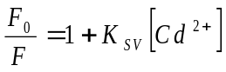
where F₀ and F are the fluorescence intensities of TG-CdSe QDs in the absence and in the presence of increasing concentration [Cd²⁺], respectively, thus determining the quenching constant K_{SV} = 2 .3 × 10⁻⁴ mol∙L⁻¹. Under standard conditions, linearity was observed in the Cd²⁺ concentration range from 1.0 to 20 µM (Figure 8B) with correlation coefficient of 0.967 and a detection limit of 0.32 µM.

The fluorescence quenching of QDs may happen by energy transfer [34], charge diverting [35] or surface absorption [36], which may change the surface state of QDs. Previous studies on some metallic cations, such as Cu²⁺, Ag²⁺ and Hg²⁺ [37-39], revealed that changes of the surface charges or capping components of QDs would alter their photophysical properties. Indeed, the addition of Cd²⁺ induces the shift of the excitonic peak at 400 nm toward higher energy (Figure 9), showing that the size of TG-CdSe QDs had turned asymmetrical. Therefore, the process of fluorescence quenching is static, the surface state of TG-CdSe QDs being changed by the addition of Cd²⁺. Furthermore, the morphology of nanoparticles changed, as confirmed by the TEM image of TG-CdSe QDs in the presence of Cd²⁺ (Figure 1B) drastically different from the image in absence of Cd²⁺ (Figure 1A).

Selectivity of fluorescence assay for Cd²⁺: To test the selectivity of the method using TG-CdSe QDs as the probe for cadmium ion detection in aqueous solution, the influence of the foreign cations Na⁺, Li⁺, Cu²⁺, Co²⁺, Ba²⁺, Zn²⁺, Ni²⁺, Mn²⁺, Hg²⁺, Pb²⁺, Fe²⁺, Fe³⁺ and Al³⁺ was investigated (Figure 10). These measures show that coexisting substances do not cause a large error on the fluorescence intensity change of TG-CdSe QDs binding Cd²⁺, and can be considered to have no interference on the detection of Cd²⁺.

- Conclusion
We have successfully developed novel water-soluble QDs stabilized with thioglycerol. Based on the quenching of fluorescence of functionalized CdSe QDs, a simple method for the recognition of cadmium ions is proposed with a wide linear range. All together, the results demonstrated that the method has a high selectivity and might be applied to the detection of Cd²⁺ in aqueous solution. The thioglycerol-capped CdSe QDs discloses facile synthesis, low cost, high sensitivity, so that the analytical applications of this sensor are very simple.

Figures

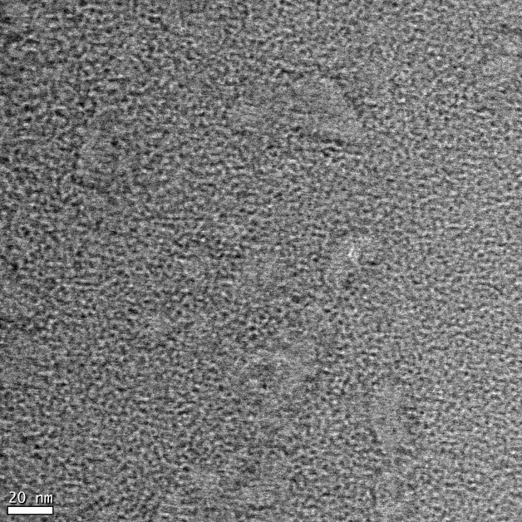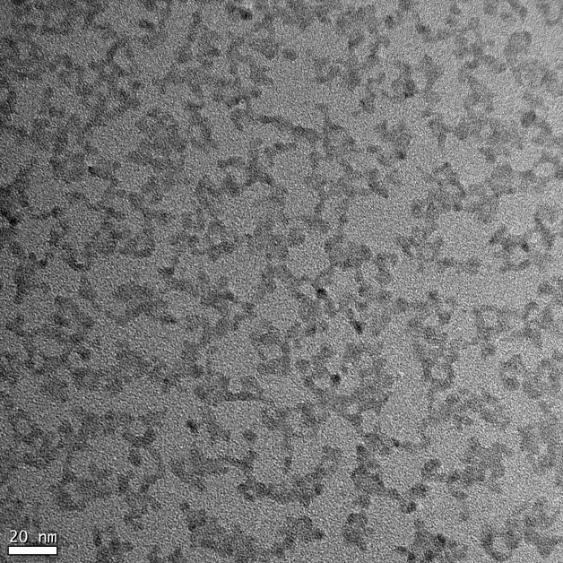
Fig. 1. TEM images of TG-CdSe QDs in the absence of Cd²⁺ (left) and in presence of Cd²⁺ 15 µM (right).

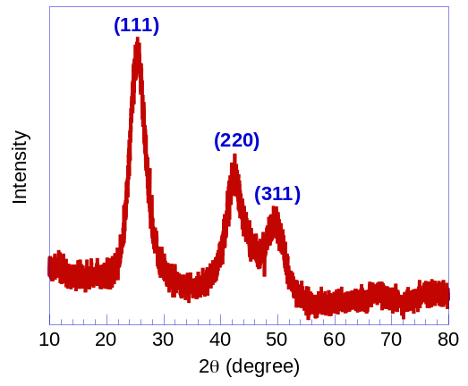
Fig. 2. X-ray diffraction (XRD) spectrogram of TG-CdSe in powder.
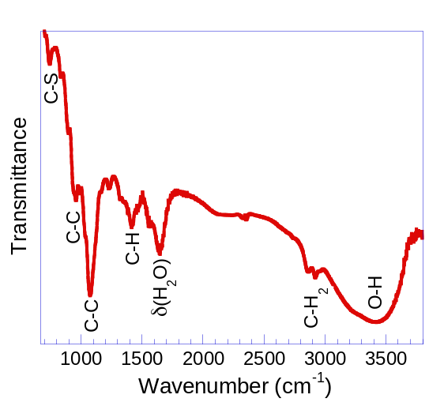
Fig. 3. FT-IR spectrum of TG-CdS QDs.
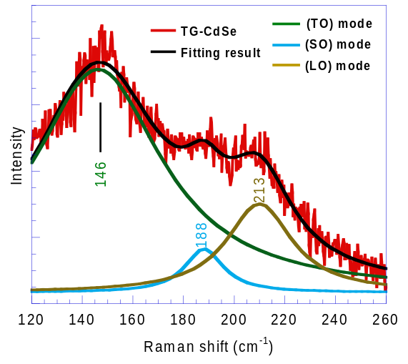
Fig. 4. Raman spectrum of TG-CdSe QDs in powder which was fitted to the sum of three Lorentzian functions.
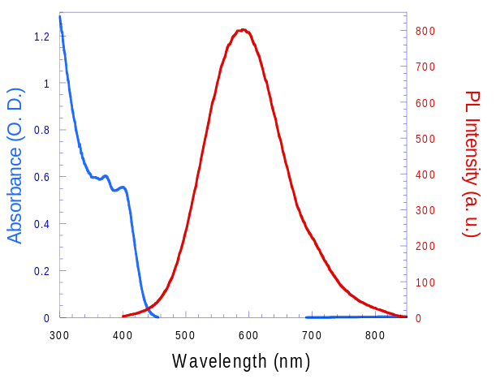
Fig. 5. UV-vis absorption (blue line) and fluorescence (red line) spectra of TG-CdSe QDs.

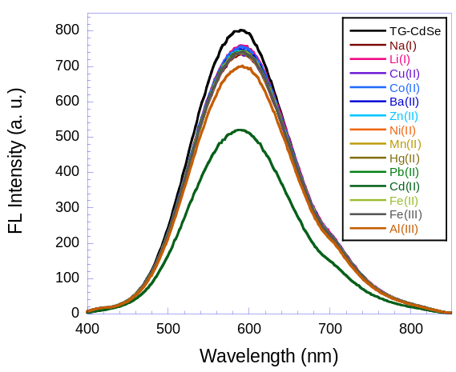
Fig. 6. Fluorescence spectra of the TG-CdSe QDs solution (5 × 10⁻⁴ M) before and after the addition of different metal ions (20 µM). The excitation wavelength was 360 nm.
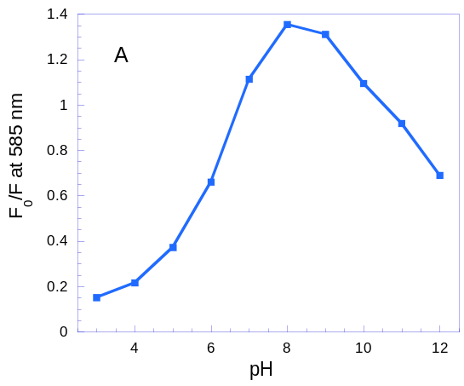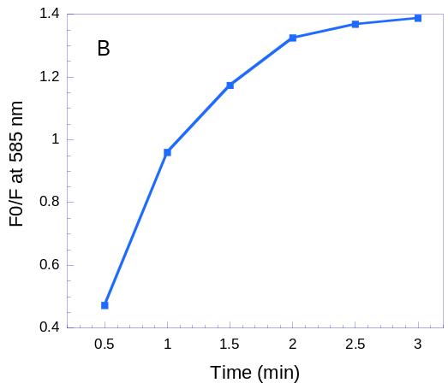
Fig. 7. Effects of pH (A) time (B) on the fluorescence quenching of TG-CdSe QDs after the addition of Cd²⁺ (15 µM).
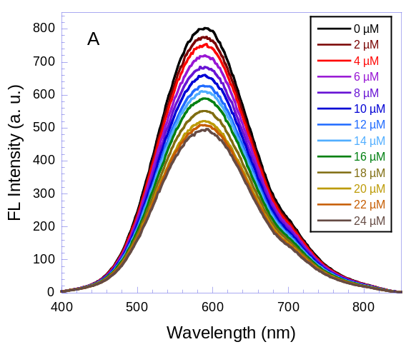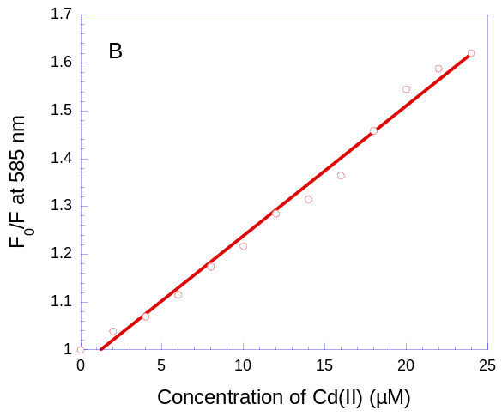
Fig. 8. (A) Fluorescence spectra of TG-CdSe QDs in the presence of increasing Cd²⁺ concentration at 20°C and pH = 8.4. (B) The Stern–Volmer plot of the Cd²⁺ dependence of the fluorescence quenching. The spectra were recorded with an excitation at 360 nm.
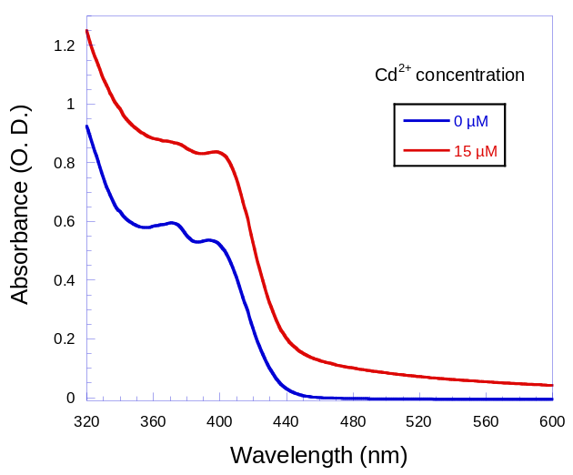
Fig. 9. UV-Vis absorption spectra of TG-CdSe QDs in absence and presence of Cd²⁺ at pH 8.4 in Tris-HCl solution and 20°C.
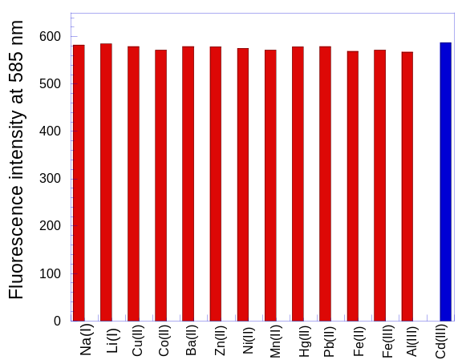
Fig. 10. Fluorescence intensity of TG-CdSe QDs with 15 µM Cd²⁺ and various coexisting metal cations (20 µM) compared to cadmium alone (right most column).

References

[1] T. Q. Duong, J. S. Kim, Chem. Rev. 110 (2010) 6280.
[2] D. W. Domaille, E. L. Que, C. J. Chang, Nat. Chem. Biol. 4 (2008) 168.
[3] X. Q. Chen, T. Pradhan, F. Wang, J. S. Kim, J. Yoon, Chem. Rev. 112 (2012) 1910.
[4] H. N. Kim, W. X. Ren, J. S. Kim, J. Yoon, Chem. Soc. Rev. 41 (2012) 3210.
[5] Z. C. Xu, J. Yoon, D. R. Spring, Chem. Soc. Rev. 39 (2010) 1996.
[6] Y. H. Sung, S. D. Huang, Anal. Chim. Acta 495 (2003) 165.
[7] Q. Tan, P. Wu, L. Wu, X. D. Hou, Microchim. Acta 155 (2006) 441.
[8] S. G. Caper, R. J. Gajan, E. Madzsar, R. H. Albert, M. Sanders , J. Zyren, J. Assoc. Off. Anal. Chem. 65 (1982) 978.
[9] G. Z. Fang, J. M. Pan, Chem. Anacz. 50 (2005) 925.
[10] J. R. Baena, S. Cardenas, M. Gallego, M. Valcarcel, Anal. Chem. 72 (2000) 1510.
[11] F. Nome, H.D. Fiedler, E. Sapelli, G.C. Bedendo, R.S. Mello, L.V. Vargas, Analyst 130 (2005) 242.
[12] JG. Liang, S. Huang, DY. Zeng, ZK. He, XH. Ji, X. Ai, HX. Yang, Talanta 69 (2006) 126
[13] H. Y. Han, Z. H. Sheng, J. G. Liang, Mater. Lett. 60 (2006) 3782
[14] A. J. Sutherland, Curr. Opin. Solid State Mater. Sci. 6 (2002) 365
[15] Q. E. Cao, K. T. Wang, Z. D. Hu, Q. H. Xu, Talanta 47 (1998) 921.
[16] A. V. Isarov, J. Chrysochoos, Langmuir 13 (1997) 3142.
[17] Y. F. Chen, Z. Rosenzweig, Anal. Chem. 74 (2002) 5132.
[18] K. M. Gattas-Asfura, R. M. Leblanc, Chem. Commun (2003) 2684
[19] H. Y. Xie, J. G. Liang, Z. L. Zhang, Y. Liu, Z. K. He, D. W. Pan Spectrochim. Acta Part A 60 (2004) 2527.
[20] B. Chen, P. Zhong, Anal. Bioanal. Chem. 381 (2005) 986.
[21] J. G. Liang, X. P. Ai, Z. K. He, D. W. Pang, Analyst 129 (2004)619
[22] B. Chen, Y. Ying, Z. T. Zhou, P. Zhong, Chem. Lett. 33 (2004) 1608
[23] N.P. Gaponik, D.V. Talapin, L. Rogach, A. Eychmuller, J. Mater. Chem. 10 (2000) 2163.
[24] A.L. Rogach, N.A. Kotov, D.S. Koktysh, J.W. Ostrander, G.A. Ragoisha, Chem. Mater. 12 (2000) 2721.
[25] D. Y. Wang, A. L. Rogach, F. Caruso, Nano Lett 2 (2002) 857.
[26] N.B-Haj Mohamed, M. Haouari, Z. Zaaboub, M. Nafoutti, F. Hassen, H. Maaref, H. B. Ouada, J. Nanopart. Res. 16 (2014) 2242.
[27] A.M. Kelley, ACS Nano 7 (2011) 5254.
[28] E.S.F. Neto, N.O. Dantas, S.W. da-Silva, P.C. Morais, M.A.P. da Silva, J. Raman. Spect. 41 (2010) 1302.
[29] S.K. Islam, M.A. Sohel, J.R. Lombardi, J. Phys. Chem. C 118 (2014) 19415
[30] F. Todescato, A. Minotto, R. Signorini, J.J. Jasieniak, R. Bozio, ACS Nano 7 (2013) 6649
[31] S. Wageh, J. Phys. E 39 (2007) 8.
[32] J. Jasieniak, L. Smith, J. van Embden, P. Mulvaney, M. Califano, J. Phys. Chem. C 113 (2009) 19468.
[33] E. M. Waleed, Sens. Actu. B 164 (2012) 76.
[34] J. Tang, R. A. Marcus, J. Chem. Phys. 125 (2006) 44703.
[35] X. J. Ji, J. Y. Zheng, J. M. Xu, V. K. Rastogi, T. C. Cheng, J. J. DeFrank, R. M. Leblanc, J. Phys. Chem. B 109 (2005) 3793.
[36] C. Q. Dong, H. F. Qian, N. H. Fang, J. C. Ren, J. Phys. Chem. B 110 (2006) 11069.
[37] A. Wang, L. Fu, T. Rao, W. Cai, M. F. Yuen, J. Zhong, Optic. Mater. 42 (2015) 548.
[38] J. L. Chen, C. Q. Zhu, Anal. Chim. Acta 546 (2005) 147.
[39] J. Duan, L. Song, J. Zhan Nano Res. 2 (2009) 61.

