Design and supervision of a PV-Wind

stand-alone system

Hocine BELMILI, Sabri BOLOUMA, Boualem BENDIB, Fayçal Mohammed ALMI

Unité de Développement des Equipements Solaires, UDES, Centre de Développement des Energies Renouvelables,

CDER, 42415, Tipaza, Algérie [belmilih@yahoo.fr](mailto:belmilih@yahoo.fr)

#### Abstract—

#### **This paper summarizes the design and the supervision of a hybrid PV/Wind stand-alone system. It consists of a 4 kW photovoltaic generator designed around five string containing six STP135 solar panels each and a wind generator made of 1 kW wind turbine each one. The energy management system is designed like modular electrical cabinets, one for photovoltaic power generation, and the second one for wind power generation. Hybridization between these resources was established by using DC-Bus configuration. Through this bus, energy is stored in batteries bank and used to supply DC and AC loads by the intermediary of inverters. The system supervision is ensured by the acquisition of different electrical parameters of subsystems.**

**Keywords- Design, supervision, PV-Wind, stand-alone system.**

# Introduction

Economic development and increasing uses of electricity-consuming devices will increase future demand for electricity. Alongside demand and security of supply issues, climate change also poses a global risk, but presents the new opportunities as well [1]. The Algerian economy is heavily based on the petroleum industries. In Algeria, 60% of government income comes from oil and gas exports. Significant economic benefits will accrue as the energy paradigm shifts from a system based on petroleum and natural gas and ever-increasing demand for electric power to one of high natural resources costs and the need to more energy management efficiency.

Algeria [2] is located in northwestern Africa, bordering the Mediterranean Sea between Morocco and Tunisia. It has an area of almost 2.4 million square kilometers, more than four-fifths of which is desert. Nearly 3.5 times the size of Texas, Algeria is the tenth largest country in the world and the second largest in Africa. The Algerian climate is diversifying. The coastal lowlands and mountain valleys are characterized by a Mediterranean climate, mild winters, and moderate rainfall. In this densely populated region, temperatures average between 21° C and 24° C in the summer and drop to 10° C to 12° C in the winter. Average temperatures and precipitation are lower in the intermountain High Plateaus region. The desert is hot and arid. Most of the country experiences little seasonal change but considerable diurnal variation in temperature (figure.1). Rainfall is fairly abundant along the coastal part of the Tell, ranging from 400 to 670 millimeters annually, with the amount of precipitation increasing from west to east. Precipitation is heaviest in the northern part of eastern Algeria, where it reaches as much as 1,000 millimeters in some years. Farther inland the rainfall is less plentiful. Algeria’s natural resources consist of petroleum, natural gas, iron ore, phosphates, uranium, lead, and zinc [2].

In parallel to the fossil resources, Algeria focus actually to develop renewable energies sources aimed to the energy conservation and also to transform the actual conventional electric power grid to a modern grid (or smart grid) to address the power increasing demand and prompting sustainable development. Under this light Algeria has created an ambitious program to develop renewable energies and promote energy efficiency by means of a series of laws and official programs. This program leans on a strategy focused on developing and expanding the use of inexhaustible resources, in order to diversify energy sources, such as solar generation both CSP with storage, photovoltaic energy, wind generation, the biomass and the geothermal generation. Such program consists to installing up to 22 GW of power generating capacity from renewable energies sources between 2011 and 2030, of which 12GW will be intended to meet the domestic electricity demand and 10 GW destined for export. This last option depends on the availability of a demand that is ensured on the long term by reliable partners as well as on attractive external funding. In this program, renewable energies are at the heart of Algeria’s energy and economic policies: It is expected that about 40% of electricity produced for domestic consumption will be from renewable energy sources by 2030. Algeria is indeed aiming to be a major factor in the production of electricity from especially solar generation, which will be drivers of sustainable economic development to promote a new model of growth [3,4,5].

This paper describes the design, realization and supervision of a platform for testing hybrid systems. Firstly the platform is composed from a photovoltaic and a wind system which can link to a storage system to evaluate stand-alone hybrid systems or linked to a micro-grid. This platform is implemented in the building of UDES (Unit of developing of solar equipments) which is a government center of research specialist in developing renewable energies and their applications. This institution situated in Bou-Ismail. It is a coastal region north of Algeria at 50Km of the capital Algiers. This platform can be duplicated to other region like mountains, arid, semi-arid and Saharan to study the climate effect on the efficiency of these kinds of installations.

# Solar and Wind ressources in Algeria

## Solar

Solar energy is the most promising of the renewable energy sources in view of its apparent unlimited potential. The sun radiates its energy at the rate of about 3.8 x 1023 kW per second. Most of this energy is transmitted radially as electromagnetic radiation which comes to about 1.5kW/m2 at the boundary of the atmosphere. After traversing the atmosphere, a square meter of the earth's surface can receive as much as 1kW of solar power, averaging to about 0.5 over all hours of daylight. The solar radiation resource is fundamentally determined by the location on the earth’s surface, the date, and the time of day. Those factors will determine the maximum level of radiation. Other factors, such as height above sea level, water vapor or pollutants in the atmosphere, and cloud cover, decrease the radiation level below the maximum possible. Solar radiation does not experience the same type of turbulence that wind does, but there can be variations over the short term. Most often, these are related to the passage of clouds [3,4,5].

## Wind

The wind resource is ultimately generated by the sun, but it tends to be very dependent on location. Over most of the earth, the average wind speed varies from one season to another. It is also likely to be affected by general weather patterns and the time of day. It is not uncommon for a site to experience a number of days of relatively high winds and for those days to be followed by others of lower winds. The wind also exhibits short term variations in speed and direction. This is known as turbulence. Turbulent fluctuations take place over time periods of seconds to minutes. Algeria’s geographic location has several advantages for extensive use of most of the renewable energy sources (RES) (solar, wind, geothermal, biomass, etc.). Figure 1 represents the solar and wind potential in Algeria and the site of the platform implementation [3,4,5].

The site of implementation (Bou-Ismail/UDES) situated in north of Algeria it a costar region.

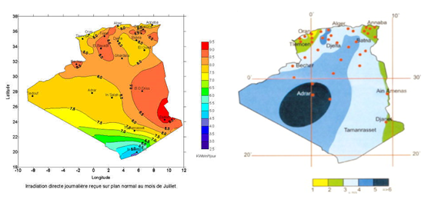

Fig.1.Solar and Wind potential resources in Algeria

This site characterized by a good potential in solar (Average sun hours per year around 2650 hours and a 1700 Kwh/m²/year of energy received). This potential is very important to implement different photovoltaic technology. In the other hand a significant wind potentialis located (annual average wind speed between 3 and 5 m/s) which make the installation of small wind turbine very interested. These benefic characteristic permits to install an off-Grid PV-Wind system of 6kW.

# Hybrid systems: Contxt and motivation

The progressive electrification of areas not yet interconnected to the main electricity grid and too remote for grid extension has mainly been achieved through installation of decentralized generation units with diesel generator and, to a lesser extent, via systems using a local renewable resource, such as solar PV stand-alone systems or wind off-grid systems [6,7]. Each of these technologies has its own limitations: the diesel generator option suffers from increasing fuel prices, added cost for both fuel transportation to remote areas and for operation and maintenance in remote areas, as well as generator inefficiency when run at low load factors; meanwhile solar energy is an intermittent energy resource, which requires storage when not used during generation time (daylight hours) and implies a high upfront investment cost but low operating costs [8,9].Wind forecasting also se differed in different region. There is some region where there is a good profile of wind speed, when the wind systems associated with storage system can be very interesting, but there other sites are not well windy so the used of wind systems only can produce some difficult in the electrification of remote area. In consequences combining these technologies makes it possible to offset some of these limitations. For this reason, PV- diesel-storage, PV-Wind-Diesel-storage, wind-diesel-storage or PV-Wind-storage hybrid-systems can offer interesting opportunities and can be used productively within local mini-grids; figure 2 represents remote area electrified by a hybrid energy system [10,11].

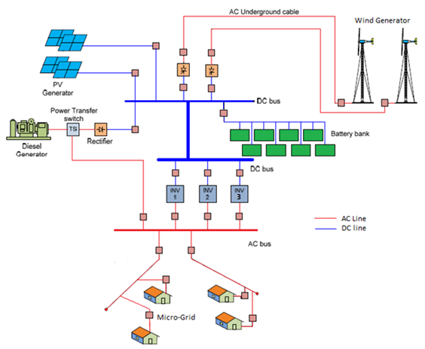

Fig.2.Hybrid energy system used to the electrification remote area.

In the present work a platform to testing off-grids PV-Wind-storage systems is established to study different configuration for these systems.

# Methodology

The methodology adapted to realize platform is the following:

Firstly, data measures and estimations, after the choice of the system configuration, with all Modeling and simulation of the platform, next the techno-economic study, and the choice of equipment’s and their acquisition, finally the phase of engineering and implementation. The next sections discuss these steps one by one.

## Data Measures and estimation

Hybrid PV–Wind systems offer the most adequate solutions for the electrification of remote areas; the combination and the ratio of the two types of energy depending greatly on the resources locally available in each geographical area. These resources can be evaluated only after a period typically one year of monitoring of the basic parameters wind speed, solar radiation and temperature), which are necessary for sizing and implementing such systems in the respective areas. The figure 3 represents examples of some measured and simulated meteorological data in the site of UDES, Bou-Ismail, Algeria.

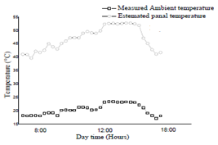

(a)



(b)

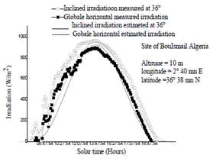

(c)

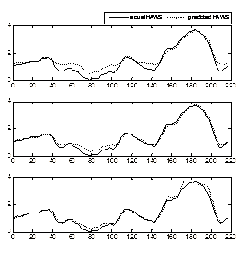

(d)

Fig.3. Measured meteorological data (a) module temperature; (b) Wind speed versus PVG temperature, (c) Measured irradiation, (d) wind speed.

## PV-Wind system configuration

In a general context, Hybrid Energy Systems (HES) combine two or more complementary renewable sources like wind turbines and photovoltaic generators and/or one or more conventional sources like diesel generators [12]. Naturally, renewable sources are not constant, so their combination with conventional ones allows an uninterrupted power generation. Most hybrid systems have an energy storage system. There are many systems for energy storage; electrochemical batteries, inertial storage and hydrogen. The latter is limited in storage capacity and has a high cost. In general there are three main aspects to consider for a hybrid system [13]:

* The configuration of the hybrid system with respect to the available resources and the constraints of utilization.
* The optimization of the available renewable resources exploitation.
* The optimization of the output power quality.

There are many configurations of hybrid systems. The most popular configurations are: DC-bus configuration and DC/AC mixed bus configuration. In what follows we present a brief description of these architectures.

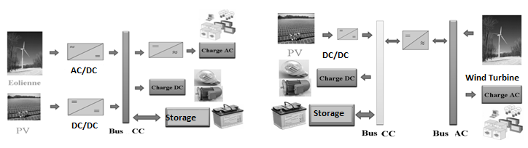

(a) (b)

Fig.4. (a) DC-bus architecture,

(b) Mixed AC-DC bus Architecture

The platform is implemented around the first configuration (DC-Bus). All sub-systems (PV and Wind generators, DC/DC chopper, AC/DC redresser and DC/AC inverters) are modeling and simulating using Matlab/Simulink. The proposed solution assembling all part constitute the platform is implemented under Simulink to test models and to establish a virtual platform for comparing and validate experimental results. The figure 5 represents the virtual platform.

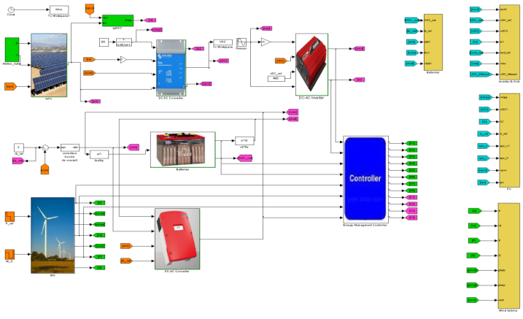

Fig.5. PV-Wind-storage Virtual platform

# Implementation of the Platform

After accomplished of all studies (sizing analysis, economic optimization and equipment’s characterization and acquisition) [14]. A team of researchers and engineers is working to concretize this platform. Firstly they implemented the renewable energies generators (the photovoltaic and the generators). They started wiring electrical cabinets and construction of the park of batteries to storage energy, next, they performing connecting between the electrical cabinets, DC bus, and battery energy storage, finishes by the implementation of various inverters and connecting the load. In this implementation a perform system of protection was designed. The figure 6 represents the platform experimentation.

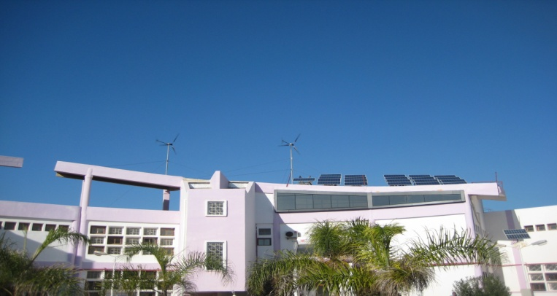

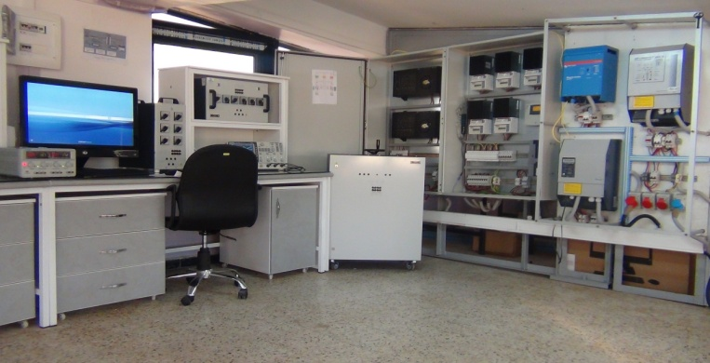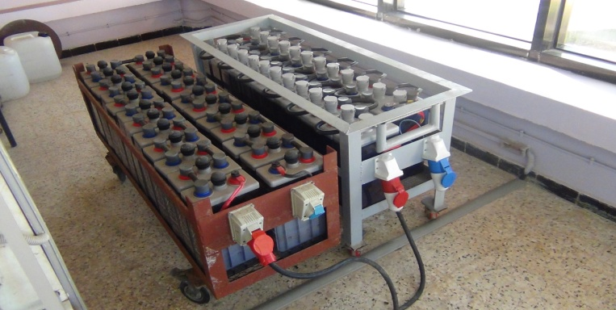

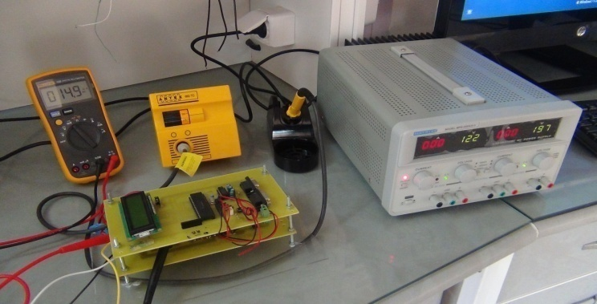

Fig.6. Photos of the PV-Wind experimental platform.

# Preliminary Results of supervision

The described hybrid platform is installed and it is operational, for the time being, it is feeding the laboratory (lighting, equipment’s supply like personnel computers, oscilloscopes, an air extractor…etc. and to supply also DC equipment’s with 48VDC). By using the RCC 2 remote control and data logging module of the Xtender inverter we were able to acquire log and visualize the AC part electrical parameters and batteries states, during a day, week, month or year, some of the results are shown in the figures bellow.

The Studer data analysis tool allows visualizing and analyzing the behavior of the inverter and its surrounding. For this work we will present the preliminary results of six months of platform functioning (from July to December). Figure 7 shows the variation of the battery voltage, the battery current and the inverter output power from July to December. Figure 8 represents comparison between a typical optimal day and an unfavorable day; it can be seen that the battery voltage rises in daytimes up to 58 V which corresponds to an almost fully charged battery, as well as the battery current, this is due the amount of PV and Wind energy that is produced during this day. Whereas the battery voltage falls to 46V in the unfavorable day which means that the battery is almost discharged, this is reasonable as there is almost no production (at night no PV production and no Wind production in steady nights) whereas the load consumption is kept constant, so the battery will discharge, this fact is clear in a weekly profile figure 9, shows almost periodic shape of both the battery voltage and current assured a satisfactory AC production.

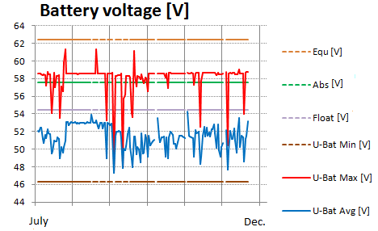

(a)

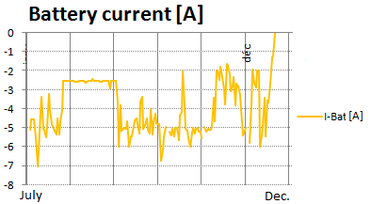

(b)

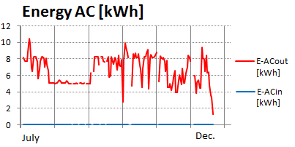

(c)

Fig.7: Six months profile

#### a) Battery voltage, b) battery current c) output power of the hybrid system.

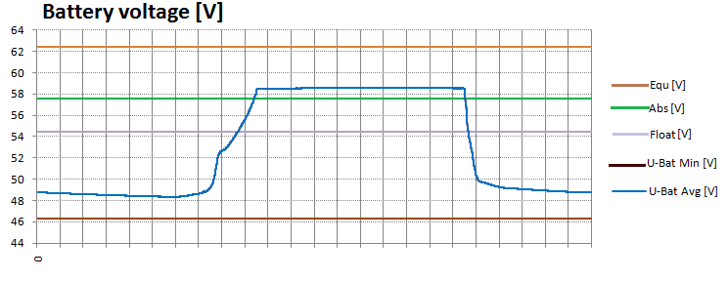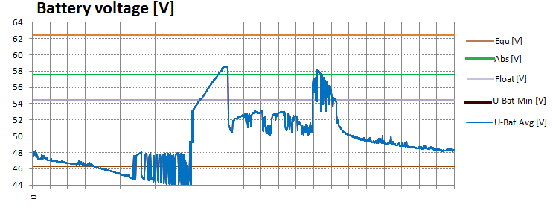

(a)

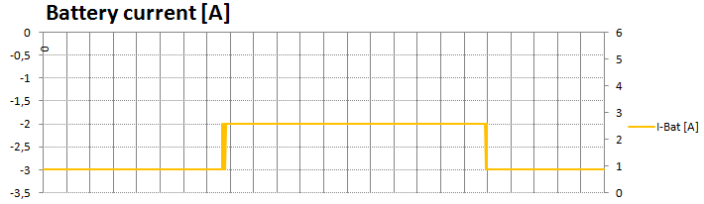

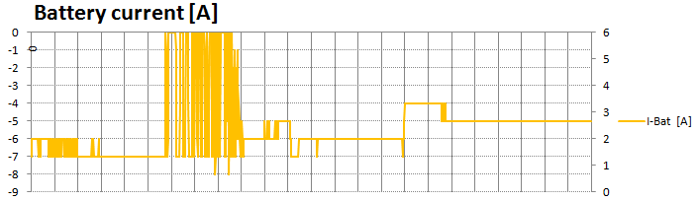 (b)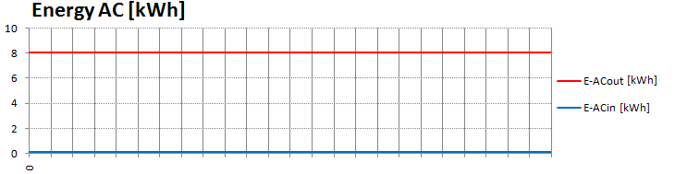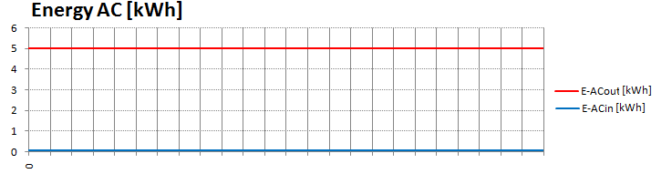

(c)

Fig.8: Comparison between a typical day and an unfavorable day profile a) battery voltage, b) battery current, c) output power of the hybrid system

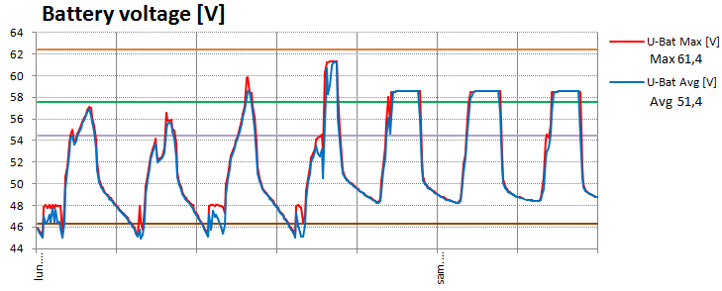

(a)

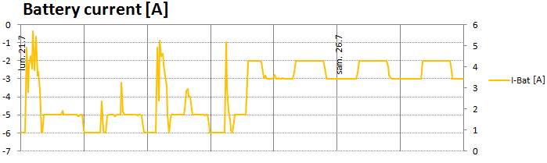

(b)

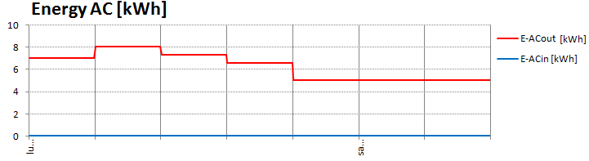

(c)

Fig.9. Weekly profile

a) Battery voltage, b) battery current and c) output power of the hybrid system

# Conclusion

The main objective of this project is to design and build a 6 kW solar-wind-Batteries hybrid power station, associated wireless sensors, and a graphics-based monitoring instrumentation system to provide a research facility on renewable energy for students and researchers. This project required purchasing of a tow wind turbine of 1kW each one. Each turbine has their AC/DC regulator. The wind turbine is associated to PV array of 4kW through a DC bus of 48V. The PV-array is designed around five strings, each string connects six panels of 130W. Each PV string has their specific MPP Tracker. Tow electrical cabinets it designed by introducing all necessary protection (circuit breakers and surge arresters). The electricity generated by this power station is used as a renewable energy input to supplying DC and AC load by using a system of Batteries storage composed from 48 Batteries implemented in serial. Each one delivered 2V and a 190Ah. The supply loads some of inverters are used. This platform supervised by a system of data acquisition system to study their performances under local climate data.

##### References

1. Nikolaus supersberger, Dennis Kumetat, Energy systems in OPEC countries of the Middle East and North Africa, system analytic and comparison of nuclear power , renewable energies and energy efficiency , Wuppertal Institute for climate environment and energy in co-operation with Adelphi Consult.
2. Library of Congress – Federal Research Division Country Profile: Algeria, May 2008.
3. Abdessalem Bouferrouk, Abdelaziz Bouferrouk, Renewable Energy Development in Algeria: Applications, Opportunities, and Challenges, Proceedings of The first International Conference on Nanoelectronics, Communications and Renewable Energy 2013, CNCRE ’13 ISBN : 978-81-925233-8-5 [www.edlib.asdf.res.in](http://www.edlib.asdf.res.in)
4. S.M. Boudia, A. Benmansour, M.A. Tabet Hellal, Assessment of Coastal Wind Energy Resource,Two Locations in Algerian East, International Journal of Energy Science (IJES) Volume 3 Issue 1, February 2013 [www.ijesci.org/](http://www.ijesci.org/)
5. Energie et Mines, Review of the Energy and Mines sector ISSN 1112-4873 Legal deposit : 1094-2004 No. 12 November 2010.
6. Grégoire Léna, Rural Electrification with PV Hybrid Systems : Overview and Recommendations for Further Deployment. IEA PVPS Task 9, Subtask 4, Report IEA-PVPS T9-13: 2013 CLUB-ER, Thematic Paper (July 2013) ISBN : 978-3-906042-11-4.
7. Sonali Goel, Sayed Majid Ali, Feasibility Study of Hybrid Energy Systems for Remote Area Electrification in Odisha, India by Using HOMER.International Journal of Renewable Energy Research, Vol. 3, (2013) No. 3.
8. Simon Rolland, Rural Electrification with renewable energy Technologies, quality standards and business models First edition – Publication date: (June 2011).
9. Recayi Pecen, MD Salim, Marc Timmerman, A Hybrid Solar-Wind Power Generation System as an Instructional Resource for Industrial Technology Students, J of industrial technology Volume 16, Number 3 - May 2000 to July 2000.
10. Luiz A. de S. Ribeiro, Osvaldo R. Saavedra, Shigeaki L. Lima, José G. de Matos, Isolated Micro-Grids with Renewable Hybrid Generation: The Case of Lençóis Island, [Sustainable Energy, IEEE Transactions,](http://ieeexplore.ieee.org/xpl/RecentIssue.jsp?punumber=5165391)  Volume:2 (2011) [Issue: 1](http://ieeexplore.ieee.org/xpl/tocresult.jsp?isnumber=5667077)pp: 1 - 11
11. Md. Kamal Hossain, Bipul Kumar Raha, Japatosh Mondal and Md. Rashedul Islam, Optimal Planning of Hybrid Energy System in Remoteb
12. Area of Bangladesh.International Journal of Scientific Engineering and Technology , Volume No.2, Issue No.12, (2013) pp : 1211-1215.
13. Zubair Ahmed,AbdullaTanvirAman,Hasan Md Mehedi.Optimal planning of standalone solar-wind diesel hybrid energy system foracoast al area of Bangladesh. Int J Electr Comput Eng (2012),2(6):731–8.
14. Patel Mukund R. Wind and solar power systems. Boca Raton London New York Washington, D.C.: CRC Press; 1999.
15. H. Belmili, M. Haddadi, S. Bacha, M. F. Almi, B. Bendib “Sizing stand-alone photovoltaic-wind hybrid system: techno-economic analysis and optimization” Renewable and Sustainable Energy Reviews, International Journal, Elsevier 30(2014) 821–832.