Characterizationof the AerosolPropertiesover Tizi-Ouzou based on sun-photometermeasurements

Fariza Meziani#1, ZohraAmeur #2, Philippe Goloub*3, Soltane Ameur#4

#Laboratoire d’Analyse et de Modélisation des Phénomènes Aléatoires (LAMPA), Département d’Electronique, Faculté de Génie Electrique et d’Informatique,   
Université Mouloud Mammeri de Tizi-Ouzou, Algérie

1[f.meziani@lampa-ummto.dz/fari_me12@yahoo.fr](mailto:f.meziani@lampa-ummto.dz/fari_me12@yahoo.fr)

2[z.ameur@lampa-ummto.dz/ameurzohra@yahoo.com](mailto:z.ameur@lampa-ummto.dz/ameurzohra@yahoo.com)

4[ameursoltane@yahoo.com](mailto:ameursoltane@yahoo.com)

*Laboratoired’OptiqueAtmosphérique (LOA)

Université des Sciences et Technologies de Lille, France

3philippe.goloub@univ-lille1.fr

Abstract—To provide preliminary results on the characterization of the aerosol properties over Tizi-Ouzou, we have used daily averagedretrievals AERONET data performed from April 2012 to July 2014. These measurements are made by a sun-photometer located on the roof of our laboratory of Tizi-Ouzou’s University. Our site is an urban area situated in the north of Algeria (36.69°N, 4.05°E). It is shown that the highest value of aerosol optical depths (AOD) exceed 0.6 and they are observed in summer. Angstrom coefficient analysis show fine particles (α>1) which characterize urban aerosolsand coarse particles (α<1). These two modes are confirmed by size distribution analysis which shows that the coarse mode dominate in summer. The large particles are transported by air masses from other sources, the most important is the Algerian Sahara.Backtrajectories illustrate the origin of introduced particles in our area.

Keywords— Aerosol properties, sun photometer, aerosol, aerosol optical depth, Angstromcoefficient.

1. Introduction

Natural or anthropogenic aerosols emitted in the atmosphere have a major impact on climate and air quality. These effects depend mainly on aerosol optical and microphysical properties integrated on atmospheric column ([1], [2]). These properties are determined by AERONET [3] sun photometer. AERONET is a federated international network founded in 1993 and coordinated by the GSFC/NASA (Goddard Space Flight Center) and the Service d’ObseravationPHOTONS/AERONET from LOA/CNRS Universityof Lille.It is dedicated to monitoring and characterization of aerosols. The site of Tizi-Ouzou is equipped with a sun photometer within AERONET since April 2012. The sun photometer is located at the roof of our laboratory of Tizi-Ouzou’s university which is an urban area situated in the north of Algeria (36,69°N, 4.05°E). It is subject to high concentrations of aerosols of various origins such as desert dust, sea salt and aerosol’s pollution emitted in particular from road traffic. The sun-photometer is an automatic instrument from passive remote sensing, it makes direct measurements of the solar radiance reaching the earth’s surface. Several parameters are output from this instrument: aerosol optical depth which is direct measure and the Angstrom coefficient. A flexible inversion algorithm developed by Dubovik and King [4] is used to retrieve columnar aerosol volume size distribution, single scattering albedo and refractive indices (real and imaginary part) from direct-sun and diffuse-sky radiance measurements.

The measurements reported in this paper are performed from April 11, 2012 to July 23, 2014 in order to characterize the aerosol properties of Tizi-Ouzou by analysis of daily averaged values of aerosol optical depths (AOD), Angstrom coefficient (α), size distribution, single scattering albedo( SSA), real (n) and imaginary (k) refractive indices.

The objective of this paper is to characterize the optical and microphysical aerosol properties of Tizi-Ouzou based on sun photometer measurements and backtrajectories analysis. The measurements are performed in an urban area.

1. Instrument and data used

We used in this study the CIMEL sun photometer CE-318 located in the roof of our laboratory LAMPA of the University of Tizi-Ouzou(36.69°N, 4.05° E) since April 2012. The sun photometer measures direct sun radiance at eight channels between 340 and 1020 nm (340, 380, 440, 500, 670, 870, 940 and 1020 nm) and diffuse sky radiances in the solar Almucantar. The available AERONET data used in this work are daily averaged level.2 measured at 440 nm, during the period from April 11, 2012 to October 2012, from May to December 2013 and from January to July 2014.

1. Aerosol properties analysis
   1. Aerosol optical depth (AOD) analysis

Theaerosol optical depth is the extinction of incident solar radiationdue to the presenceof particles inthe atmospheric layer.It depends onthe wavelengthλandthe aerosol extinction coefficient that is made of the scattering and absorption coefficient. It is given bythe following equation:

$$τ_{ext}=\int_{z_{min}}^{z_{max}}{σ_{ext}}\left(z, λ\right)dz (1)$$

With *z* is the atmospheric layer depth and $σ_{ext}$ is the extinction coefficient. It is given by the equation 2:

$$σ_{ext}\left(z, λ\right)=\int_{0}^{∞}{{πr}^{2}Q_{ext}}\left(η, r, z, λ\right)n\left(r, z\right)dr (2)$$

$Q_{ext}$ is the efficiency coefficient, it depends on the refractive index (η).r is the particle size and n(r, z) is the size distribution.

The figurebelow showsthe temporal evolution of the AOD daily averaged.

Fig. Temporal variation of the daily average of AOD_440, Data encircled in red correspond to the summer.

The variations of the daily average of AODs illustrated in fig.1 shows that AODs span the 0.05 à 0.86 range at 440 nm. The highest AOD values are 0.86, 0.68 and 1.52 observed in June 20, 2012, August 27, 2013 and February 18, 2014, respectively. The low values of AOD (AOD <0.3) are observed in autumn-winter (November 2013-March 2014), while the highest (AOD> 0.4) are recorded in spring-summer. Thehigher values of AOD correspond to a larger concentration of aerosols particles. Thisconcentration becomes more important in summer due to the intrusion of air masses chargedwithparticlescomingfrom the Sahara, from Europe or from the Mediterranean sea in the absence of the rain washing the atmosphere.It isalso due to the largeramount of solar radiation reaching the earth’s surface that favours photochemical reactionsthat affect optical and microphysicalproperties of the particles [5].

* 1. Angstrom coefficient (α) analysis

The Angstrom coefficient is calculated by using AODs values measured at wavelengths 440 and 870 nm. The values of *α* arerelated to the aerosol size. Small value of *α* represents large particles(*α* ≈ 0)and large values indicatesmallparticles (*α* ≈2) [6].

Fig.2 shows the presence of fine and coarse particles during the year. It is shown that *α* vary in the 0.2 - 1.70 range. It isworthobservingthat the coarseparticles (*α*< 1) are predominant. The large particles are observedthroughout the year but they are more important in the summer (July and August). TheseparticlesmaybeSaharandustcharacterizedwith*α*< 0.7 [7]or seasaltwhich the Angstrom coefficient variesfrom 0 to 1 [8]. The large particles are introduces into ourstudy area by long-range transported air masses coming fromother sources such as the Sahara or the Mediterranean sea (fig.9). The fine particlescharacterized by *α*> 1 are observed all the year and theyrepresenturbanaerosols. According to Hess et al. [9], the Angstrom coefficients in the 0.35 - 0.41 range indicatepolluted maritime air masses.

Fig. 2 Temporal evolution of the daily averaged values of the Angstromcoefficient(440-870)

Fig.3 shows the relationship between the AOD_440 and the Angstrom coefficient. The value of *α* at Tizi-Ouzou is inversely proportional to the AOD. We observe that for large values of AOD (AOD > 0.3), it corresponds values of *α* varying in the 0.2 - 1.7 range. By theseresultswecan conclude that Tizi-Ouzou ischargedwith fine and coarseparticles.



Fig. 3 Temporal variations of the dailyaveraged of the Angstrom coefficient based on AOD_440 nm,

Thesetwo types of aerosol are clearlyillustratedwith the volume size distribution given in fig.4. It is clearly shown thatthesize distribution is bimodalfor the allstudy period.The coarsemode centeredat3 µmislargely dominantin 2012 withhigh concentrations ofparticles reaching0.23forAOD>0.65. Thefine modecentered at0.1 µmwith a peak of0.07forthe same valueofAOD. In 2013, it is observed thatthetwo modes aresimilar.Thefine and coarsemode arecentered at0.11µm,2 µm forthe peaksof0.06and0.08respectively forAODsvarying from0.45to 0.52. In2014,the coarsemode iscloselydominantwith a peak of0.08. We deducethenthat theTizi-Ouzouregionis loadedwith fineandcoarse particleswiththe dominancepractically of the large particlesduring the all seasons.

Fig. 4 Daily averaged variations of the size distribution for AODs classes of 0.1.Minimum, maximum and the number of measures for each class.Error bars represent the standarddeviation.

* 1. Single scattering albedo analysis (SSA)

Fig.5 shows that the SSA vary from 0.75 to 0.99 at 440 nm, but it is worth observing that the predominant values of SSA span the 0.85-0.99 range, which meansthat the particles are moderately absorbing. We show also that a few values of SSA are in the 0.65-0.75 range such as February 28, 2013. These low values of SSA correspond to the low values of AOD and they represent clear days.

The urban aerosols, the maritime particles and the desert dust are characterized by 0.942<SSA< 0.984, 0.957<SSA<0.993 [10], 0.93<SSA<0.99 [11] respectively. The urban aerosols are predominant in winter while the Saharandust dominates in summer.

Fig. 5 Temporal variation of the daily averaged of single scattering albedo at 440 nm

* 1. Real (n) and imaginary (k) refractive index analysis

Fig.6-7 represent the temporal evolution of the daily averaged level 1.5 of the real and imaginary refractive index respectively. The values of *n* and *k* vary from 1.33 to 1.60 and from 0.0005 to 0.005 respectively. The lower valuesof *k* andthehigher values of*n* areobservedin summer.Higher valuesof *n*correspond toa largescattering coefficient, whereas high values of*k*correspond toan absorption coefficient[5]. Thefig.4-5clearlyshow thatthe dominant valuesof *n*span the1.40-1.52 rangeand thoseof*k*varyintherange0.0005-0.01and are observed in summer.

According to [12], the particles with *n* and *k* values are spanning the 1.35-1.53 and 0.0003-0.005 range represent the water soluble particles. In fact, the water soluble particles are the main components of the urban/industrial and maritime aerosols. The *n* values spanning the 1.54-1.60 range represent the mineral and soot particles. We can deduce that in Tizi-Ouzou, the urban and maritime particles are observed in summer, the mineral particles are observed in winter.

Fig. 6 Temporal evolution of the daily averaged of thereal refractive index at 440 nm

Fig. 7 Temporal evolution of the daily averaged of the imaginary refractive index at 440 nm

1. Five day’saerosolparameterAnalysis

To show the different types of aerosols existing in our study area, we have chosen five days characterized by high values of AOD at 440 nm. Daily averaged values of *AOD, α, SSA, n* and *k* of these five days are given in table 1. Daily averaged values of size distribution, single scattering albedo and refractive index are illustrated in fig.8. The fine and coarse mode are clearly observed during these five days in the size distribution (fig.8a). A high concentration of the large particles (α = 0.34) is observed on June 20, and a concentration about 0.15 µm2/µm3 is observed on August 18 for both modes with α = 0.70. These values correspond to the ​​desert particles coming to our region from the Algerian Sahara (North Africa). These results are similar to those found in other AERONET sites influenced by the desert dust ([5], [13], [7]). For these two days, low values of *SSA* are shown (0.88 and 0.84)on 06/20 and 08/18 respectively. This is explained by the contribution of absorbing particles (*k*=0.005 and 0.01) [5] coming from the Mediterranean Sea and the Atlantic on 06/20 and 08/18 respectively. A concentration less important (≈0.05) is observed for the other three days. Parameters (*α* = 0.76-1.12, *k* = 0.007-0.13, *SSA* = 088-0.91) given in table.1 and Fig.8 show that small particles are predominant over those three days. These fine particles are emitted in our region by air masses that cross large urban cities and European industrial regions (see fig.9c-e). Consequently, these masses can be affected by urban/industrial aerosols.

TABLE I

dailyaveragedaerosolparametersat 440 nm of five chosendays

|  |  |  |  |  |  |
| --- | --- | --- | --- | --- | --- |
|  | **AOD** | **α** | **SSA** | ***n*** | ***k*** |
| **20/06/2012** | 0.86 | 0.34 | 0.88 | 1.45 | 0.005 |
| **18/08/2012** | 0.62 | 0.71 | 0.84 | 1.36 | 0.011 |
| **11/09/2012** | 0.45 | 0.76 | 0.90 | 1.42 | 0.008 |
| **12/10/2013** | 0.37 | 0.98 | 0.91 | 1.37 | 0.007 |
| **13/04/2014** | 0.35 | 1.12 | 0.88 | 1.46 | 0.013 |

1. Five dayanalyticalbacktrajectories

The back trajectories illustrated in fig.9a-e are computed by the HYSPLIT model [14] for the five days. In each day, a 168h back trajectory finishing at 16 UTC has been calculated for heights of 500 m, 1000 and 2000 m.The back trajectories for June 20 and August 18, 2012 (fig.9.a-b) show Saharan dust coming in the study area from the Algerian Sahara. They also showair masses arriving to our area came from the Mediterraneansea and from the Atlantic respectively.Europe is the source of all air masses arriving at Tizi-Ouzou onSeptember 11, 2012. The back trajectories (fig.9.d-e) showurbanparticlestransported by air masses from Europe on October 12,2013, and on April 13, 2014. Air masses comingfrom western Africa and the Atlantic alsoare the sourceregions of backtrajectories of October 12, 2013 and April 13, 2014.

(a)

(b)



(c)



(d)



Fig. 8The differentaerosolparametersmeasuredat 440 nm of the five chosendays :(a) size distribution, (b) single scattering albedo, (c) realrefractive index, (d) imaginaryrefractive index

(a)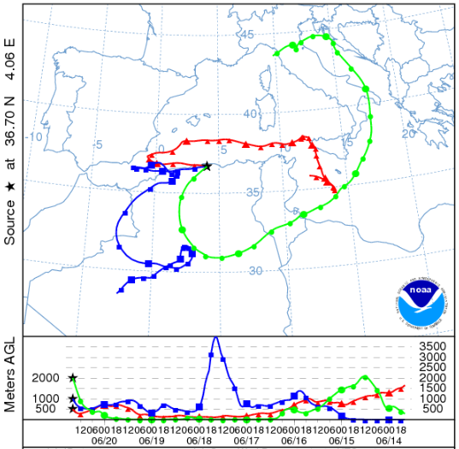

(b)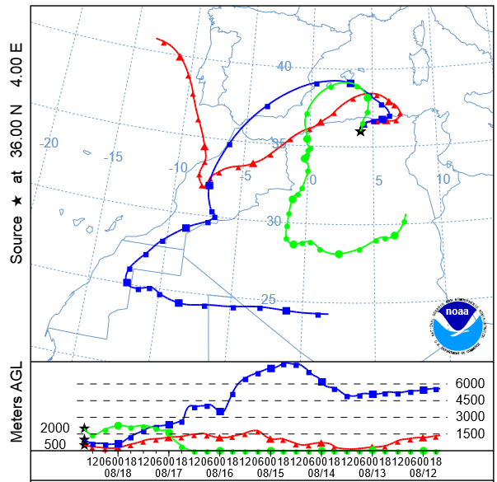

(c)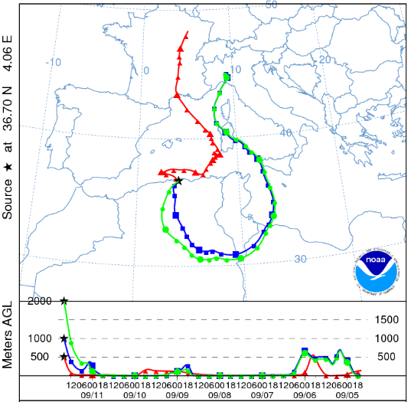

(d)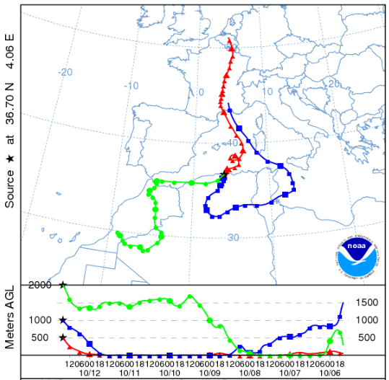

(e)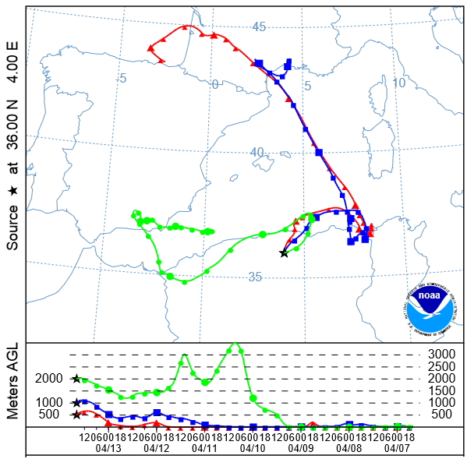

Fig. 9The backtrajectoriesfinishingat Tizi-Ouzou at 16 UTC of the five chosendays : (a) June 20, 2012, (b) August 18, 2012, (c) September 11, 2012, (d) October 12, 2013, (e) April 13, 2014.

1. CONCLUSION

The characterization of the aerosol parameters over Tizi-Ouzou based in this paper on daily averaged retrievals of AERONET sun photometer measurements performed from April 11, 2012 to July 23, 2014.Temporal evolution of the aerosol optical depths shows days with a large concentration of aerosol particles (AOD>0.4). Daily averaged analysis at 440 nm of the particle size distribution, Angstrom coefficient, *SSA, n, k andα*showthat Tizi-Ouzou is charged with fine and large particles. This analysis allowed us to classify the aerosol into local urban particles emitted by the road traffic, and those transported from Europe by air masses traveling across several large cities and industrialized European areas before reaching Tizi-Ouzou. Aerosols with a predominant of Saharan dust arriving from the Sahara, and sea salts coming from the Atlantic Ocean and MediterraneanSea are observed especially in July and August. This is mainly due to the transportation of the sand particles to the north; it is also due to the evaporation of the ocean and sea water which inject sea salts into the atmosphere in the presence of wind.Five day analytical backtrajectoriesare used to give the different aerosol sources for high values of AOD. It is shown that the urban aerosol is characterized by an Angstrom coefficient larger than 0.7, and lower than 0.7 for the mineral particles.

The results analysis based on about three years of sun photometer measurements can contribute to get a preliminary characterization of the aerosol over our region study. These results can also use to monitoring the air quality in this region.

REFERENCES

1. Y.J.Kaufman, D. Tanre, O. Boucher, “A satellite view of aerosols in the climate system”, *Nature*, vol. 419,pp.215–224, 2002.
2. R. J. Charlson, S. E. Shwartz, J. M. Hales, R. D. Cess, J. A. Coakley Jr., J.E. Hansen, D. J. Hofmann, “Climate forcing by anthropogenic aerosol”. *Science,* vol. 255,pp.423-430, 1992.
3. The IAERONET website. [Online].Available: http:/aeronet.gsfc.nasa.org/
4. O. Dubovik, M. D. King, “A flexible inversion algorithm for retrieval of aerosol optical properties from sun and sky radiance measurements”, *Journal of Geophysical Research,* vol. 105,pp. 20673-20696, 2000.
5. M.R. Perrone, M. Santese, A.M. Tafuro, B. Holben, A. Smirnov, “ Aerosol load characterization over South-East Italy for one year of AERONET sun-photometer measurements”, *Atmospheric research,* vol. 75,pp. 111-133, 2005.
6. O. Dubovik, B.N. Holben, T.F. Eck, A. Smirnov, Y.J.Kaufman,M. D. King, D. Tanre, I. Slutsker, “Variability of absorption and optical properties of key aerosol types observed in worldwide locations”, *Journal of Atmospheric Science,*vol. 59,pp. 590-608, 2002a.
7. H. Abderrahim, A. Mortier, A. Hamou, “Caractérisation et modélisation des aérosols sahariens”, *Communication Science and Technologie N°12,* Janvier 2013.
8. S. Mukai, I. Sano, M. Satoh, B.N. Holben, “Aerosol properties and air pollutants over un urban area”, *Atmospheric research,* vol. 82,pp. 643-651, 2006.
9. M. Hess, P. Koepke, I. Schult, “Optical properties of aerosols and clouds: the software package OPAC”, *Bulletin of the American Meteorological society,* vol. 79,pp.831-884, 1998.
10. G.A. d’Almeida, P. Koepke, E.P. Shettle, “Atmospheric aerosol-global climatology and radiative characteristics”, *A. Deepak, Hampton, V. 561 pp.*
11. I.N. Sokolik, O.B. Toon,”Incorporation of mineralogical composition into models of the radiative properties of mineral aerosol from UV to IR wavelength”, *Journal of Geophysical Research,* vol. 104, pp. 9423-9444, 1999.
12. J. Ackermann,”The extinction to backscatter ratio of tropospheric aerosol: a numerical study”, *Journal of Atmospheric and Oceanic technology,* vol. 15, pp. 1044-1050, 1998.
13. H. Lyamani, F.J. Olmo, L. Alados-Arboledas, “Saharan dust outbreak over southeastern Spain as detected by sun photometer”, *Atmospheric Environement,* vol.39, pp.7276-7284, 2005.
14. R.R. Draxler, G.D. Hess, “description of the HYSPLIT-4 modelling system, *NOAA Technical Memorandum,* ERL ARL-224, December 1997, p.24.