The synthesis and characterization of spin coated ZnO and CZO films
A.Arrar
Department of Science, Faculty of Physics,
Centre University CUR
Relizane, Algeria
Amina.phys.magister@hotmail.fr

M. Benhaliliba
Material Technology Department, Physics Faculty,
USTO-MB University
BP1505 Oran, Algeria.
mbenhaliliba@gmail.com

Y.S. Ocak
Department of Science, Faculty of Education,
Dicle University
Diyarbakır, Turkey.
yusufselim@gmail.com

Abstract
In this study, we report on the surface morphology of pure and Cd doped ZnO nanostructures grown by Sol- gel spin coating route a glass substrate. This film, which crystallize with a wurtzite structure preferred (002) orientation with analysis X-ray. The optical band gap was a bit changed by doping.
Keywords: ZnO; cadminium doping CZO;Sol-gel spin coating; XRD pattern; AFM analysis

- Introduction
Zinc oxide (ZnO) is a most studied semi-conductor material. ZnO, a wide band direct gap, belongs to the II–VI family with a band gap of 3.37 eV at room temperature and large exciton binding energy of 60 meV. It is used in different areas such as the fabrication of optoelectronic devices operating in the blue and ultra-violet (UV) region, Shottky diodes and sensors. Zinc oxide is doped with various metals such as cadmium, aluminium and tin. Further, the conditions of deposition and the choice of the substrate material are important for the film growth. Various depositions techniques have been employed for the growth process of the film. Some of them are laser deposition, electrode position and sol-gel. Here, we investigate the physical and surface properties of the pure and Cd-doped ZnO films produced by the sol-gel spin coating route onto a glass substrate.

- Experimental procedure

  - Filmsgrowth

The films were grown by sol–gel spin coating route onto microscope glass slides (76 x 26) mm² supplied by object trager Isolab. Half a mole of zinc acetate dehydrate [Zn(CH3COO)2.2(H2O)] supplied by Carlo Erba reagents with purity of 98,5%,was dissolved in 2-Methoxy ethanol

(C3H8O2) at 10ml, and stirred at 60°C for 10min, The doping precursor, cadmium acetate dehydrate Cd (CH3COO) 2.2(H2O) supplied by Himedia with purity of 99%, was added to the solution the Mono- Ethanolamine (C2H7NO; abridged MEA) as stabilizer, was added drop by drop until the homogeneous and clear solution was obtained, then the stirring continued for 60min.The solution was then aged at ambient for one day until the gel formation. The weight of the added dopant source wascalculated as function of the desired Cd/Zn ratios, which were taken equal to 3%.
The viscous solution was homogenously poured by micro-Pipette on the substrate, sticking it on the stainless steel spin plate of a MTI, EQ-TC-100Desk-top Spin Coater [1,2,4,7]. The sample rotated for one minute at1200rpm, and then was heated under air on hot-plate at 150 1C for10min.This process was repeated 5 times, before the film was finally annealed in air at 400 °C for 60 min at the furnace.

  - Films characterization

The structural properties of Cd:ZnO (CZO) films were investigated by means of a Rigaku X-ray diffractometer with CuKα1 radiation (λ=1.5418 A1) between 20° ≤ 2$θ$ ≤ 80° . The coated films transmittance are recorded by a Shimadzu 3600PC double beam UV–VIS–NIR spectrophotometer, the morphology of surface of the simple was analysed with atomic force microscope type XEI‒ Park using a laser light and the non-contact mode NC-AFM of 256 pixel [1,3,2,4,7].

- Results and discussion

3.1. Structural analysis

Figure 1 shows the X-rays patterns of the pure and 3% Cd-doped ZnO thin films. The films have polycrystalline structure with a hexagonal wurtzite and the calculated lattice parameters (a and c) are given in Table 1

Figure 1. The X-ray pattern of pure and 3% Cd-doped ZnO thin films.

Table 1: Structural parameters of the ZnO and CZO films

Cd/Zn  (%) | Grain size (nm) | Tc | T %  (550  nm) | Eg  (eV) | a (nm) | c (nm)
0 | 121.9 | 1.15 | 86.48 | 3.92 | 0.33 | 0.52
3 | 209 | 1.33 | 84.46 | 3.83 | 0.33 | 0.52

The undoped film has a random orientation with three dominant peaks of (1 0 0), (0 0 2) and (1 0 1) and the peak of (002) is the predominant [3,4,7,8,11]. When the doping level is increased, the (0 0 2) diffraction peak becomes progressively more strong. The orientation of (0 0 2) is the dominant plane in the doped films. A weak peak at (101) direction and another peak at (1 0 2), (110) were observed. These observations are in agreement with those observed by [1,2,3,4,11,10]. The grain size G of the deposited thin films are determined by using the Debye–Scherre formula [1,2] Equation 1:
$G=\frac{k}{βcosθ}$ (1)

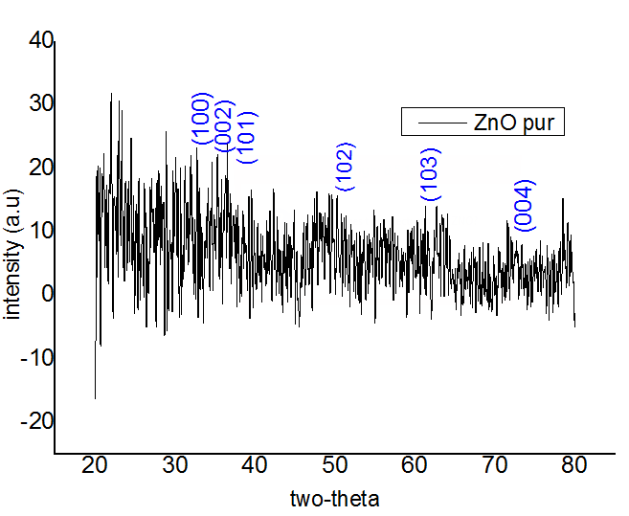
Where λ is the X-ray wavelength equal to 1.54 Å, $θ$ is Bragg diffraction angle and B (radians) is the full-width at half maximum. Results of G values are given in Table 1.The Cd doping induced an increase in grain size and in the coefficient TC along [002] direction. The texture coefficient (TC), which was calculated, for the mains peaks from the X rays diffractograms. It is expressed as follows for a plane (hkl) with “Equation 2”

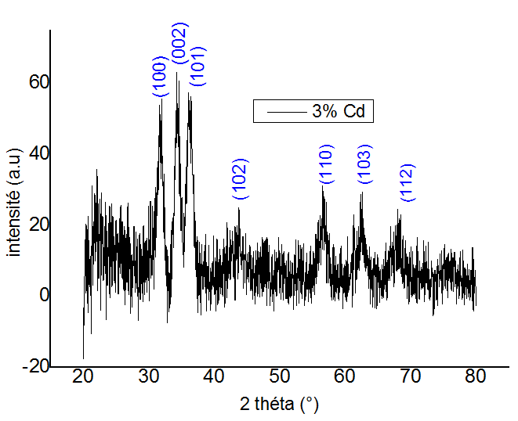
$T_{c(hkl)}= \frac{{I_{hkl}}/{I_{0(hkl)}}}{N^{-1}cosθ}$ (2)

when I(hkl) is the measured intensity of the plane (hkl), I0(hkl) is the ASTM standard intensity, and N is a reflection number.

3.2 Optical characterization

Figure 2: depicts the variation of the transmittance as a function of the incident photon wavelength of pure and 3%Cd-doped ZnO thin films. The optical transmittance is slightly improved with the dopant from 84,48% (at 550 nm) to 91,41% (at 2466 nm). Same trends are reported by M.Benhaliliba [1,2,3,4]. The average transmittance at 550nm almost equal with doping level, as listed in Table 1. The direct optical band gap (Eg) is expressed by “Equation 3”

${\left(αh\right)}^{2}=h-E_{g}$ (3)

where Eg (eV) is the optical band gap, $α$ (m^{_1}) is the absorption coefficient and $σ$ (Hz) is the photon frequency. We estimate the band gap Eg from the optical transmission spectra by extrapolating the linear part of the plot of (${\left(αh\right)}^{2}$ versus $h$ to $α$ =0 it should be noted that Cd doping level has an influence on Eg as listed in Table 1. The values of optical band gap are diminished with an uncertainty of 0.09ev [9].
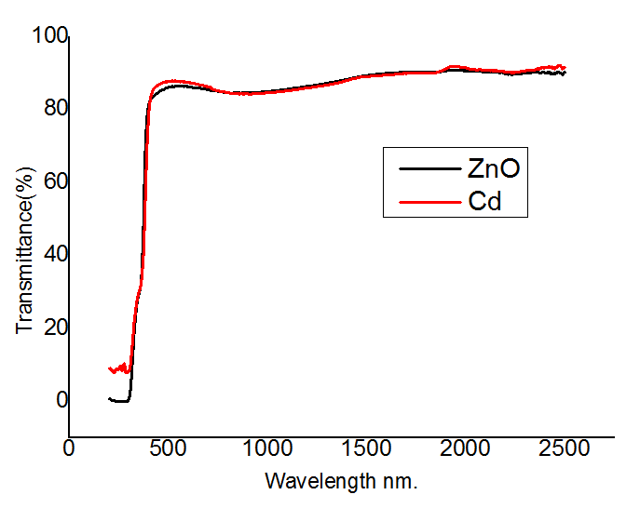
Figure 2. The variation of the transmittance as a function of the incident photon wavelength of pure and 3%Cd-doped ZnO thin films

3.3. Surface morphology investigation

The surface morphology and the roughness of samples are sketched in figure 3.the 3D views have dimension 5µm × 5µm. We can observe that surface of selected samples is nanofiber and become rectangular in the case of Cd-doped and the grains have a size, which sweeps in the range 18 – 42 nm.
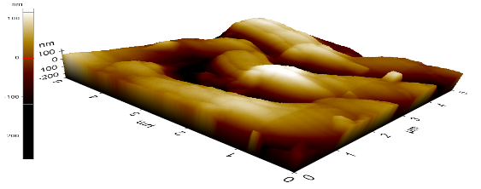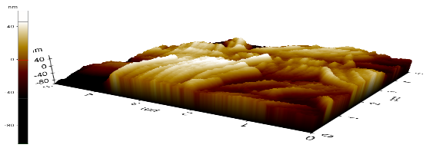
(a)
(b)
5μm
5μm
5µm
5µm
(a)

Figure 3: (5µm x5µm) AFM scanned 3D- images of pure (a) and 3% Cd-doped (b) thin films.

Conclusion

The impact of cadminium doping on structural, optical, electrical and morphological properties XRD pattern reveals that coated CZO films are poly-crystalline and grow according to a preferential [002] orientation. The intensity of the main peak increases as a result of Cd content in the solution and the grain is increased due to the Cd ions incorporation in the ZnO lattice.The transmittance is slightly improved with the dopant from 84, 48% (at 550 nm) to 91, 41% (at 246 nm) and The nanofiber shape is observed in ZnO and become more rectangular in the case of Cd-doped ZnO.

Acknowledgements

This work is included in the PNR Project U311/R77 supervised by Prof. Dr BENHALILIBA M., and financed by " la direction générale DG-RSDT", "l’agence ATRST" and USTO-MB". It is also a part of CNEPRU project B0L002UN310220130011. The second author would thank the head PrHamdiTemel and the staff of the central laboratory, Education Faculty- University of Dicle, Diyarbakir TURKEY.

References

[1] C.E. Benouis, M. Benhaliliba, A. Sanchez Juarez, M.S. Aida, F. Chami, F. Yakuphanoglu, “The effect of indium doping on structural, electrical conductivity, photoconductivity and density of states properties of ZnO films,” Journal of Alloys and Compounds 490 (2010) 62–67
[2] M. Benhaliliba, C. E. Benouis, M. S. Aida, F. Yakuphanoglu , A. Sanchez Juarez J, Sol-Gel Sci Technol (2010) 55:335–342
[3] Yusuf Selim OCAK, Mostefa BENHALILIBA, “Annealing Effects on DC Sputtered ZnO Thin Films”. Culture and Science Conference, Turkey,Apr.2012.
[4] M. Benhaliliba, Y.S. Ocak, A. Tab “Characterization of Coated Fe-Doped Zinc Oxide Nanostructures” journal of nano- and electronic physics, Vol. 5 No 3, 03001(4pp) (2013)
[5] A. El Hichou, M. Addoua, A. Bougrine, R. Dounia,J. Ebothé , M. Troyon, M. Amrani, Materials Chemistry and Physics 83 (2004) 43–47. [6] Emin Bacaksiz , Serdar Aksu , Salih Yılmaz, Mehmet Parlak , Mustafa Altunbaş, Thin Solid Films 518 (2010) 4076–4080
[7] M. Benhaliliba, C.E. Benouis, F. Yakuphanoglu,Y. Attici, Y.S. Ocak, M. Cavas “Nanostructural, optical and electrical properties of sol gel spin coated ZnO films,”.Umm Al-Qura University Makkah, Saudi Arabia, 2012
[8] M. Benhaliliba, C.E. Benouis, Z. Mouffak, Y.S. Ocak, A. Tiburcio-Silver, M.S. Aida, A.A. Garcia, A. Tavira, A. Sanchez Juarez; Preparation and characterization of nanostructures of in-doped ZnO films deposited by chemically spray pyrolysis: Effect of substrate temperatures, Superlattices and Microstructures 63 (2013) 228–239
[9] A. Fouzri, M.A. Boukadhaba, A. Toure, N. Sakly, A. Bchetnia, V. Sallet,” Structural, morphological and optical properties of Cd doped ZnO filmgrown on a- and r-plane sapphire substrate by MOCVD”, Applied Surface Science 311 (2014) 648–658
[10] Fahrettin Yakuphanoglu, Saliha Ilican, Mujdat Caglar, Yasemin Caglar, “Microstructure and electro-optical properties of sol_gel derived Cd-doped ZnO films”, Superlattices and Microstructures 47 (2010) 732_743
[11] Gang Li , Xuebin Zhu, Xianwu Tang, Wenhai Song, Zhaorong Yang, Jianming Dai, Yuping Sun, Xu Pan, Songyuan Dai,”Doping and annealing effects on ZnO:Cd thin films by sol–gel method”, Journal of Alloys and Compounds 509 (2011) 4816–4823.

