Simulation of an absorption refrigeration machine operating with alkane mixtures

Rami Mansouri#*1 , Radhouane Ben Jemaa#2, Ismail Boukhoulda#3, Mahmoud Bourouis*4 and

Ahmed Bellagi#5

# U.R. Thermique et Thermodynamique des Procédés Industriels, Ecole Nationale d'Ingenieurs de Monastir, ENIM, University of Monastir, Tunisia

*\**  Universitat Rovira i Virgili, Department of Mechanical Engineering, Av. Països Catalans No. 26, 43007Tarragona*,* Spain

[1rami_mansouri62@yahoo.fr](mailto:1r_bjemaa@yahoo.fr)

2r_bjemaa@yahoo.fr

3boukholda_ismail@yahoo.fr

4mahmoud.bourouis@urv.cat

5ahmed.bellagi@enim.rnu.tn

Abstract— We present in this paper the study of an absorption chiller operating with binary mixtures of alkanes as a refrigerant. The focus is particularly on the research of operating conditions allowing, at least in principle, the actuation of these machines to the thermal solar energy. The proposed machines are operated by low temperature thermal energy (temperature of the driving heat equal to or less than 120°C). Six mixtures of alkanes (propane/n-hexane, propane/n-pentane, propane/i-pentane, propane/n-octane propane/n-heptane, propane/n-nonane) have been considered and compared in the case of two modes of alternative cooling: ambient air at 35°C and cooling water at 25°C. The refrigeration cycle with the different binaries was simulated using the software fowsheeting "ASPEN-HYSYS" platform. The machine modeling was carried out in three steps up to the closing of the cycle. The performance of these devices has been determined for each alkane mixture. The results showed that the binary mixture propane / n-hexane allows to achieve the best performance with a COP of about 0.54.

Keywords— **absorption system, propane, hexane, isopentane, pentane, heptane, octane, nonane, ASPEN-HYSYS, COP.**

1. Introduction

The market for refrigeration and air conditioning is in full growth everywhere in the world due to the increase in the needs of comfort and of population growth. This rapid evolution has resulted in a galloping consumption of energy in general and particularly electrical power to operate these machines this form of energy is produced primarily by combustion of fossil energy resources which contributed to a significant share to the emissions of greenhouse gases, mainly CO2. In addition the refrigerants, type of CFC and HCFC, used in these machines operating according to the technique of vapor compression, have proved to be destructive of the ozone layer which protects life on earth and, by consequence, highly harmful. To reduce emissions into the atmosphere of greenhouse gases on one side and the gas responsible for the holes observed in the ozone layer, on the other, several international protocols and agreements have been signed: Montreal Protocol in 1987 to restrict the use of CFCS and HCFC, Kyoto protocol in 1998 for CO2 and greenhouse gases, etc. The absorption technique for the production of cold represents an interesting alternative to the vapor compression technique. Indeed this technique uses electrical energy only marginally: the absorption refrigerating machines are operated to the thermal energy. In addition, the refrigerants used are compatible with the environment. As these devices essentially use of heat to operate, their use is interesting if one has a source of free heat (heat lost, solar energy, etc. ). Current research in this area has the objective to find non-harmful working fluid mixtures for the environment but more suited to solar operation than standard fluids [1-5].

It is in this context that the work whose results are reported in this paper. The aim of our study was to explore the possibility of using binary mixtures of light alkanes as the working fluid for absorption installations. Light alkanes binary mixtures used as refrigerants are chemically stable over a wide temperature range, non-toxic and environmentally friendly with a zero ozone depletion potential (ODP) and an extremely low global warming potential (GWP) They exhibit good thermodynamic and transport properties, low viscosity and high thermal conductivity, which result in good performances of the condenser and the evaporator. They are also characterized by a good compatibility with copper, the material of choice for such devices. It is thermally stable blends in the field of operating temperatures of the refrigerating machine and available everywhere. Machines based on the proposed mixtures offer an attractive advantages: they can be operated with the heat of low temperature level (≤120°C), as certain discharges industrial thermal. In addition, this low level of temperatures drive makes these machines to the scope of solar thermal, which opens up promising prospects for this technique.

1. Working principle

The machine is considered to be single-effect, consisting of a refrigeration part similar to that of a machine to vapor compression (Fig.1) and comprising a condenser, a heat exchanger, an evaporator and an expansion valve. The drive section which replaces the compressor is made up of its side of an absorber, a generator, a solution heat exchanger, and an expansion valve. The generator is usually a column of rectification. The rich solution supplying the generator it receives a quantity of heat Q106 at the temperature Tb which causes the desorption of the refrigerant dissolved in this solution. At the head of the generator is obtained almost pure refrigerant vapor (YC3 = 99.5%) and at the bottom of the column, the lean solution. The vapor refrigerant in outgoing head of the generator and after partial condensation is liquefied in the condenser. This operation is accompanied by a rejection of a quantity of heat Q100 to the outside environment. The cooling mode and the temperature of the ambient set the temperature and the condensation pressure. After detente which causes a decrease of its pressure, the refrigerant is vaporized in the evaporator by absorbing a quantity of heat Q101 from the medium to be cooled. The refrigerant in the vapor state from the evaporator passes through a heat exchanger before entering the absorber where it is dissolved in the weak solution from the generator: this phenomenon is exothermic and is accompanied by a heat release which is evacuated to the outside environment (Q101 and Q102).



Fig. 1: Basic vapor compression cycle

1. Feasibility of the air cooling at 35°C

The condenser and the absorber are cooled with ambient air at an average temperature of 35°C. The temperature at end of condensation is assumed to be equal to 55°C, that of the driving heat supplied to the generator, 120°C. The temperature of the cold refrigerant at the outlet of the evaporator is fixed to 0°C.

• Tb = 0°C (output temperature of the evaporator)

• Th = 120°C (temperature of generator)

• Tm = 55°C (temperature at end of condenser)

**BINARY C3 /n-C5**

When the working fluid enters in the desorbeur, it will be first warmed up to the temperature T5 (Fig.2), given by the intersection of the isotitre xd and the isobaric Ph. The desorption then begin at point 5. The trace of the cycle of our machine with these conditions reveals a problem in the absorber. In fact, point (8) corresponds to the entry of the poor solution in the absorber with a content of XC3 = 27 %. This solution absorbs normally the vapors of refrigerant from the evaporator (3) and is enriched. However this is not what is being observed since, from the diagram, the point (4), representative of the rich solution is to the right of the point (8) and therefore more poor in refrigerant that this last! It’s therefore deduced that under these conditions the cycle is not feasible. The same results were found for the other binaries (C3 /i-C5, C3 /n-C6, C3 /n-C7, C3/nC8 , C3/n-C9).

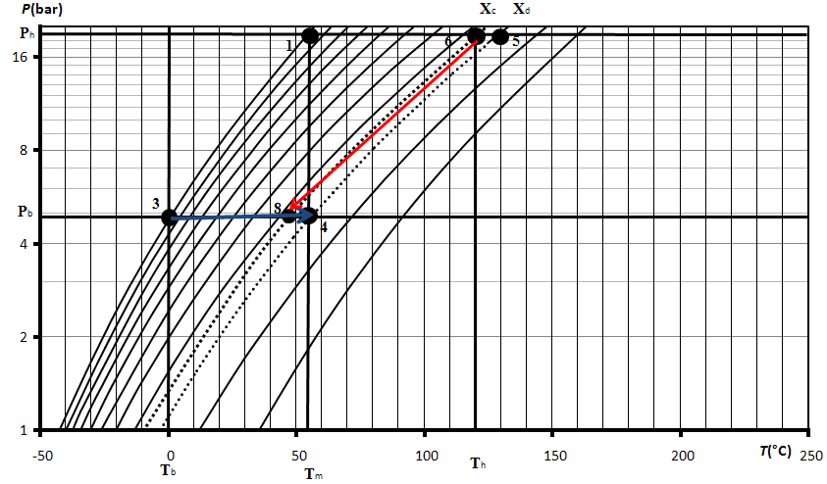

Fig. 2: Cooling to ambient air of the binary C3 / n-C5

1. Feasibility of the cooling water at 25°C

The condenser and the absorber are cooled with water supposed to be at an average temperature of 25°C. The temperature at the end of condensation is set at 30°C, the temperature of the driving heat supplied to the generator is taken equal to 120°C and the temperature of the cold refrigerant at the outlet of the evaporator is supposed to be 0°C. The same approach described previously for the tracing of the cycle of our machine was followed but with the new chosen conditions.

• Tb = 0°C (output temperature of the evaporator)

• Th = 120°C (temperature of generator)

• Tm = 55°C (temperature at end of condenser)

**BINARY C3 /n-C5**

Point (8) (Fig.3) corresponds to the input of the poor solution in the absorber with a content of XC3 = 5 %, this solution absorbs the vapor refrigerant from the evaporator (3) and is enriched up to point (4), representative of the rich solution. We found that under these conditions water for cooling the cycle is now feasible. The same results were found for the other binaries (C3 /i-C5, C3 /n-C6, C3 /n-C7, C3/n-C8, C3/n-C9).

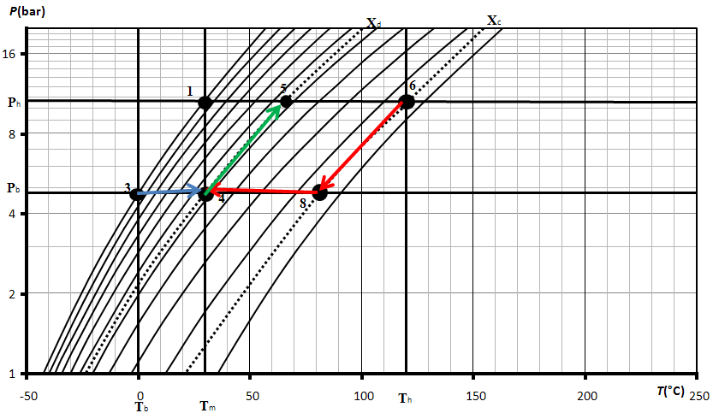

Fig. 3: water cooling of the binary C3 / n-C5

1. Simulation of an absorption refrigerating machine using alkane mixtures
   1. Model of the machine

The modeling of the machine has been carried out in 3 steps. The first is devoted to the refrigeration compartment: evaporator, expansion valve 1, exchanger 1, condenser and absorber. In the second step we added the pump as well as the heat exchanger 2 and the expansion valve 2 and we have introduced two logical operators relating to the flow rate of the poor solution (wwsol) at the output of expansion valve 2 and the poor solution (weak sol) at the entrance of the absorber. In the third step we added the generator represented by a plate distillation column and then closes the cycle.

Table I gives the ASPEN-HYSYS blocks for the various machine elements. The generator is modeled using shortcut block, the condenser is modeled using a single COOLER block connected with a heat stream and the evaporator using a single HEATER block connected with a heat stream. An Absorber block connected with a heat stream is used for the absorber. An two-flow heat exchanger HEATX simulates the gas heat exchanger and the solution heat exchanger. The two throttling valves were respectively represented by the VALVE 1 (détendeur1) and VALVE 2 (détendeur2) and the Pump is modeled using a PUMP block.

TABLE I

Machine elements and their ASPEN-HYSYS Models

|  |  |
| --- | --- |
| Machine Element | ASPEN-HYSYS Block |
| Generator | shortcut block |
| Condenser | single COOLER block |
| Evaporator | single HEATER block |
| Absorber | Absorber block |
| Gas heat exchanger | two-flow heat exchanger HEATX |
| Solution heat exchanger | two-flow heat exchanger HEATX |
| Valve 1 (détendeur1) | VALVE |
| Valve 2 (détendeur2) | VALVE |
| Pump | PUMP block |

* 1. Data and assumptions

As the variance of our machine is 14, it must first attach the 14 independent parameters to characterize the state of its operation:

1- Condensation temperature: 30°C

2- Temperature of the subcooled liquid at the exit of the heat exchanger 1: 12°C

3- Low pressure: 4.5 bar

4- High pressure: 10.73 bar

5- Outlet temperature in the evaporator: 0°C

6- Cooling capacity: 17.5 KW

7- Saturated liquid at the end of condensation

8- Flow rate of the poor solution: 11.46 kmol / h

9- Temperature of the rich solution at the inlet of the generator: 90°C

10- Temperature of the heat supplied to the generator: 120°C

11- Generator reflux ratio: 0.5

12- Heat evacuated through the absorber, Q1A and Q2A

13- Number of absorption column: N

14- Temperature of the subcooled liquid at the outlet of the exchanger 2

After we have fixed these 14 independent parameters we will pass to the simulation of the operation of the machine. The simulation takes place in three successive steps according to the three steps of modeling to closes the cycle (Figure 4).

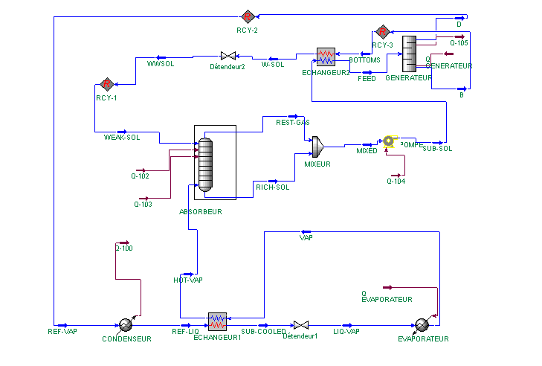

Fig.4 : Cycle operating with the binary C3 /n-C6

1. Results and discussions

Simulations are performed for the all considered mixtures as working fluid in the case of water cooling. In order to compare the working fluids systems the cooling coefficient of performance COP, defined as the ratio of the evaporator heat duty to the generator heat input



(1)

The results of the simulations of the cycles of the various binaries of light alkane mixtures (C3 /n-C6), (C3/n-C5), (C3/i-C5), (C3/n-C7), (C3/n-C8), (C3/n-C9) are given in figure 5 and figure 6, it is noted that the binary C3/n-C6 allows to obtain the best performance (COP = 0.54). It therefore represents our optimal binary.

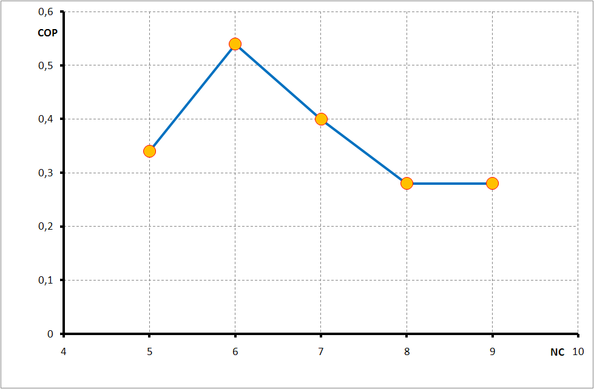

Fig.5 : Variation of COP in function of the alkane mixtures

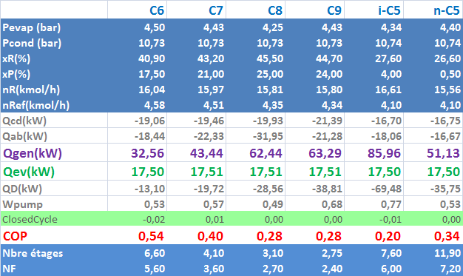

Fig.6 : Simulation results of the different working fluid systems

1. Conclusion

We have studied in this work the feasibility of use of binary mixtures of light alkane mixtures as working fluids for absorption refrigeration machines. The binaries studied are C3/n-C5, C3/I-C5, C3/n-C6, C3/n-C7, C3/n-C8, C3/n-C9 and the machine considered is a single-effect absorption refrigeration machine with driving heat at a temperature below 120. The Oldham diagram has been plotted for the studied systems in order to test the feasibility of the machine operation with the two modes of cooling, to the ambient air at 35°C and cooling water at 25°C. The results obtained have shown that only the water-cooling method is feasible for the operation of our machine with the chosen operating conditions. Eventually the machine cycle considering the various alkane mixtures as a working fluid has been simulated using the fowsheeting software ASPEN-HYSYS. The COP was calculated for the different binary mixtures considered in the present work. The best working fluid for our application is the binary C3/n-C6 with a COP of 0.54 .

References

1. Nihel Chekir and Ahmed Bellagi, Performance improvement of a butane/octane absorption chiller. Energy. Vol. 36, Nos. 10, (2008), pages 6278-6284.
2. R. M. Lazzarin, A. Gasparella and A. G. Longo, Chemical dehumidification by liquid desiccants: theory and experiment. International Journal of Refrigeration. Vol. 22, Nos. 4, (1999), pages 334-347.
3. N.Chekir, Kh. Mejbri and A. Bellagi, Simulation d'une machine frigorifique à absorption fonctionnant aves des mélanges d'alcanes. International Journal of Refrigeration. Vol. 29, Nos. 3, (2006), pages 469-475.
4. E. Granryd. Hydrocarbons as refrigerants - an overview. International Journal of Refrigeration. Vol. 24, (2001) , pages 15-24.
5. M. Semanani-Rahbar and P. Le Goff. Utilisation de couples d’ahydroacrbures dans les frigopompes et les thermofrigopompes à absorption. International journal of refrigeration. Vol 25, (2002), pages 75-88.