Structural, morphological and optical study of Li doped ZnO thin films on glass substrates by the spray pyrolysis technique

Mohamed Salah#1, Samir Azizi#2, Abdelwaheb Boukhachem*, Chokri Khaldi#3, Mosbah Amlouk*

*#Equipe des Hydrures Métalliques, Laboratoire de Mécanique, Matériaux et Procédés, Ecole Supérieure des Sciences et Techniques de Tunis, Université de Tunis. 5 Avenue Taha Hussein, 1008 Tunis, Tunisia*

\**Unité de Physique des Dispositifs a Semi-Conducteurs, Faculté des Sciences de Tunis, Tunis El Manar University, 2092 Tunis, Tunisia*

1[bohr2011@gmail.com](mailto:bohr2011@gmail.com)

2[samir.azizi@esstt.rnu.tn](mailto:samir.azizi@esstt.rnu.tn)

3[chokri.khaldi@esstt.rnu.tn](mailto:chokri.khaldi@esstt.rnu.tn)

Abstract**— Structural, morphological and optical properties of Li doped ZnO thin films grown on glass substrates using a chemical spray technique at different Li doping concentrations are reported. The effects of lithium element content on structural, morphological and optical proprieties of ZnO: Li thin films were investigated by means of X-ray diffraction, Scanning electron microscopy (SEM) and optical measurement. XRD and Scanning electron microscopy (SEM) analysis revealed that all films consist of single phase ZnO and were well crystallized in wurtzite phase with the crystallites preferentially oriented towards (002) direction parallel to c-axis. The results show that these films have polycrystalline wurtzite-structure and high c-axis preferred orientation. UV–visible transmission spectra showed that Li doped ZnO thin films had high transparence (about ≈70%). Moreover, the spectra depict a reflectance less than 30%; hence their absorptions are almost worthless. This may be due to the doping effect. Doping lithium resulted in a slight decrease in the optical band gap energy of the films.**

Keywords— Thin films, spray pyrolysis, ZnO, Lithium

1. Introduction

Transparent conducting oxides (TCOs) are very important for a variety of current and future applications, including flat panel displays, photovoltaic and transparent electronics [1], [2]. It is one of the most promising candidates for optoelectronic devices such as light-emitting diodes, laser diodes and UV photo detectors [3], [4]. Zinc oxide (ZnO) is an II–IV compound semiconductor with a wide direct band gap of 3.3eV [5] at room temperature and a free- exciting binding energy of 60 meV [6].

The ZnO thin films can be prepared by several techniques, for our sample we used chemical spray technique. This method is based on spraying a solution containing the atoms to be deposited, generally chlorides or nitrates which are readily soluble in water or alcohol. We have used as a precursor of zinc an amount of solid zinc chloride 0.4g ZnCl2, in a volume of water H2O (0.3 L) as solvent. ZnO doped and undoped thin films were deposited on glass substrates at 460 °C. Nitrogen was used as the gas carrier (pressure at 0.35 bar) through a 0.5 mm-diameter nozzle. As reported previously [7], the nozzle-to-substrate plane distance was fixed at the optimal value of 27 cm. During the deposition process, the precursor mixture flow rate was taken constantly at 4 mL/min throughout the thin films deposition.

X-ray diffraction data of Cu doped ZnO films were performed by a copper-source diffractometer (Analytical X Pert PROMPD) with the wavelength k = 1.54056 Å. The optical measurements in the UV–Visible range were carried out using a Shimadzu UV 3100 double-beam spectrophotometer within 300–1800 nm wavelength range. XRD diffraction pattern allows us to determine the structural properties of undoped ZnO: grain size, microstrain and dislocation density for comparison with doped ZnO. The studies by optical transmission allow us to determine the absorption coefficient α. We can determine other parameters such as energy band gap.

1. Structural properties



1. X-ray diffraction patterns of Li-doped ZnO thin films with various Li doping concentration

The XRD study was carried out to identify the structural changes and phases of the pure and Li-ZnO thin films. Fig. 1 shows the XRD patterns of ZnO pure and all Li-ZnO thin films. The pattern of Li-doped zinc oxide (ZnO: Li) thin films show defined peaks of (100), (101), (102), (103) and (002) principal orientation, corresponding to hexagonal wurtzite phase,

Also, the orientation degree of the peak representing (002) plane was lower in the ZnO film than in all ZnO: Li films. This indicates that dopant incorporation affects the crystallinity of the films.

The positions of (0 0 2) peak are given in TABLE I. It can be seen that the position of (0 0 2) peak shifted to higher angles gradually with the increasing of doping concentration (Fig.2).

This slight peak shift is due to the possibility of insertion of the Lithium ions in ZnO matrix which creates the lattice strain and consequently modified the lattice parameters [8]. It is reported that Li atoms take interstitial sites rather than replacing Zn sites thereby deforming the lattices [9].

The average crystallite size has been inferred from 2θ and the full width at half maximum (FWHM) of the (h k l) peaks using Debye–Scherrer relation:

$$D=\frac{kλ}{β_{1/2}\cos{θ}}$$

Where k = 0.90 is the Scherer constant, β1/2 is the full width at half maximum of (002) peak and λ= 1, 5406 Å is the wavelength of Cu Ka radiation.

In the same line, the microstrain (ɛ) developed in these thin films was calculated with the following relation:

$$ε=\frac{β_{1/2}}{4\tan{θ}}$$

Finally, the dislocation density (δ) which is given by the following relation:

$$δ=\frac{1}{D^{2}}$$

The microstrain decreases from 13, 50 10-4 to 9, 55 10-4 when Li concentration increases.

The dislocation density (δ) decreases from 13, 28 1013 to 6,651013 lines/m2 with Li content.

POSITION OF (002) PEAK AND VALUES OF GRAIN SIZE, MICROSTRAIN AND DISLOCATION DENSITY

|  |  |  |  |  |
| --- | --- | --- | --- | --- |
|  | **Position (0 0 2) 2θ (◦)** | **The grain size D (nm)** | **The microstrain ɛ (10-4)** | **Dislocation δ (1013 Lines /m2)** |
| ZnO: Li 0% | 34,3702 | 86,75 | 13,50 | 13,28790 |
| ZnO: Li 2% | 34,4553 | 109,34 | 10,70 | 8,36353 |
| ZnO: Li 3% | 34,4646 | 122,55 | 9,55 | 6,65792 |



1. Shifting of the (002) peak position with Li doping

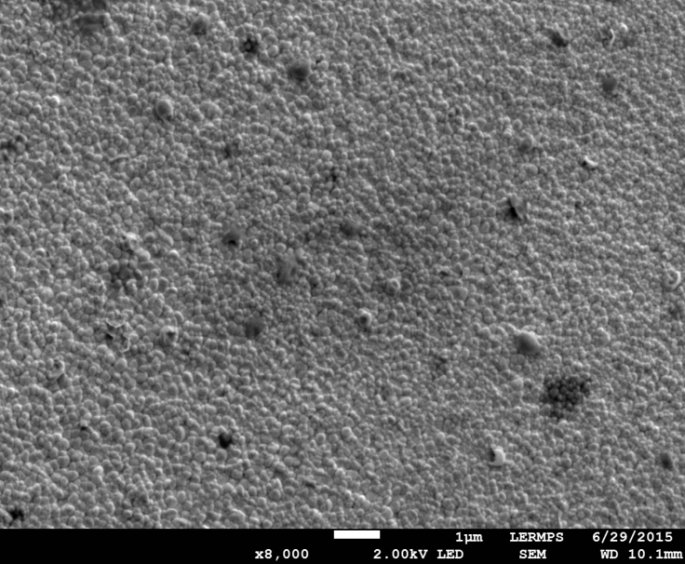

1. SEM images of Li-doped ZnO thin films at 0%

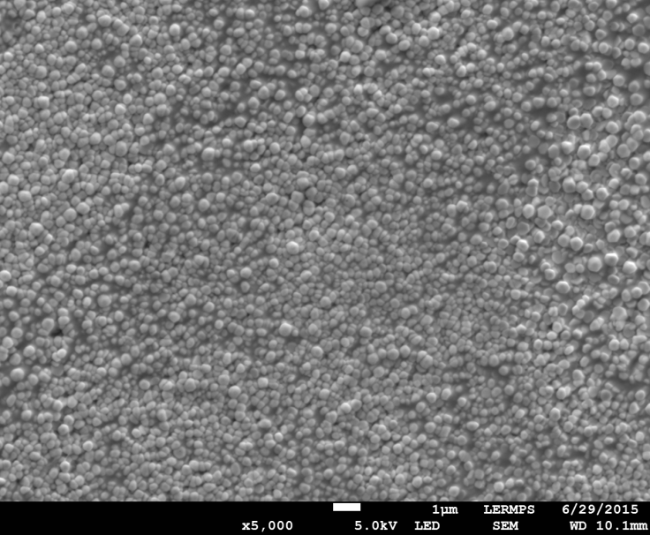

1. SEM images of Li-doped ZnO thin films at 2%

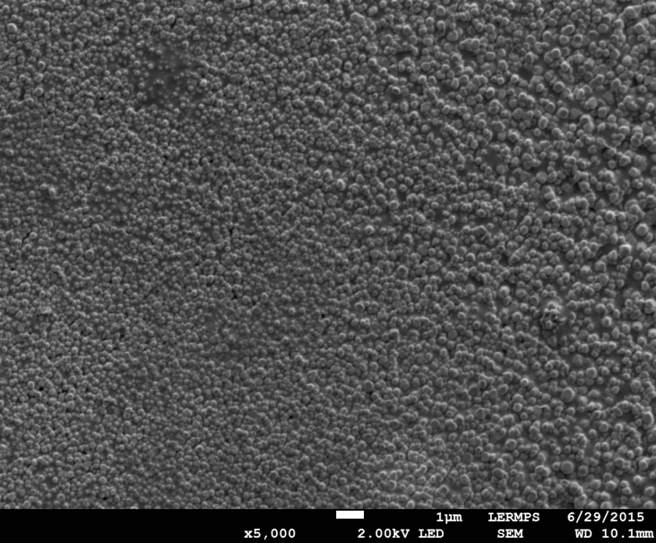

1. SEM images of Li-doped ZnO thin films at 3 %
2. morphological proprieties

The images of scanning electron microscopy (SEM) are represented in figures 3, 4 and 5. An evolution in the morphology of the surfaces is observed as a function of Li content and the grain size increase with the increasing of Li concentration. SEM images show uniformity of the films with dense spherical-shaped grains.

1. optical properties

UV/vis spectroscopy was used to characterize the optical transmittance of undoped and doped ZnO thin films in the wavelength region of 300–1800 nm.

We note that these films show a high transparency within the visible range with an average transmittance lying between 65% and 85%. The transmission decreased as the concentration of Li increased.

To calculate the optical band-gap energy (Eg) of the thin films, the absorption coefficient was estimated using the following relation [10].

$$α=\frac{1}{d}Ln(\frac{1}{T})$$

The optical band gap energy Eg for a direct transition is given by [11], [12].

$${(αhυ)}^{2}=A(hυ-E_{g})$$

Where A is a constant, Eg is the optical band gap energy, hυ is the photon energy, and α is the absorption coefficient. Fig. 6 shows a plot of [αhυ] 2 versus the photon energy (hυ) for the undoped and Li-doped ZnO thin films.

The results show a decrease in energy from 3.285 to 3.254 eV with the Lithium content. This result can be explained by imperfection in ZnO crystal. This phenomenon may be related to the influence of several factors such as thickness, grain size, structural parameters and lattice strain, carrier concentration.



1. Transmission spectra of sprayed ZnO: Li thin films



1. Plot of (αhυ)2 versus photon energy (hυ)
2. Conclusions

Li-doped ZnO thin films were prepared with different Li doping concentrations (0 at%, 2 at %, and 3 at %) on glass substrates using the spray pyrolysis technique. In conclusion, we have studied the effect of Li doping on structure, optical and morphological proprieties. XRD study shows that all sprayed ZnO: Li thin films are in polycrystalline hexagonal wurtzite state (with preferential c-axis orientation). It is obtained that the (002) peak shifts slightly to higher Bragg angle, indicating the incorporation of lithium. The thin films exhibited a relatively dense surface structure that was composed of spherical and granular crystallites. We remarked that the prepared thin films have a transmittance between 65 % and 85% and is more important for pure film. The optical band gap was determined from the absorption coefficient value. Optical energy gap of undoped ZnO film is calculated equal to 3.285 eV and is equal to 3.254 eV for Li-doped ZnO film at 3%.

Acknowledgment

This work was supported by the University of Tunis, Tunisia and The University of Tunis El-Manar, Tunisia. The authors would like to extend their immense gratitude to Prof M. Amlouk for his help and for the spray pyrolysis technique.

References

1. R.G. Gordon, Materials Research Bulletin. 25 (2000) 52.
2. B.G. Lewis, D.C. Paine, Materials Research Bulletin. 25 (2000) 22.
3. D.C. Look, D.C. Reynolds, J.W. Hemsky, R.L. Jones, J.R. Sizelove, Production andannealing of electron irradiation damage in ZnO, Applied Physics Letters. 75 (1999)811.
4. M.H. Huang, S. Mao, H. Feick, H.Q. Yan, Y.Y. Wu, H. Kind, E. Weber, R. Russo, P.D.Yang, Room-temperature ultraviolet nanowire nanolasers, Science 292 (2001)1897.
5. Ondo-Ndong R, Ferblantier G, AlKalfioui M, Boyer A, Foucaran A. Journal of Crystal Growth 2003; 255:130.
6. Gao YF, Nagai M, Masuda Y, Sato F, Koumoto K. Journal of Crystal Growth 2006;286:445.
7. K.Boubaker, A.Chaouachi, M.Amlouk, H.Bouzouita, European Physical Journal Applied Physics 37(2007) 105–109.
8. Xiaolu Yan, Hu Dan, Hangshi Li, Linxiao Li, Xiaoyu Chong, Yude Wang, Physica B 406 (2011) 3956–3962.
9. Zeng Y-J, Ye Z-Z, Xu W-Z, Chen L-L, Li D-Y, Zhu L-P, Zhao B-H, Hu Y-L (2005) J Cryst Growth 283:180
10. Ben ramache Said,Benhaoua Boubaker. Super lattices Microstruc t2012;52:1062–70.
11. M. Caglar, S. Ilican, Y. Caglar, Influence of dopant concentration on the optical properties of ZnO: In films by sol–gel method, Thin Solid Films 517 (2009) 5023–5028.
12. J.E. Bardeen, F.J. Blatt, L.H. Hall, Proceedings of Atlantic City Photoconductivity Conference, Wiley, New York, 1954, pp. 146–153.