Numerical Study of the Inclination Impact of an Inclined “T” Shaped Double Cavity
on the Solution Symmetry and Heat Transfer
M’barka Mourabit^{#1}, Hicham Rouijaa^{#2}, El Alami Semma^{#3}, Mustapha El Alami*, Mostafa Najam*
# Laboratory of Mechanics, Faculty of Science and Technology, Hassan 1st University, Po Box.577
Settat, Morocco
¹mobaraka.mourabit@gmail.com
³semmaalam@yahoo.fr
* LPMMAT Laboratory, Department of Physics, Aïn Chock Science Faculty, Hassan 2nd University, Po Box.5366
Casablanca, Morocco
²hrouijaa@hotmail.com

Abstract —This work has as principal goal the numerical investigation of mixed convective heat transfer in an inclined “T” shaped double cavity containing four heated blocks and four openings. The heated blocks are attached to the lower wall and maintained at a constant temperature θ_{H}. The upper wall is maintained cold at a constant temperature θ_{C} (θ_{C}<θ_{H}). The vertical walls are rigid and adiabatic. The equations that rule the problem are solved by using the finite volume method and the SIMPLEC algorithm. We will put emphasis on the impact of the inclination angle on the solution symmetry and the heat transfer. The most important parameters are: the inclination angle 0°≤ϕ≤90°, the Rayleigh number Ra =2.10⁵, the Reynolds number 100≤ Re≤1000, the Prandtl number Pr=0.72, the height of the blocks B=0.5, the opening width C=0.15 and the distance between blocks D=0.5. Various results for flow field, isotherms and Nusselt number variations with Re and φ are presented.

Keywords— Mixed Convection, inclination effect, “T” shaped double cavity, air jet
- Introduction
The failure rate of electronic devices ascends with temperature almost exponentially. Thermal cycling can cause break at connections. Therefore, thermal control has become increasingly important in the design and operation of electronic equipments in many fields of the new industry in order to reduce temperature and heat excess [1-3].
For that, many authors and scientists have put emphasis on convective heat transfer inside channels. Where, A.Korichi et al [4] have carried out numerically heat transfer and fluid flow in a horizontal channel containing two obstacles on the lower wall and one obstacle on the upper wall located in between the two. They found that the increase of the Reynolds number value, leads to the increase of the heat removed from the obstacles with a maximum heat removal around the obstacle corners. A numerical simulation [5] into an alternative method of natural convection enhancement by the transverse oscillations of a thin short plate, strategically positioned in close proximity to a rectangular heat source was carried out. The results indicated that this method can serve as a feasible, simpler, more energy and space efficient alternative to common methods of cooling for low power dissipating devices operating at conditions just beyond the reach of pure natural convection.
However, a numerical study [6] of mixed convection heat transfer in an inclined rectangular channel with three heat sources on the lower wall was carried out using the finite element method and the Petrov–Galerkin technique. They obtained that the inclination has a stronger influence on the flow and heat transfer for low Reynolds numbers. In general, cases which show the lowest temperature distributions on the modules are those where the inclination angles are 45° and 90°.
Among the studies in literature, there exist various investigations that treat heat transfer in cavities of different forms such as Rahman and al [7] that have analyzed numerically a computational work to show the effects of buoyancy ratio on heat and mass transfer in a triangular enclosure with zig-zag shaped bottom wall for different parameters. They obtained that average Nusselt and Sherwood numbers increase by 89.18% and 101.91% respectively as Br increases from -10 to 20 at Ra_{T}=10⁶. Also, average Nusselt decreases by 16.22% and Sherwood numbers increases by 144.84% as Le increases from 0.1 to 20 at this Rayleigh number. Mahmoodi [8] has put emphasis on problem of natural convection fluid flow and heat transfer of Cu-water nanofluid inside L-shaped cavities. He has obtained that the mean Nusselt number for all rage of cavity aspect ratio increases with increase in the Rayleigh number and the solid volume fraction of the nanofluid. More, he has observed that the rate of heat transfer increases with decreasing the aspect ratio of the cavity.
Moreover, numerous researchers [9, 10, 11] have investigated convective heat transfer inside ”T” form cavities. Meskini and al. [9] have examined numerically the enhancement of heat transfer in a square cavity with identical heated rectangular blocks adjacent to its upper wall, and submitted to a vertical jet of fresh air from below. They found different solutions, when varying Re, Ra and B, on which the resulting heat transfer, depends significantly.
Recently, various articles have appeared in literature, one of them the investigation [12] of mixed-convection fluid flow and heat transfer in a square cavity filled with Al₂O₃–water nanofluid using the finite volume method (FVM) and SIMPLER algorithm. They obtained that the average Nusselt number for all ranges of solid volume fraction increases with a decrease in the Richardson number. The results elucidate irregular changes of mean Nusselt number at different Richardson numbers versus variation of inclination angles in any case.
This paper has as purpose the numerical study of the inclination effect on mixed convection inside a “T” form double cavity which contains four openings and four heated blocks attached to its lower wall. The upper wall is maintained cold while the vertical walls and the lower wall are adiabatic as displayed in Fig. 1.
- Physical problem and mathematical formulation
The configuration shown in Figure 1 is considered. It is a “T” shaped double cavity containing four openings and four heated blocks arranged on its lower wall and it is maintained at a constant temperature θ_{H}. The upper wall is cold at θ_{C}<θ_{H}. The vertical walls and the lower wall are adiabatic. The height of the blocks is constant for B=0.5.
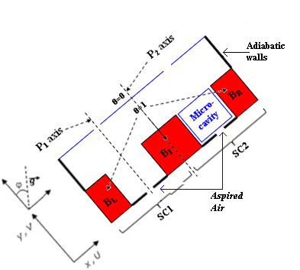
Fig.1 Schematic representation of the problem
- Mathematical Formulation
The governing equations of this problem are those of Navier-Stockes associated to the energy equation in unsteady state.
The fluid is supposed to be bidimensional, laminar and incompressible while Boussineq approximation is validated and the fluid properties are constant.
The local Nusselt numbers along the heated blocks Nu_{L}, Nu_{I} and Nu_{R} will be calculated for examining the heat exchange through the double cavity. Respectively, the mean Nusselt number over the active surfaces of the double cavity is given by:

(1)

The global Nusselt number on the left block surface is:

(2)

The global Nusselt number on the intermediate block surfaces is:

(3)

The global Nusselt number on the right block surfaces is:

(4)
The dynamic and thermal boundary conditions associated to the problem equations are:
•for y=0; 0.425≤x≤0.575 and 1.425≤x≤1.575 (admission openings)
•for y=0; 0.25≤x≤0.425; 0.575≤x≤0.75; 1.25≤x≤1.425and 1.575≤x≤1.75 (The parts of lower wall separating the opening and the blocks)
•for B≤y≤1; x=0 and x=2 (adiabatic vertical walls)
•on the rigid walls.
The θ, U and V values in the evacuation opening are extrapoled by imposing the second derivates null with respect to y as in [13,14].
- Numerical Method
The finite volume method and the SIMPLEC algorithm will be used to solve the governing equations and to treat the Velocity-Pressure coupling [15,16] while, the schema Quick is chosen to discritisize the convective terms of the transport equation [17]. The grid size of 120x81 has been chosen to model accurately the flow fields. The time step considered in this investigation is between 10⁻⁴ and 10⁻³. The code is validated by comparing our results with those reached by Kalache [18] in case of natural convection flows inside trapezoidal cavity and then they will be compared with results obtained in natural convection in a vertical channel by Destrayaud and Fichera [19]. It is worthy to say that we have obtained a good agreement in this comparison.
- Results and discussion
The results in terms of stream lines, isotherms and Nusselt number variations for inclination angle 0°≤ φ ≤90°, Reynolds number 100≤Re≤1000 and Ra=2.10⁵ ,will be displayed.
- Streamlines and isothermal lines
When we vary Re and φ, we remark the existence of different solutions: ICF (Intra Cellular Flow), ECF (Extra Cellular Flow) [9,10] and a combination of FF (Forced Flow) and UCLF (Uni Cellular Left Flow) or ECF and UCLF [9]. More, we also remark that the solution of the double cavity is formed of two solutions, one in each sub cavity: SC1 (Simple Cavity 1) and SC2 (Simple Cavity 2). According to the flow field, it is observed that a communication is between the two adjacent cavities.

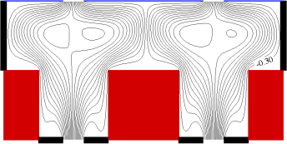 (a) 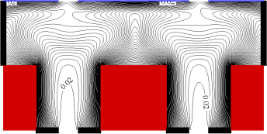
Re=200
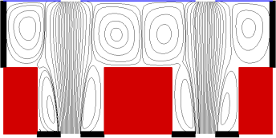 (b) 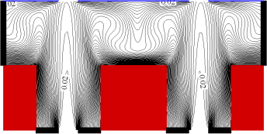
Re=500
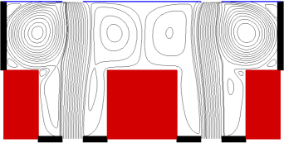 (c) 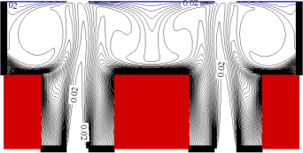
Re=1000
Fig. 2 Streamlines and isotherms for Rayleigh number Ra=2.10⁵; inclination angle φ=0°: {(a),(b),(c)}

In this section, we notice that all the solutions are symmetric, with respect to P₂ axis passing by the middle of the double cavity, for cases not inclined (φ = 0°) as presented in Fig. 2. Where, at Re=200, φ = 0°, Fig. 2a, we note that this solution is an ICF type and the solution symmetry is conserved with respect to P₂ axis. The flow structure is composed of the Open lines (OL) that fill the whole double cavity surrounding two cells (in each domain SC1 and SC2). The corresponding thermal fields reveal that the horizontal surfaces of the heated blocks are badly ventilated due to the absence of the convective cells while, the vertical active ones are well ventilated because the air jet is still inside the two micro cavities. They also reveal that the isotherms have a tooth shape inside each sub cavity. By increasing Reynolds number to 500, φ = 0°, Fig. 2b, we perceive that the solution is an ICF type and symmetric. Fig. 2b presents the appearance of four Rayleigh-Bénard cells above the blocks. The open lines are parallel to P₁ axis and pushed by the convective cells to the middle of SC1 and SC2. This figure also presents that the recirculation cells have increased in size. The corresponding isotherms show that the horizontal surfaces of the heated blocks are more cooled than the other ones because of the convective cells. This demonstrates that the symmetry of the solutions ICF is in favor of the cooling of the horizontal heated surfaces. The air jet arrives to the upper part of the double cavity.By more increasing Re to 1000, φ = 0°, Fig. 2c, the solution (ICF) is seen symmetric with respect to P₂ axis while the symmetry to P₁ axis is not conserved. The flow structure shows that the shape of the convective cells, which are above B_{L} and B_{R}, has changed. The isothermal lines of this case indicate that the horizontal surfaces are well ventilated due to the rotation of the convective cells. The vertical active surfaces are badly ventilated because of the recirculation cells. They also indicate a sharp heat decrease of the temperature gradient above the block B_{I}. The flow is influenced by the convective and the recirculation cells.
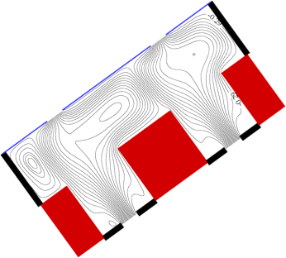 (a) 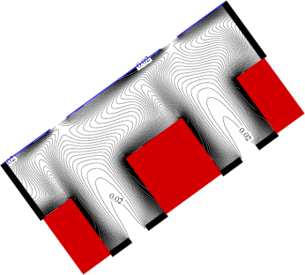
Re=200
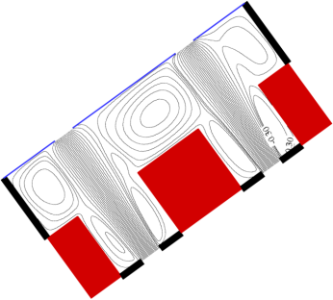 (b) 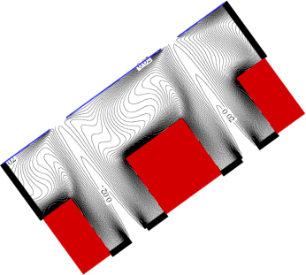
Re=500
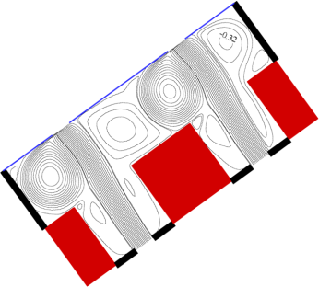 (c) 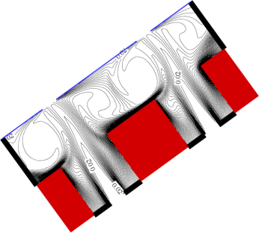
Re=1000
Fig 3. Streamlines and isotherms for Rayleigh number Ra=2.10⁵; inclination angle φ=36°: {(a),(b),(c)}
When we incline the double cavity, φ = 36°, Fig. 3, we notice that the solution symmetry is destroyed. Where, at Re=200, φ = 36°, Fig. 3a, we remark that the solution is asymmetric (UCLF+ECF). The flow field is composed of a convective cell above B_{L} and a small cell above B_{I}. The open lines are divided into two parts, one part fills (the middle of SC1), the other one deflects in the corner of B_{I} then turn around a cell for exiting from the evacuation opening (of SC1). In addition, the OL fill the majority of SC2 domain, indicating a communication between the two sub cavities. The corresponding isotherms show a good ventilation of the vertical active walls. Most, the horizontal active wall of B_{L} is more cooled than the other horizontal ones. For Re=500, φ = 36°, Fig .3b, we remark that the solution symmetry is not conserved. The type of this solution is ICF. The flow structure reveals that the right convective cell of SC1 has disappeared letting the space above B_{I} to the convective cell (of SC2), which demonstrates a mutual communication between the two sub cavities. Besides, the flow in SC2 overtakes the flow in SC1 domain. It also reveals the Rayleigh Bénard cell above B_{R} has decreased in size. The corresponding isotherms depict that the horizontal active surfaces of B_{L} and B_{I} are more ventilated than the horizontal surface of B_{R}. They also depict the bad ventilation of the vertical surfaces of the heated blocks due to the recirculation cells. By increasing Re to 1000, φ = 36°, Fig. 3c, we perceive that the solution symmetry is not conserved with respect to P₂ axis and it is an ICF type. The type of this solution is conserved (ICF) while the form of the convective cells has changed. The isotherms of this case show that the horizontal active wall of B_{R} is no more ventilated due to the small cell. The vertical active walls are badly ventilated.
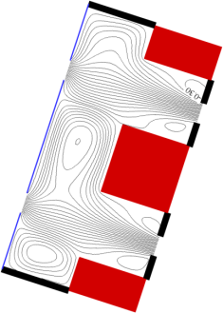 (a) 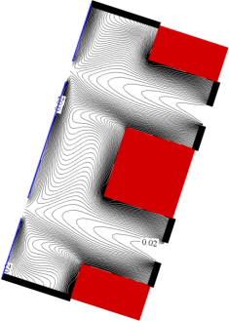
Re=200
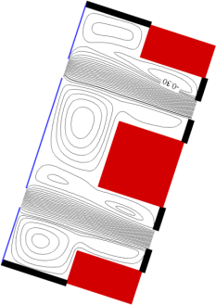 (b) 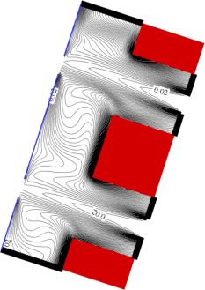
Re=500
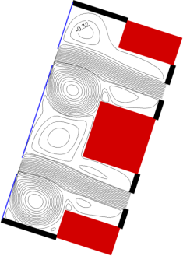 (c) 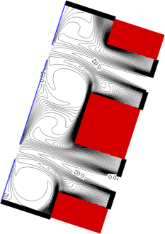
Re=1000
Fig .4 Streamlines and isotherms for Rayleigh number Ra=2.10⁵; inclination angle φ=72°: {(a),(b),(c)}
By more inclining the double cavity φ = 72°, we observe that the solutions are still asymmetric. At Re=200, φ = 72°, Fig. 4a, we remark that the solution is asymmetric with respect to P₂ axis (UCLF+FF). The flow field exposes that the convective cells above B_{L} and B_{I} have increased in size. The recirculation cells have also increased in size and the small cell inside the OL of SC2 has disappeared. The corresponding isotherms evince that the horizontal active surface of B_{L} is more ventilated than the other horizontal one. The lower parts of the vertical walls of B_{L} and B_{I} (SC2) are badly ventilated. Most, the flow is influenced by the inclination. By increasing Re to 500, φ = 72°, Fig. 4b, we note that the solution is still asymmetric. The type of this solution is ICF. The flow structure indicates that the intensity of the convective cell above B_{R} has increased. While, the intensity of the Rayleigh Bénard cell above B_{I} is reduced letting space to a new cell to appear (in SC1). The right recirculation cell of SC2 has increased in size. The isotherms prove that the vertical walls are badly ventilated. They also prove the horizontal active surface of B_{R} is less ventilated than the other horizontal ones. By increasing Re to 1000, φ = 72°, Fig. 4c, we behold that the solution is not symmetric and it is an ICF type. The flow structure and the corresponding isotherms have not changed. They show the same phenomenon as the case of Re=1000, φ = 36°. It is worthy to say that the inclination angle has no effect on the solution symmetry for high Reynolds number Re and for φ > 0°.
- Heat transfer
We will present the variations of the global Nusselt numbers along the heated blocks Nu_{L}, Nu_{I} and Nu_{R}, according to Reynolds number 100≤Re≤1000 and inclination angle φ between 0° and 90° (Ra=2.10⁵), in Fig .5-7.
In one hand, we observe that the global Nusselt number along the left block Nu_{L} falls gradually with Reynolds number Re, in the zone of mixed convection, and then it increases sharply for all inclination angles 36°≤φ≤90° as mentioned in Fig .5. Most, it varies in the same manner for different inclination angle. However, the global Nusselt number along the right block Nu_{R} goes up with Re, declines (36°≤φ≤54°) and then it increases, Fig .5. The global Nusselt number along the intermediate block Nu_{I} rises steadily, Fig .6, decreases then it rockets with Re in the zone of the forced flow (in general, 500≤Re≤1000). Furthermore, the heat transfer is similar for different values of the inclination angle in the left, intermediate and right blocks.
In the other hand, Fig .6 indicates that the global Nusselt number along the intermediate block Nu_{I} varies differently with the inclination angle φ for 100≤Re≤500. While it increases with φ then it remains constant for Re=1000 (36°≤φ≤90°). We note that there is a steady increase for the variation of the global Nusselt number along the left block Nu_{L} with the inclination angle φ, Fig .7, for 300≤Re≤1000 in the mixed and forced convection zone.
Nonetheless, there is a slow rise then a gradual decrease with φ for the lower Reynolds number 100≤Re≤200. The global Nusselt number along the right block Nu_{R} diminish with the inclination angle φ for Re=100 while it goes up very slowly with φ for 200≤Re≤500 as displayed in Fig .7. More, Nu_{R} ascends steadily with φ for high Reynolds number Re=700.
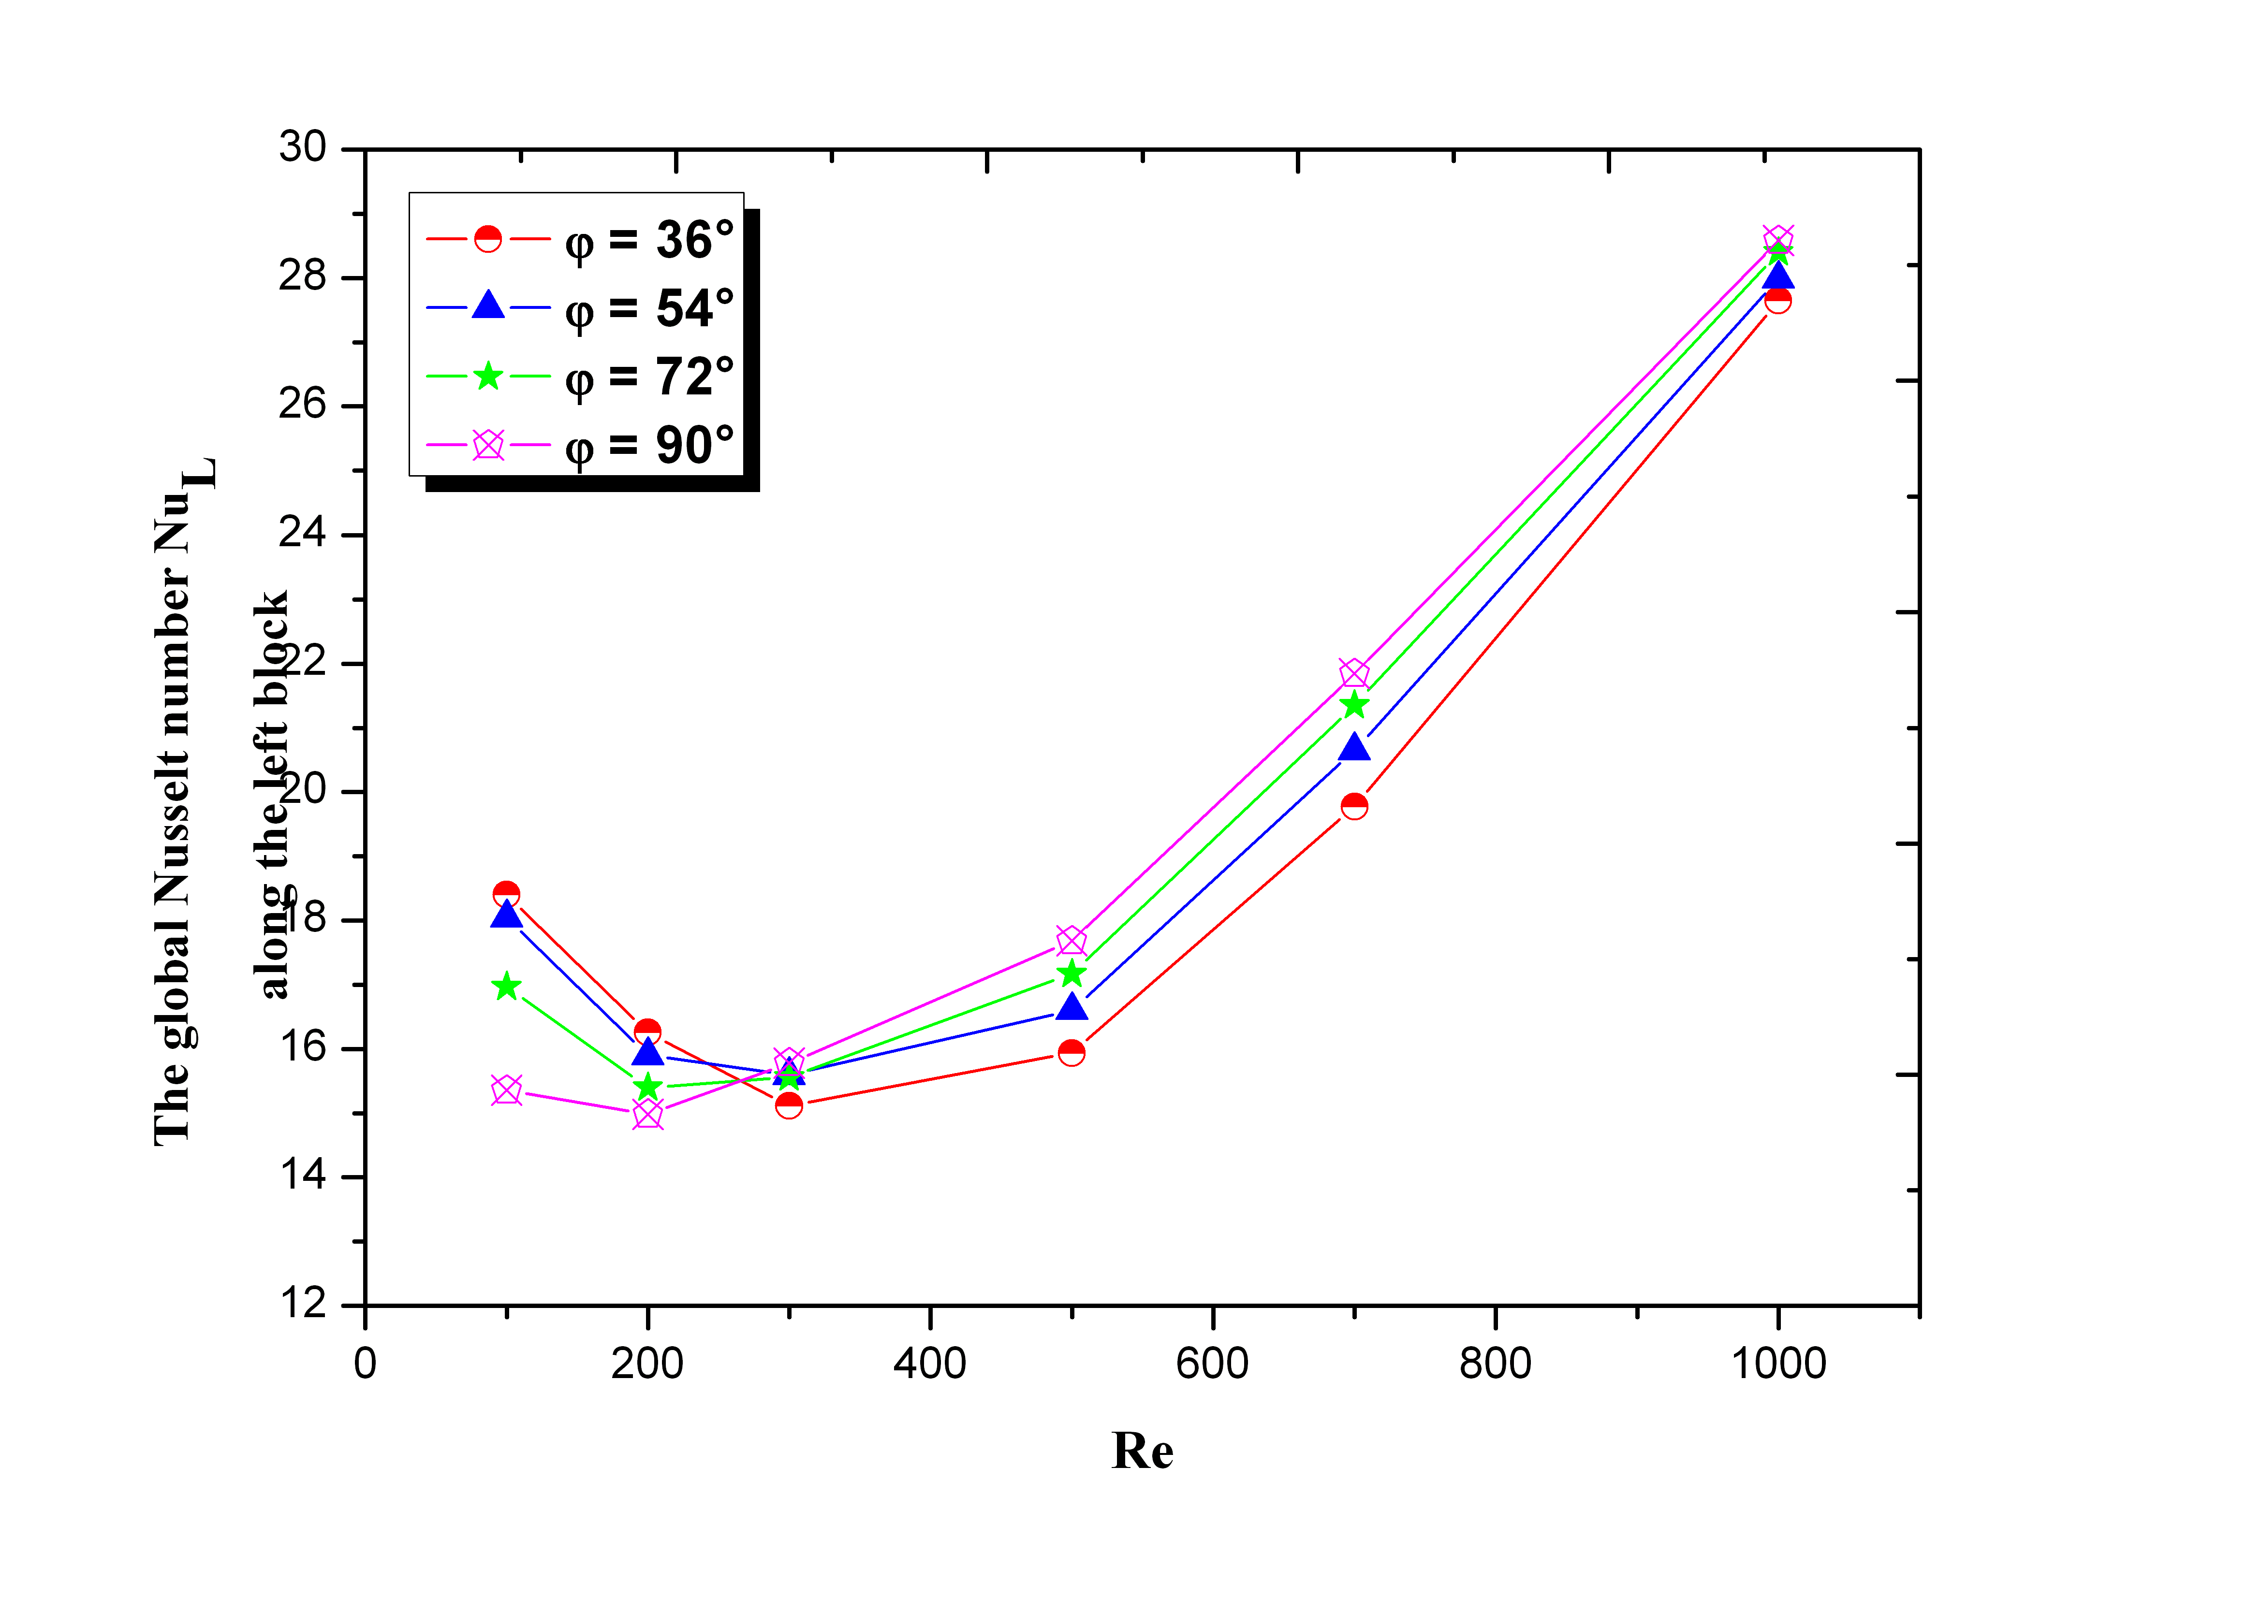
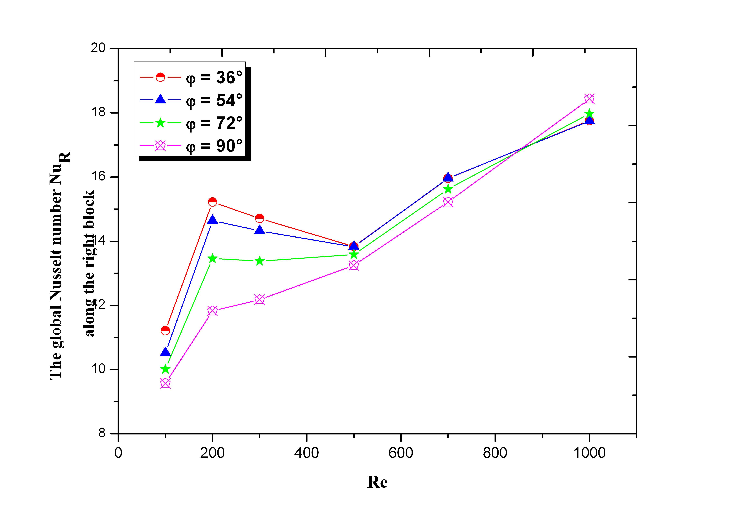
Fig .5 Nu_{L} and Nu_{R} variations with Reynolds number Re and different values of inclination angle φ (Ra=2.10⁵)
- Conclusion
This work simulates the influence of inclination angle on mixed convection inside a “T” shaped double cavity containing four heated blocks on its lower wall and four opening.
The results obtained, indicate:
- The existence of different solutions ICF, ECF and a combination of UCLF and FF or UCLF and ECF.
- The solution symmetry, with respect to P₂ axis, is destroyed under the effect of inclination for cases with inclination.
- The symmetry of solutions ICF is in favor of the ventilation of the horizontal heated walls.
- When we increase Re, the inclination has no influence on the flow structure of the solution (φ>0°).
Nomenclature
A | Aspect ratio of calculation domain A= L’/H’
B | Dimensionless block height (B= h’/H’)
C | Dimensionless openings diameter (C=l’/H’)
D | Dimensionless space between blocks (D=d’/H’)
d’ | Space between adjacent blocks (m)
H’ | Cavity height (m)
h’ | Blocks height, (m)
L’ | Horizontal length of calculation domain (m)
l’ | Opening diameter (m)
g | Acceleration due to gravity (m/s²)
Nu_{L} | Global Nusselt number along the planes of the left block
Nu_{I} | Global Nusselt number along the planes of the intermediate block
Nu_{R} | Global Nusselt number along the planes of the right block
θ | Dimensionless temperature, (T-T_{C})/(T_{H}-T_{C})
T | Temperature of the fluid
ΔT | Temperature difference (T_{H}-T_{C})
U₀ | Characteristic velocity of the forced flow
(x ,y) | Dimensionless Cartesian coordinates in the two directions (x,y) = (x’,y’)/H’
(u,v) | Velocities
(U ,V) | Dimensionless velocities (U ,V) =(u,v)/U₀

Greek Symbols
µ | Thermal diffusivity (m²s⁻¹)
ρ | Volumetric coefficient of thermal expansion(K⁻¹)
ϕ | Inclination angle of the cavity
Λ | Thermal conductivity (Wm¹K⁻¹)
ν | Cinematic viscosity (m²s⁻¹)
Ρ | Fluid density (kg/m³)
Ψ | Dimensionless stream function, ψ =ψ’/α
Ω | Dimensionless vorticity Ω=Ω’H^{’2}/α

Subscripts
H | Heated wall
C | Cold wall

Non-dimensional Numbers
Pr | Prandtl number (Pr=ν/α)
Re | Reynolds number (Re=U₀×H’/ν)
Ra | Rayleigh number, (Ra=gβΔTH’³/(αν))
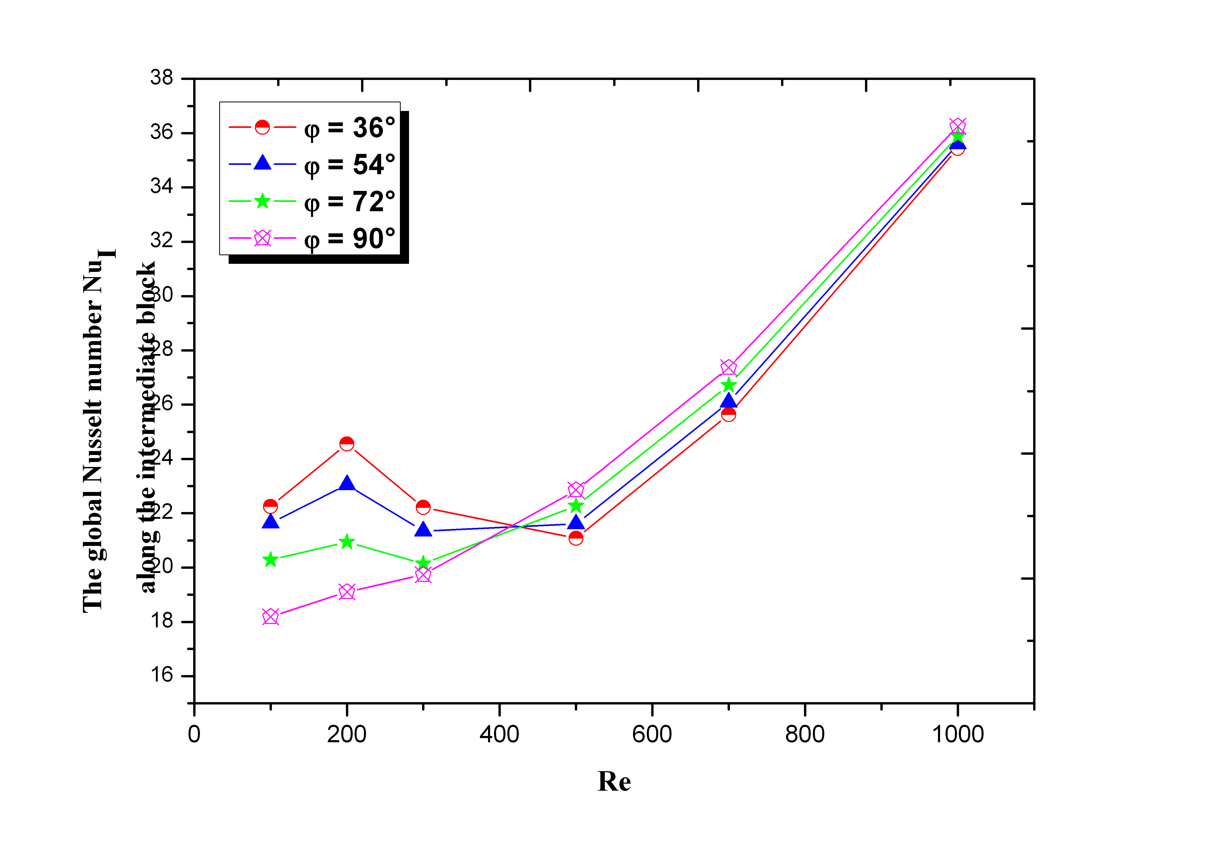
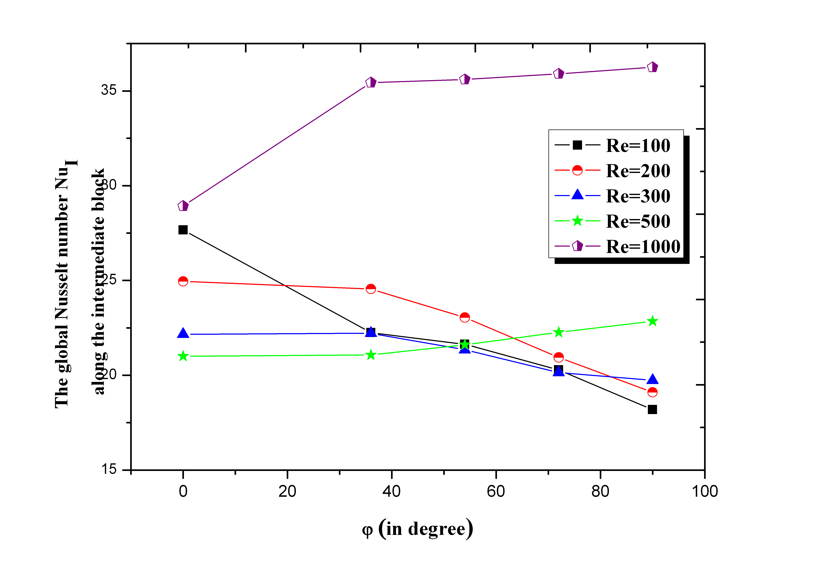
Fig .6 Nu_{I} variations with Reynolds number Re and the inclination angle φ (Ra=2.10⁵)
Références
- R. Bessaih and M. Kadja, Turbulent natural convection cooling of electronic components mounted on a vertical channel, Applied Thermal Engineering 20 (2000) 141-154.
- G. Madhusudhana Rao, G.S.V.L. Narasimham, Laminar conjugate mixed convection in a vertical channel with heat generating components, International Journal of Heat and Mass Transfer 50 (2007) 3561–3574.
- A.S. Huzayyin, S.A. Nada, M.A. Rady and A. Faris; Cooling an array of multiple heat sources by a row of slot air jets. International Journal of Heat and Mass Transfer, Vol. 49, pp. 2597-2609 (2006)
- A. Korichi, L. Oufer, Numerical heat transfer in a rectangular channel with mounted obstacles on upper and lower walls,Int. J. thermal Sciences 44 (2005) 644-655.
- L.A. Florio, A. Harnoy, Use of a vibrating plate to enhance natural convection cooling of a discrete heat source in a vertical channel, Applied Thermal Engineering 27 (2007) 2276-2293.
- P.M. Guimarães, and G.J. Menon; Combined free and forced convection in an inclined channel with discrete heat sources. International Communications in Heat and Mass Transfer, Vol. 35, pp. 1267-1274 (2008)
- M.M. Rahman, Hakan F. Öztop, A. Ahsan and J. Orfi; Natural convection effects on heat and mass transfer in a curvilinear triangular cavity. International Journal of Heat and Mass Transfer, Vol. 55, pp. 6250-6259 (2012)
- M. Mahmoodi, Numerical simulation of free convection of a nanofluid in L-shaped cavities, International Journal of Thermal Sciences 50 (2011) 1731-1740.
- M. Najam, M. El Alami, A. Oubarra, Heat transfer in a « T » form cavity with heated rectangular blocks submitted to a vertical jet: the block gap effect on multiple solutions, Energy Conversion and Management 45 (2004) 113-125.
- M. El Alami, E.A. Semma, A. Oubarra, F. Penot, Chimney effect in a « T » form cavity with heated isothermal blocks: The blocks height effect, Energy Conversion and Management 45 (2004) 3181-3191.
- A. Meskini, M. Najam and M. El Alami, Convective mixed heat transfer in a square cavity with heated rectangular blocks and submitted to a vertical forced flow, FDMP 7 (2011) 97-110.
- M. H. Esfe, M. Akbari, A. Karimipour, M. Afrand, O. Mahian and S. Wongwises; Mixed-convection flow and heat transfer in an inclined cavity equipped to a hot obstacle using nanofluids considering temperature-dependent properties. International Journal of Heat and Mass Transfer, 85(2015) p. 656-666.
- C. Yücel, M. Hasnaoui, L. Robillard and E. Bilgen; Mixed convection in open ended inclined channels with discrete isothermal heating, Numerical Heat Transfer, Part A, 34, pp. 109-247 (1993)
- M. El Alami, Etude numérique de la convection naturelle dans un canal muni d’ouvertures et de blocs chauffants, Thèse de doctorat(2005).
- B.P. Léonard ; A Stable and Accurate Convective Modeling Procedure Based on Quadratic Upstream Interpolation, Computer Methods Applied Mechanics and Engeering 19 (1979) 59-98.
- J.P. Van Doormaal, G.D. Raithby, Enhancements of the SIMPLE method for predicting incompressible fluid flows, Numerical Heat Transfer 7 (1984) 147-163.
- S.V. Patankar, Numerical Heat Transfer and Fluid Flow, Hemisphere Publishing Corporation. Washington D. C (1980).
- D. Kalache, Contribution à l’étude de la convection naturelle en cavités trapézoïdales chauffées par-dessous, Thèse de l’Université de Poitiers (1987).
- G. Desrayaud, A. Fichera, Laminar natural convection in a vertical isothermal channel with symmetric surface mounted rectangular ribs. Int. J. Heat and Fluid Flow 23 (2002) 519-529.
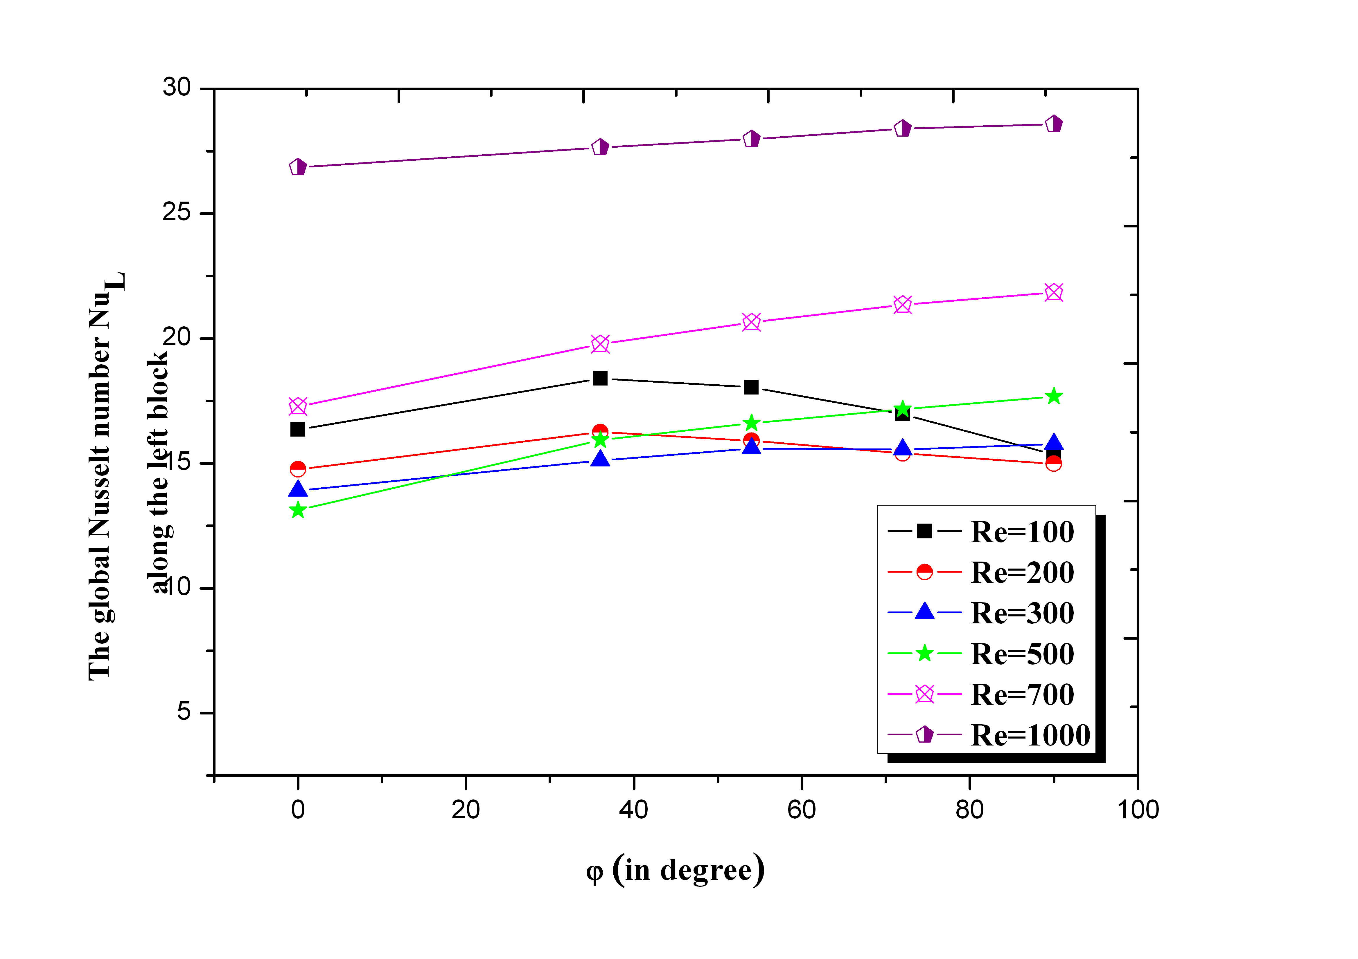
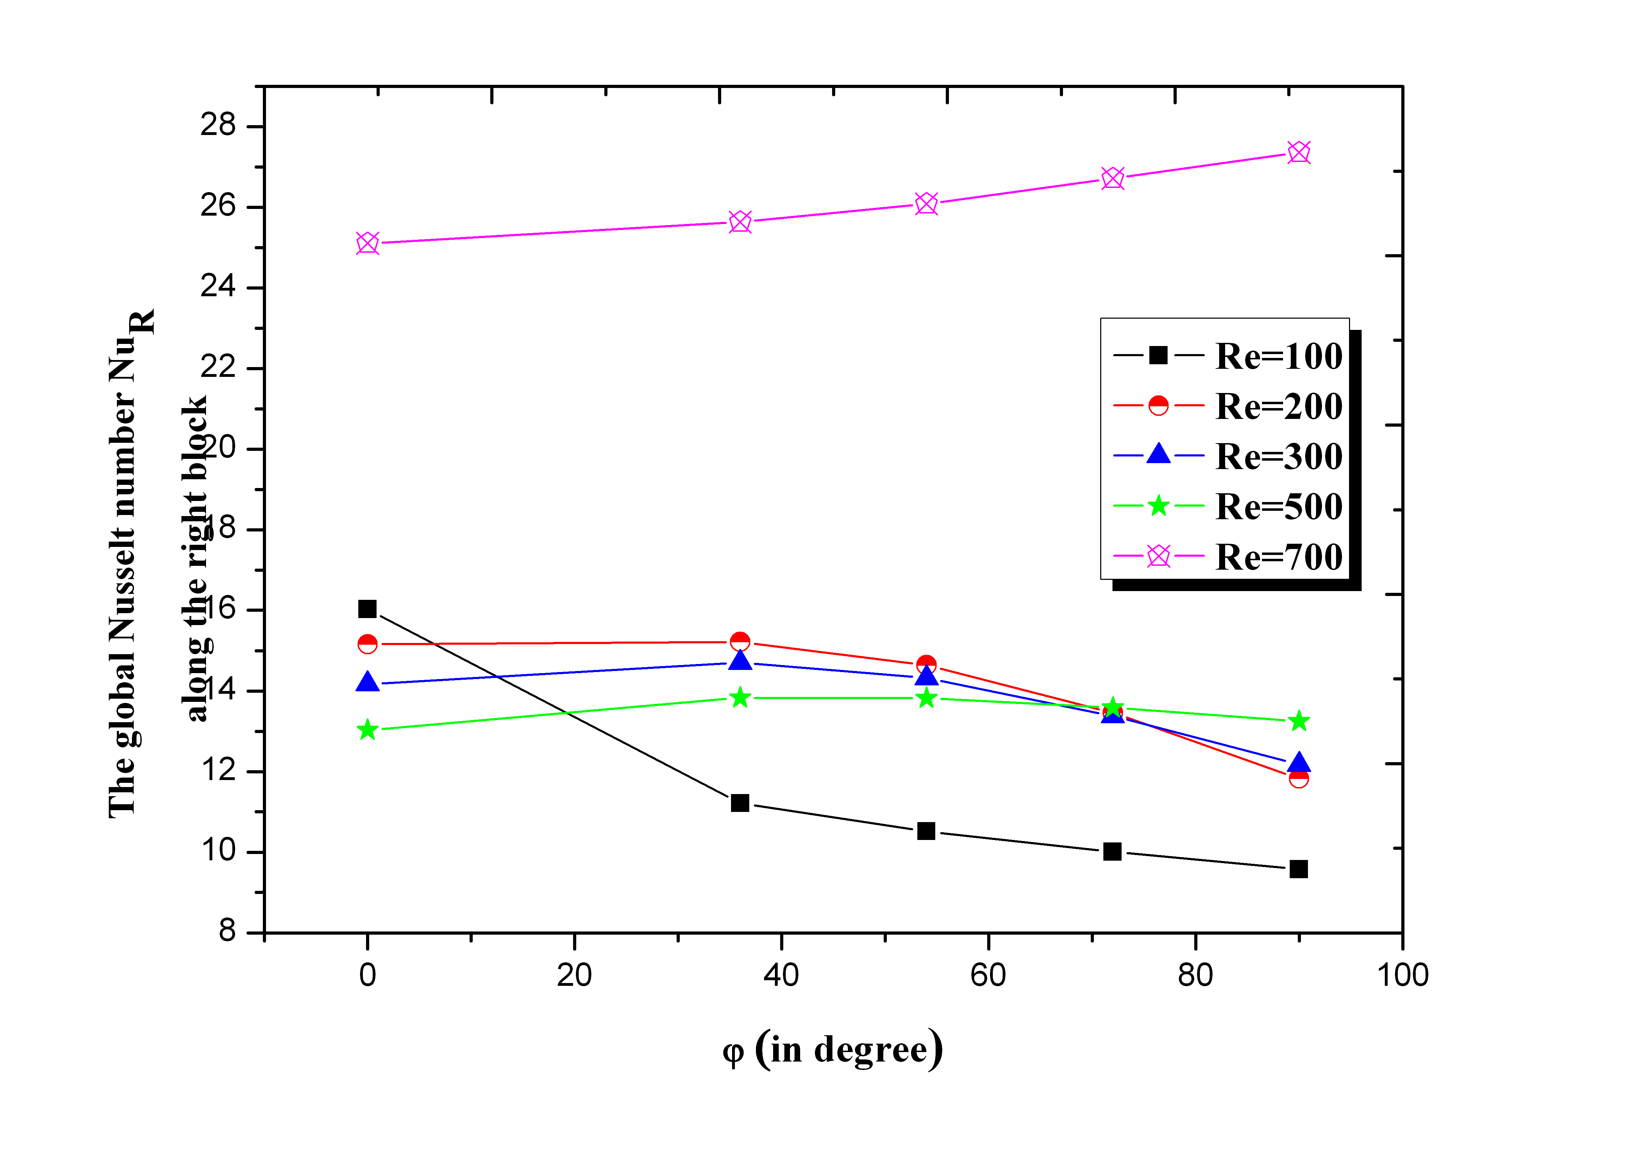
Fig .7 Nu_{L} and Nu_{R} variations with inclination angle φ and different values of Reynolds number Re (Ra=2.10⁵

