**Thermal fluid flow through porous media containing obstacles**

Saida CHATTI, Chekib GHABI, Abdallah MHIMID

*Energetic Department, Monastir University  
Ibn El JazzarAvenue*

[*chatti_saida@yahoo.com*](mailto:chatti_saida@yahoo.com)

[*ghabchekibi@yahoo.fr*](mailto:ghabchekibi@yahoo.fr)

[abdmhimid@yahoo.fr](mailto:abdmhimid@yahoo.fr)

Abstract— The present work is interested on the heat transfer and fluid flow in porous channel. For this aims the lattice Boltzmann method was adopted to simulate mixed convection in porous domain. The Brinkman Forchheimer model was implemented to simulate porous channel including obstacles maintained at constant temperature. The velocity and the temperature are plotted at various parameters. The simulation was carried out for different porosity, Darcy, Reynolds and conductivity ratio. The Results shows that the rise of the Reynolds or the decrement of the porosity leads to the heat transfer enhancement. Also the result points that the obstacle position has effect on heat transfer.

***Keywords***—**Lattice Boltzmann method; heat transfer; fluid flow; obstacles; porous media; parametric study**

1. Introduction

During the past several decades, heat transfer in porous media has attracted the attention of many engineers and scientific researchers because of its wide applications. The porous medium are usually used for enhancing heat transfer in industry such as fuel cells, nuclear Reactors cooling, heat pipes, packed bed reactors and heat exchangers. Kaviany [1] studied fluid flow and heat transfer in porous media with two isothermal parallel plates. Huang and Vafai [2] treated forced convection in a channel containing blocks arranged on the bottom wall. Rizk and Kleinstreuer [3] showed that an increase in heat transfer can be obtained by using porous channel. Indeed the study of forced convection in a porous channel containing discrete heated blocks brings out the importance of the transport phenomena. Hadim [4] is interested on forced convection in a channel partially or fully filled with porous medium. Alkam and al. [5] investigated, using numerical approach, the heat transfer in parallel-plate ducts with porous medium attached to the bottom wall. They interested on the effects of thermal conductivity, the Darcy number and microscopic inertial coefficient on the thermal performance. The lattice Boltzmann method (LBM) is an efficient and powerful numerical tool, founded on kinetic theory, for simulation of fluid flows and modeling the physics proprieties. This approach has several advantages such as the parallelism and the simplicity of implementation of boundary conditions which allows it to analyze difficult phenomena. This method is also widely used thanks to its rapidity comparing to others numerical method [6].The incompressible laminar flows through porous media by using lattice Boltzmann method was studied by many researchers such as Zhao and Guo [7]. The presence of solid obstacles inside the computational domain is also broadly studied thanks to its importance in many scientific fields [8]. In this paper LBM is used to simulate flow behaviors and heat transfer in a channel with solid blocks located inside a porous media. It focuses on scrutinizing the effect of various obstacles geometries on the fluid attitude and heat transfer. This study is continuity to previous authors work interested on the influence of two obstacles having triangular geometries [9].

1. Numerical Simulation of Incompressible Flow In Porous Media Using The Lattice Boltzmann Method (LBM)

The LBM is considered as one of the recent computational fluid dynamics (CFD) methods. Counter to the others a macroscopic Navier Stokes (NS) method; the Lattice Boltzmann Method (LBM) is founded on a mesoscopic approach to simulate fluid flows [7] [10]. The general form of Lattice Boltzmann equation accounting for external force can be written as [9] [11]:

 (1)

Wheredenotes lattice time step, are the discrete lattice velocities in direction, is the external force in direction of lattice velocity, refers to the lattice relaxation time, is the equilibrium distribution function. The local equilibrium distribution function determines the type of problem that needs to be solved. Equation (1) can be interpreted as two successive processes streaming and collision steps. The collision expresses various fluid particle interactions such as collisions and calculates new distribution functions [12]. Many models are advanced for the simulation of the fluid flow in the porous medium. The Brinkman-Forchheimer model has been used successfully in simulation porous media in large values of porosities, Darcy, Rayleigh and Reynolds numbers [6]. This model includes the viscous and inertial terms by the local volume averaging technique. The Brinkman-Forchheimer equation is:

 (2)

 (3)

The equilibrium distribution functions are calculated by [15]:

 (4)

For D2Q9 model, the discrete velocities ${ c}_{i}$ are given by:  (5)



The weights are defined as follows:

 (6)

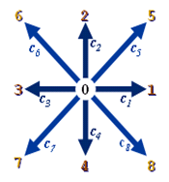

Figure 1: the velocity distribution in the D2Q9 models.

Denotes the porosity, is the effective viscosity, is the total body force which contains the viscous

diffusion, the inertia due to the porous medium and an external force given by the Ergun’s relation. The forcing term model is as follow [13] [14]:

The macroscopic quantities are available through the distribution functions. Indeed the density and the fluid velocity:

 (7)  (8)

The fluid viscosity is determined using the following relation:  (9)

The temperature is carried out by a second distribution function called. It is governed in $i$ direction by the following equation:



The equilibrium distribution functions are given by the following expression

 (11)

The fluid temperature is obtained from the distribution function by:

 (12)

The thermal diffusivity is:

 (13)

#### **2 Problem presentation**

#### In the present study we consider a fluid flow in porous channel of width $H$. The walls are fixe. The bottom plate is cold and the upper one is hot. The computational domain includes hot solid blocks at different positions and and geometries as shown in figure 2.

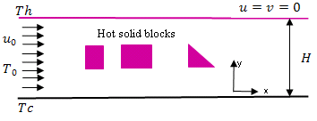

Figure 2: schematic of flow in the channel

For this simulation we adopt that the laminar and incompressible flow is viscous, Newtonian and the buoyancy effects are assumed to be negligible. All the physical properties of the fluid and solid are constant. For this flow in porous channel the fluid behavior can be studied by the following equations [16]:

The continuity equation:

 (14)

The momentum equation:

 (15)

Energy equation:

 (16)

We occur to the distribution functions to convert physical limits (the velocity in the inlet of the flow is defined) to numerical ones. The distribution functions pointing out of the domain are known from the streaming process. The unknown distribution functions are those toward the domain. The solid walls are assumed to be no slip, for this reason the bounce-back scheme is applied. For example in the north boundary the following conditions are used [17].

  (17)

The inlet of the channel is simulated using the Zou and He boundary conditions. An extrapolation in the outlet boundary is applied [15] [17]. For the thermal boundary the Direchlet boundary are necessary.

1. **Results and interpretation**

The parametric study starts with the conductivity ratio. Indeed the porosity is equal to 0.7, the Reynolds number is 80 and the Darcy one is 0.1. The thermal conductivity ratio Rk changes from 69 to 29. The heat transfer and the fluid velocity increase by decreasing the thermal conductivity ratio.

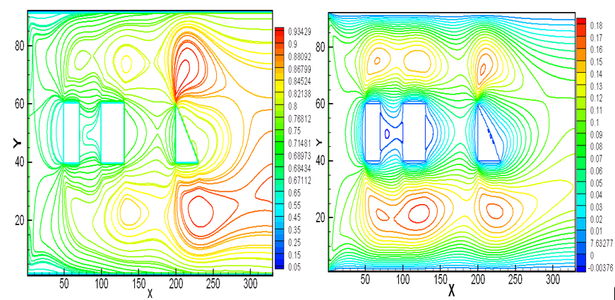

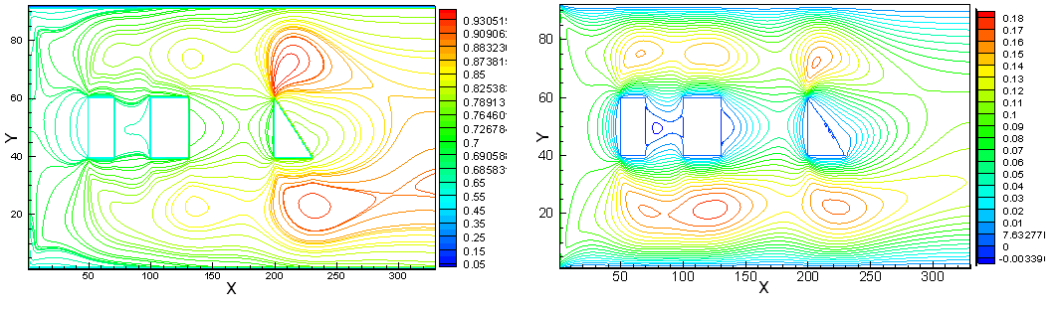

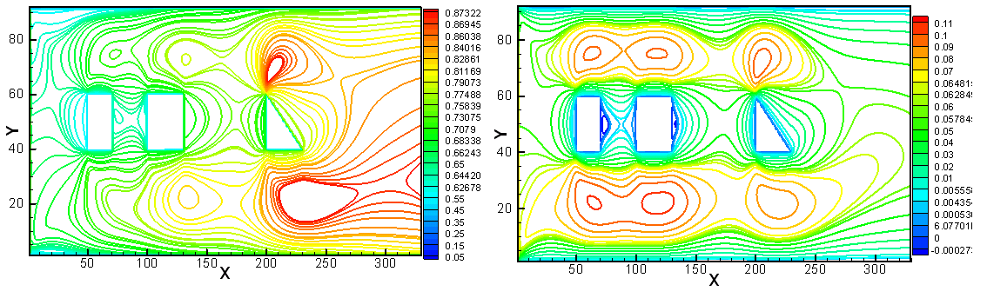

Figure 3: Isotherms (left) and velocity contours (right) at different conductivity ration: respectively 69, 59 and 29.

Then the Reynolds number changes from 180 to 80, the porosity is equal to 0.7 and the Darcy number set to be 0.1. The results of simulation are plotted on the following figure.

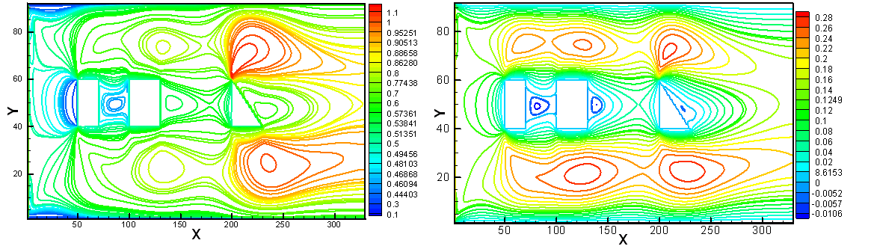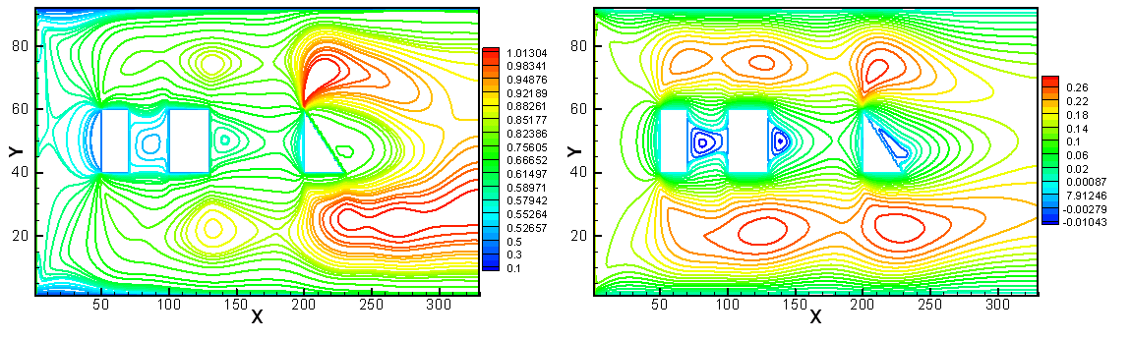

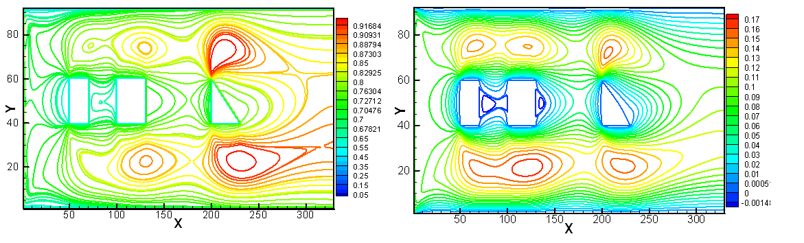

Figure 4: Isotherms (left) and velocity contours (right) at different Reynolds number: respectively 180, 150 and 80.

The above figure proves that the increment of the Reynolds number leads to the rise of the heat transfer in the channel. At high value of Reynolds the fluid velocity increases.

In order to study the effect of the Darcy number it changes from 10-3 to 1, porosity is 0.7 and the Reynolds number is taken 80. The following figure shows the isotherms and the velocity at different Darcy values.

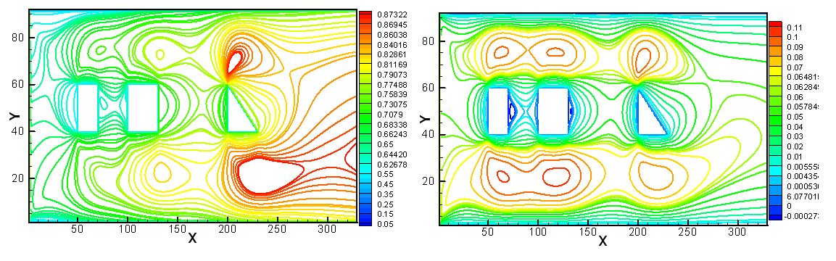

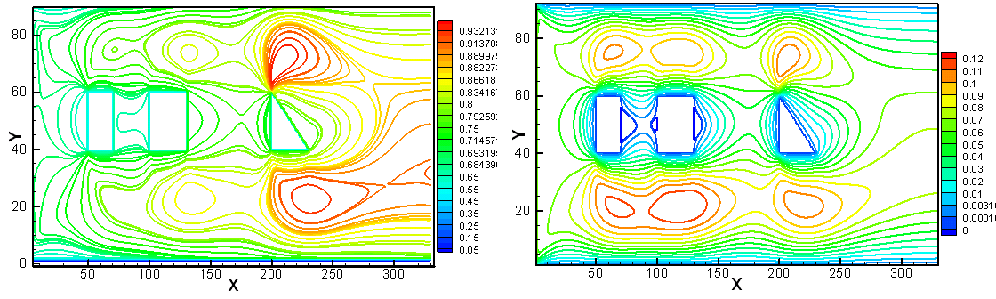

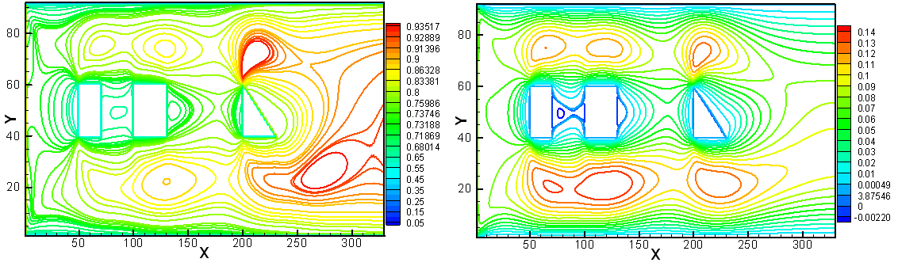

Figure 5: Isotherms (left) and velocity contours (right) at different Darcy number: respectively 10-3, 10-2 and 1.

The heat transfer is more important at high value of Darcy number.

Finally the porosity changes from 0.99 to 0.5, the Reynolds number is equals to 80 and the Darcy one is 0.1. The results are exposed in figure 4.

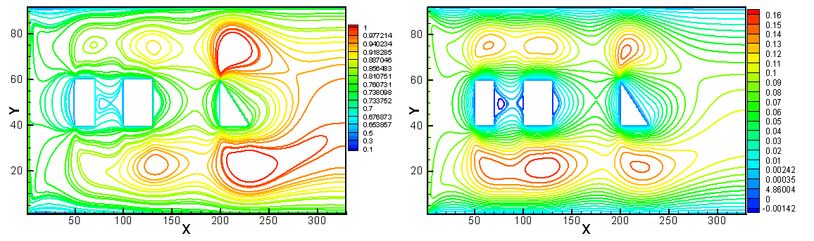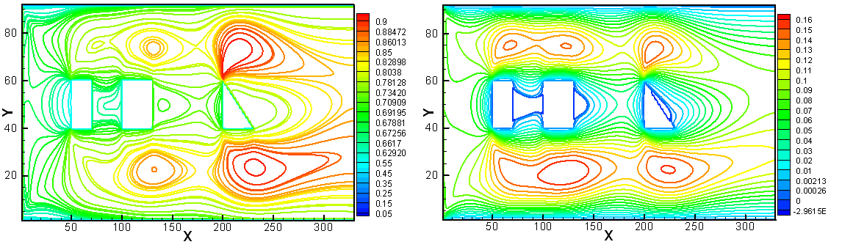

Figure 6: Isotherms (left) and velocity contours (right) at different porosity: respectively 0.99 and 0.5.

Through this figure, it’s shown that for low value of porosity the heat transfer and the velocity of the flow are more significant. Indeed by increasing the porosity the fluid temperature decreases due to lower values of effective thermal conductivity in blocks which can causes the heat transfer reduces. An Increment in the porosity value causes the velocity rises. Indeed for high porosity, it easier for fluid to change its path.

Conclusion

The heat transfer phenomena is widely applied in many scientifique and engeeniring field. In this paper a numerical simulation was carried out for heat transfer and Fluid flow in a porous channel containing hot solid blocks having different geometries and located at different positions. This study, interested on the effect of parameters such as Reynolds number, thermal conductivity ratio and porosity on the flow attitude and thermal field, is achieved using thermal lattice Boltzmann method. Indeed the Brinkman-Forchheimer approach was adopted for the simulation. The temperature of fluid reduces by increasing the porosity due to lower values of thermal conductivity. Consequently the heat transfer decreases with blocks. The increase of the thermal conductivity ratio leads to the fluid temperature drop. The results indicate that increasing the Reynolds and the Darcy number raises the heat transfer. It will be important to study the effect of obstacles positions for different parameters. We also will interessted on the moving obstacles which can describe a linear or sinusoidal motions. The results will be also compared to other numerical method such finite element. The lattice Boltzmann method is a potent tool for simulation of fluid flow and heat transfer in porous media and many other physical phenomena. Due to its simplicity and the easy coding LBM is applied in complicated situation such as multicomponent and multiphase flows.

##### **References**

[1] M. Kaviany, Laminar flow through a porous channel bounded by isothermal parallel plate, Int. J. Heat MassTransfer 28, 851–858, 1985.

[2] P.C. Huang, K. Vafai, Analysis of forced convection enhancement in a channel using porous blocks, AIAA J. Thermophys. Heat Transfer 18, 563–573, 1994.

[3] T. Rizk, C. Kleinstreuer, Forced convective cooling of a linear array of blocks in open and porous matrix channels, Heat. Transfer Eng 12, 4–47, 1991.

[4] A. Hadim, Forced convection in a porous channel with localized heat sources, ASME J. Heat Transfer 8, 465–472, 1994.

[5] M.K. Alkam, M.A. Al-Nimr, M.O. Hamdan, Enhancing heat transfer in parallel plate channels by using porous inserts, Int. J. Heat Mass Transfer 44, 931–938, 2001.

[6] T. Seta, E. Takegoshi, K. Kitano, K. Okui, *Thermal lattice Boltzmann model for incompressible flows through porous media*, Jounal of Thermal Science and Technology, 90-100, 2006.

[7] Z. Guo, T.S. Zhao, Lattice Boltzmann model for incompressible ﬂows through porous media, Physical Review E 66, 2002.

[8] A. Grucelski, J. Pozorski, *Lattice Boltzmann simulations of heat transfer in ﬂow past a cylinder and in simple porous media,* International Journal of Heat and Mass Transfer 86, 139-148, 2015

[9] S. Chatti, C. Ghabi, A.Mhimid, Effect *of Obstacle Presence for Heat Transfer in Porous Channel,* Springer International Publishing Switzerland, M. Chouchane et al. (eds.), Design and Modeling of Mechanical Systems - II,823-832, 2015.

[10] A.A. Mohamad, *lattice Boltzmann method fundamentals and engineering applications with computer codes,* Springer Verlag, London, 195, 2011.

[11] X. JIE, *A generalized Lattice-Boltzmann Model of fluid flow and heat transfer with porous media,* National University of Singapore, Master of engineering, 2007.

[12] M. Arab, *Reconstruction stochastique 3D d’un matériau céramique poreux à partir d’images expérimentales et évaluation de sa conductivité thermique et de sa perméabilité,* Thèse de doctorat, Université de Limoges, 2010.

[13] M. AZMI, *Numerical study of convective heat transfer and fluid flow through porous media*, Thèse de doctorat, Université de Technologies de Malaysia, 2010.

[14] N.Janzadeh, M. A Delavar, *Using Lattice Boltzmann Method to Investigate the Effects of Porous Media on Heat Transfer from Solid Block inside a Channel*, Transport Phenomena in Nano and Micro Scales 1, 117-123, 2013.

[15] N. A Che Sidik, M. Khakbaz, L. Jahanshaloo, S. Samion, A.N Darus, *Simulation of forced convection in a channel with nanofluid by the lattice Boltzmann method,* Nanoscale Research Letters, 1-8, 2013.

[16] H. J RABEMANANTSOA, M. A RANDRIAZANAMPARANY and E. ALIDINA, *Etude numérique de la convection naturelle dans une enceinte fermée inclinée*, Afrique SCIENCE 11(1) ,12 – 26, 2015.

[17] M. Farhadi, A.A Mehrizi, K.Sedighi, H. H Afrouzi, *Effect of Obstacle Position and Porous Medium for Heat Transfer in an Obstructed Ventilated Cavit,* Jurnal Teknologi, 59–64, 2012.

|  |  |  |  |  |  |
| --- | --- | --- | --- | --- | --- |
| **Nomenclature:** | | | | | |
|  | Lattice spacing |  | Fluid velocity | | |
|  | Discrete velocity for D2Q9 model | **Greek letters** | | | |
|  | Darcy number |  | Thermal diffusivity | | |
|  | Density distribution function |  | Thermal time  relaxation | | |
|  | Density equilibrium distribution function |  | Dynamic time  relaxation | | |  |
|  | Total body force |  | Time step | | |  |
|  | Geometric factor |  | Porosity | | |  |
|  | Thermal distribution function |  | Viscosity | | |
|  | Thermal equilibrium distribution function |  | Effective viscosity | | |
|  | Channel width |  | Density | | |
|  | Lattice index in the $x$ direction |  | Collision operator | | |
|  | Lattice index in the $y$ direction |  | The weights coefficient  in the direction | |
|  | Permeability | **Subscripts** | |
|  | Thermal conductivity |  | effective |
|  | Pression |  | Fluid |
|  | Rayleigh number |  | Discrete velocity direction |
|  | Reynolds number | **Superscript** | |
|  | Fluid temperature |  | equilibrium |
|  | Cold temperature |  |  |
|  | Hot temperature |  |  |