Performance Evaluation of Photovoltaic Modules in Saharan Environment

Mohammed Mostefaoui , Ahmed Bouraiou

*Unité de Recherche en Energies renouvelables en Milieu Saharien, UERMS,*

*Centre de Développement des Energies Renouvelables, CDER, 01000, Adrar, Algeria*

m.mostefaoui@urerms.dz

Abstract— This paper presents an evaluation of the performance of Photovoltaics modules (UDTS 50) after a period of exposition under a desert environment in south of Algeria. This approach based on determining the degradation factor, the different performances parameters of tested photovoltaic modules (Pmax,Vmax,Imax,Voc,Isc,Rs,Rp,FF,η) under the standard test condition (STC) with the references parameters (Pmax0,Vmax0,Imax0,Voc0,Isc,Rs0,Rp0,FF0,η0 ) are used to calculate the degradation rate, the I-V and P-V Characteristics of the tested Photovoltaic modules (PVm1, PVm2) are compared with the reference(PVref) I-V and P-V Characteristics under STC condition are presented in this work.

Keywords— **Photovoltaic module; Performance ; Desert environment;STC**

1. Introduction

Photovoltaic solar energy is the direct conversion of part of the solar radiation into electrical energy. This energy conversion is carried out through a so-called photovoltaic (PV) cell [1] based on a physical phenomenon known as the photovoltaic effect of producing an electromotive force when the surface of the cell is exposed to light. The combination of several PV cells in series/parallel give a photovoltaic generator which has a current-voltage characteristic (I-V) non-linear with a maximum power point. The photovoltaic module performance and its degradation depend on the weather conditions [2,3,4] such as irradiation and temperature, wind, humidity. this paper divided into two sections, the first allowed to give the modeling of photovoltaic module based on one diode model and the description of the degradation factor that used for evaluate the PV performance, the second is the application of this approach for the assessment procedure.



1. Modelling Of Photovoltaic Module
   1. *The single diode model*

The following figure presents the single diode electric model of the photovoltaic module [5]

Fig . 1 Equivalent electrical Circuit of one diode model



(1)

Where I and V is the output current and voltage of the photovoltaic module and Io is the reverse saturation current of diode, a is the diode ideality factor.

The photocurrent is given by



(2)

Where the Iph,STC is the photocurrent under standard test Conditions (STC] , ∆T=T-TSTC (T=25°C),G is the actual Irradiation and GSTC (1000W/m2),KI the short-circuit current/temperature coefficient.

(3)

(3)

KV is the open-circuit voltage/temperature coefficient, Isc,STC is short circuit current and Voc,STC is open circuit voltage at STC condition. VT is the thermal voltage.



(4)

* 1. Determination of the photovoltaic module parameters

In this work the Rs and Rp are obtained through iteration method proposed in [6].the flowchart presented as below(figure 2) give the solution for determent the value of dynamic resistances Rp and Rs. The basic idea maximum power point matching, between the experimental data peak power Pmp,ex and the calculated Pmp,cal peak power by iteratively calculating the Rp value while increasing the value of Rs .





(5)

The initial value of Rs and Rp are given below.



(6)

(7)



The photocurrent is calculated by



(8)

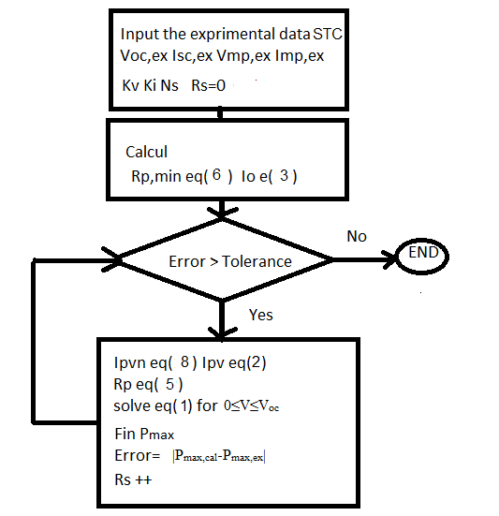

Fig .2 Flowchart of Algorithm

1. Degradation Of A Photovoltaic Module

The photovoltaic module performance and efficiency can be degraded due to several factors: climatic condition (irradiation temperature, humidity), and external cause such as mechanical shock [7].

* 1. *Modes of modules degradation*

The table below shows the Failure Modes of photovoltaic module existing in the PV Fields [7,8,9].

TABLE   
Degradation Modes of PV Panel

|  |
| --- |
| Degradations |
| Delamination of the encapsulant  Discoloration of the encapsulant  Corrosion  Broken cells  Broken glass  Junction box failures  Broken interconnects  Hotspots  Bypass diode failures |

* 1. Degradation rate (degradation factor)

In order to evaluate the photovoltaic performance modules the degradation factor is used in this work [10,11,12].



(8)

Where Y=[ Pmax,Vmax,Imax,Voc,Isc,Rs,Rp,FF,η] after degradation Y0=[ Pmax0,Vmax0,Imax0,Voc0,Isc,Rs0,Rp0,FF0,η0] the reference values given manufacturers data under standard test condition (STC).

1. Results and Discussion

A. Experimental Setup

The figure below presents the Hardware and software used in the experiments.



Fig .3 Hardware and software MP-160 of experimental Setup URERMS ADRAR

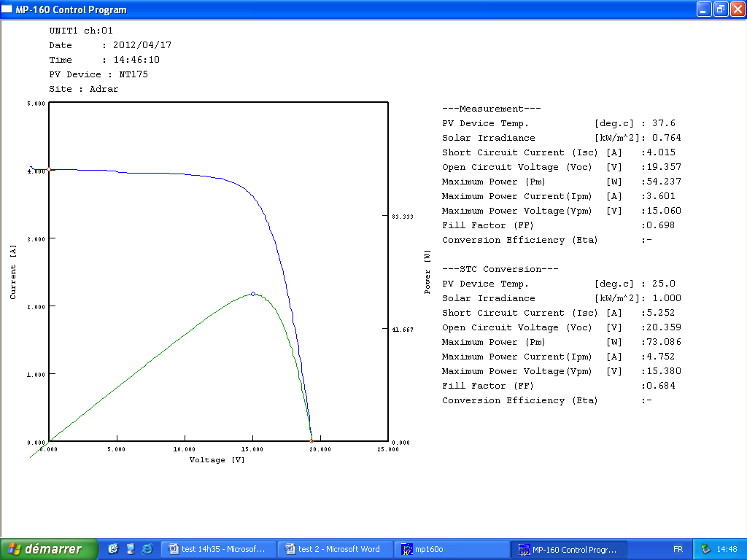

Fig .4 I-V and P-V Tracer

1. Matlab/simulink model

The Matlab/Simulink model used for simulation the characteristics I-V and P-V of photovoltaic UDT50 panel is presented by [5,6]:





Fig .5 Matlab/Simulik Model used in simulation of photovoltaic

panel

1. The Electricals Parameters of UDTS 50

The Parameters in STC condition of UDTS 50 Modules are given from data sheet presented in the Table 2 below.

TABLE 2  
 the PV module datasheet

|  |  |
| --- | --- |
| Parameters | Values |
| Short-circuit current Isc (A)  Open-circuit voltage Voc (V)  Maximum current Imp (A)  Maximum voltage Vmp (V)  Maximum power Pmax  Cells numbers Ns  Fill factor FF  Efficiency η | 3.18  21.6  2.9  17.5  49.4  36  72 %  12.83% |

1. Extraction of the photovoltaic module parameter

In this part we use the method presented in previous section for determination of PV module parameters (UDTS50). the following table show the parameters of PV module after using the extraction algorithm

TABLE 3  
 Parameters for one diode model

|  |  |
| --- | --- |
| Parameters | Values |
| Isc (A)  Voc (V)  Imp (A)  Vmp (V)  I0 (A)  Ipv(A)  Shunt Rp (Ω)  Series Rs (Ω) | 3.18  21.6  2.9  17.5  5.021x10-8  3.184  198.10  0.25 |

1. Simulation of I-V and P-V Characteristics under STC condition

Fig .6 I-V and P-V curve under STC condition

1. Evaluation performance of PV Module

The table below contain the main parameters of some tested modules (PVm1, PVm2) under STC condition with the parameters of reference module (PVref) presented section 2 c [13]

TABLE 4  
 main parameters of some test module compared with reference VALUES (STC data)

|  |  |  |  |
| --- | --- | --- | --- |
| Parameters | PV ref | PVm1 | PVm2 |
| pmax  Isc (A)  Voc (V)  Imp (A)  Vmp (V)  Rp  Rs  FF %  η % | 49.4  3.18  21.6  2.9  17.5  198.10  0.25  72  12.83 | 23.2  2.06  18.83  1.71  13.56  70.11  1.29  59.9  5.47 | 44.52  3.20  21.19  2.81  15.82  97.05  0.78  65.6  10.43 |

Table 5 shows the evaluation of photovoltaic module performance using the degradation factor

TABLE 5  
degradation factor of some module

|  |  |  |
| --- | --- | --- |
| Parameters | RDm1 | RDm2 |
| pmax  ∆Isc (A)  ∆Voc (V)  ∆Imp (A)  ∆Vmp (V)  ∆Rp  ∆Rs  ∆FF %  ∆η % | 53.04  35.22  12.82  41.03  22.51  64.61  -416  16.8  57.36 | 10.53  -0.62  1.9  3.1  9.8  51  -212  8.89  18.71 |

The followings figures present the I-V and P-V curves of the Photovoltaic modules (Pm1, Pm2) compared with the reference I-V and P-V Characteristics under STC condition.

Fig .7 P-V curve of PVref compared with PVm1 and PVm2 under STC

Fig .8 I-V curve of PVref compared with PVm1 and PVm2 under STC

From the tables analysis and the figures presented, we can deduce that the power decrease due the degradation of the modules performances caused by the long time of exposition in outdoor weather conditions in desert area.

1. Conclusion

In this paper the performance evaluation of photovoltaic module UDTS 50 under the Saharan environment is investigated. The modelling of PV panel based on one diode model is presented, the analysis of the degradation factor shows the impact of the climatic conditions on the photovoltaics modules performance.

References

1. R. Messenger and J. Ventre, “Photovoltaic Systems Engineering”, CRC Press, 2000, pp.41-51.
2. ChengquanXiao,Xuegong Yu , Deren Yang,Duanlin Que“Impact of solar irradiance intensity and temperature on the performance of compensated crystalline silicon solar cells“Solar EnergyMaterials&SolarCells128(2014)427–434.
3. Kyoko Ichida , Shunichi Fukushige , Akihiko Nakajima , Takashi Minemotoa,, Hideyuki Takakura”Impact of environment factors on solar cel lparameters of a-Si uc-Si photovoltaic modules” Solar Energy Materials & Solar Cells 93 (2009) 879–883.
4. John K. Kaldellis, Marina Kapsali, Kosmas A. Kavadias”Temperature and Wind speed impact on efficiency of PV installations. Experience btained from outdoor measurement in Greece” Renewable Energy 66 (2014) 612-624.
5. M. G. Villalva, J. R. Gazoli, E. R. Filho ,“Comprehensive Approach to Modeling and simulation of Photovoltaic Arrays”, IEEE Transactions on Power Electronic,Vol. 24,No. 5,pp.1189-1208,May 2009.
6. M. G. Villalva, J. R. Gazoli, E. R. Filho, “Modeling And Circuit-Based Simulation Of Photovoltaic Arrays“, Brazilian Journal of Power Electronics,2009,Vol. 14,No. 1,pp.35-45,ISSN 1414-8862.
7. Ndiaye A, Charki A, Kobi A, K_eb_e CMF, Ndiaye PA, Sambou V. Degradations of silicon photovoltaic modules: a literature review,. Sol Energy 2013;96:140-51.
8. Wohlgemuth JH, Kurtz S. Reliability testing beyond qualifications a key component in photovoltaic's progresstoward grid parity. In: IEEE International reliability physics symposium Monterey, California; 2011. p. 10-4.
9. Dubey R, Chattopadhyay S, Kuthanazhi V, John JJ, Arora BM, Kottantharayil A, et al. All-India survey of photovoltaicmodule degradation: report of the national centre for photovoltaic (NCPRE). IIT Bombay & Solar Energy Centre (Gurgaon); 2014.
10. Farida Bandou , Amar Hadj Araba, Mohammed Said Belkaid ,Pierre-Olivier Logerais, Olivier Riou , Abderafi Charki “Evaluation performance of photovoltaic modules after a long time operation in Saharan environment”,i n t e r n a t i o n a l journal of hydrogen energy xxx ( 2 0 1 5 ) 1-1 0.
11. M. Sadok and A. Mehdaoui, “Outdoor testing of photovoltaic array in the saharan region,” *Renewable Energy*, vol. 33, pp. 2516-2524, 2008.
12. Ndiaye A, K_eb_e CMF, Charki A, Ndiaye PA, Sambou V, Kobi A. Degradation evaluation of crystalline-silicon photovoltaic modules after a few operation years in a tropical environment”. Sol Energy 2014;103:70-7.
13. N. Kahoul, M. Houabes, and M. Sadok, “Assessing the early degradation of photovoltaic modules performance in the saharan region,” Energy Conversion and Management, vol. 82, pp. 320-326, 2014