Control of a Doubly-Fed Induction Generator for Wind Energy by ANN

Sakina Elkhadiri, Pr.Lamiaa Elmenzhi, Pr.Ali Haddi, Pr.Abdelouahid Lyhyaoui
Laboratory of innovative technologies, Tangier, Morocco
el.khadiri.sakina@gmail.com
lamdockit@yahoo.com
Haddi.ensat@gmail.com
lyhyaoui@gmail.com

Abstract— In this paper, control scheme using artificial neural network (ANN) is applied to a doubly fed induction generator (DFIG) based on variable speed wind turbine system whose stator is directly connected to the grid and the rotor is supplied by a back-to-back AC-DC-AC PWM converters. The results from a system using the proposed ANN controller show more accurate control performance than a normal system without Neural Network. The simulations are carried out using MATLAB Simulink.

Keywords— Doubly fed induction generator (DFIG), Power Control, Artificial neural network (ANN), variable speed wind turbine.
- Introduction
The demand of electrical energy has become very important through declining the world stock of hydrocarbon that causes global warming, so it become necessary to figure out a new harmless and inexhaustible energy. Renewable energies have attracted great attention especially wind turbine that is the main subject of researches in electrical engineering to improve its extracted energy. Doubly fed induction is widely used for its performance and high efficiency in wind turbine.

This paper presents the control scheme using ANN for DFIG; the first part explains the modelling of wind turbine and the DFIG, and the second part presents the performance of this type of controller. It is clear from results that the ANN control has better stability and regulation of the DFIG.
- MODELING OF WIND TURBINE
  - Turbine model

Wind turbine uses the power extracted from the wind to produce electric power, then drive it to electrical generator. The power contained in the wind is given as:

(1)
The mechanical turbine power and the torque on the shaft are given by the expressions:
(2)
(3)
Where, and are respectively: radius of the turbine (m), air density (kg/), wind speed (m/s), the power coefficient, the tip speed ratio and blade pitch angle (deg). To drive the DFIG, fixed pitch is chosen as
The power coefficient of the wind turbine is given as follow:
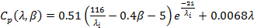 (4)
With: (5)
Where is the wind turbine speed.
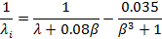

Fig.1 shows the Cp curve for =0.

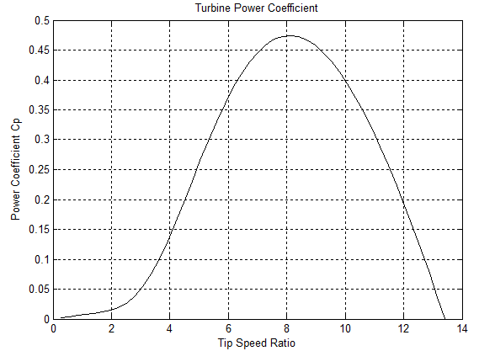
Fig.1 Turbine power coefficient.
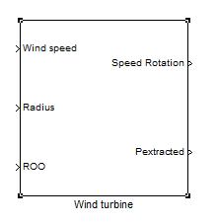
Fig.2 Wind-Turbine model.

  - DFIG model

The doubly fed induction generator is a system in which the electronic power controls the rotor currents to achieve the maximum energy with variable wind speed.
The stator is directly connected to the grid, and the rotor is connected via slip rings to a back-to-back converter.
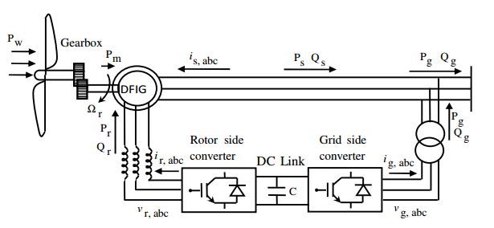
Fig.3 Schematic diagram of DFIG-based wind generation systems

The model of DFIG is established in the dq reference. The stator and rotor voltages are given by the following expressions:
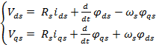 (6), (7)
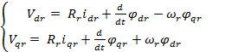 (8), (9)

Where and and represent respectively resistance of windings, inductance, mutual inductance, flux and current. The subscripts s, r, d and q respectively indicate stator, rotor, d-axis and q-axis.
The flux equations are given as:

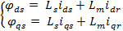 (10),(11)
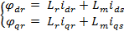 (12),(13)

Where et and are the direct and quadrate stator and rotor currents.
The DFIG electromagnetic torque can be expressed as:
(14)

The active and reactive stator power equations in dq-axis are:

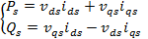 (15),(16)
- VECTOR CONTROL OF DFIG

We choose dq reference to represent the DFIG, d-axis is aligned with the stator flux , we have:

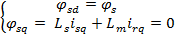 (17)

Then 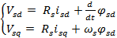 (18)

The voltage drop are neglected: and so 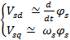 (19)

We work in a steady state so we write:

(20)

The DFIG is connected to the grid so we have:

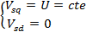 (21)

And 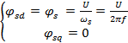 (22)

Now by using the equations (12 ,13) , the equations (8,9) become:

)
with σ =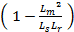

and are the unlinear voltages that we have to compensate by this control.

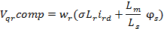 (23)

- ARTIFICIAL NEURAL NETWORK CONTROLLER

Neural networks have received considerable attention in various areas such as signal processing, pattern recognition and automatic control.
The most popular network is the Multi-Layer Perceptron architecture which is trained using the back propagation algorithm. It consists of at least three layers: an input layer, an output layer and one or more hidden layers, as shown in Figure below.

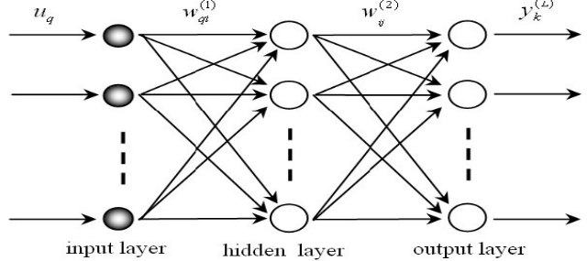

Fig.4 An example of two layers feed forward network architecture

Suppose we have n hidden layers and u input vector, the output y will be:
(24)

Where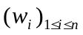is the weight matrix of the layer i, 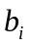 is the bias vector of the neuron and 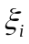is a non-linear operator defined by:
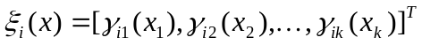 (25)
Where 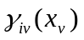is the activation function of neuron I from the layer v. The transfer function is in general a sigmoid: 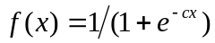
MLP is trained by a gradient descent using the back propagation algorithm to optimize the cost function. For example, the most common cost function is the mean square error criteria which is defined as follows:
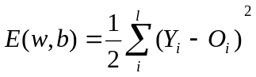 (26)
Where Y is the true target value and O is the output of the network (function of w and b). The purpose of neural-network training is to adjust w in such a way that the error function is minimized. The back propagation is a gradient descent on this cost function and the backpropagation weight updates are equivalent to:

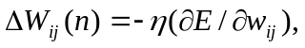 (27)

Whereis a positive step size known as the learning rate and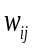 is the connection strength of the wire between nodes i and j. If is small enough, the above weight updating will decrease the error between the desired output and the actual network output.
The gradient at the output layer of neurons are:
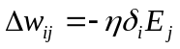 (28)
And the gradient at the hidden layer neurons are:
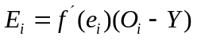 (29)
And the hidden layer neurons are:
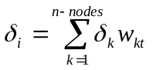 (30)
Where k describes all the nodes in the next layer .The number of hidden neurons depends upon the complexity of the problem to be solved.

Using the neural network fitting tool in MATLAB, the input and output data’s are fed in the neural network for training. The network training was done until the system undergoes 1000 iterations.

- RESULTS

To achieve the results of our study. The model is implemented in Matlab/Simulink.
As a results of the training, we have:

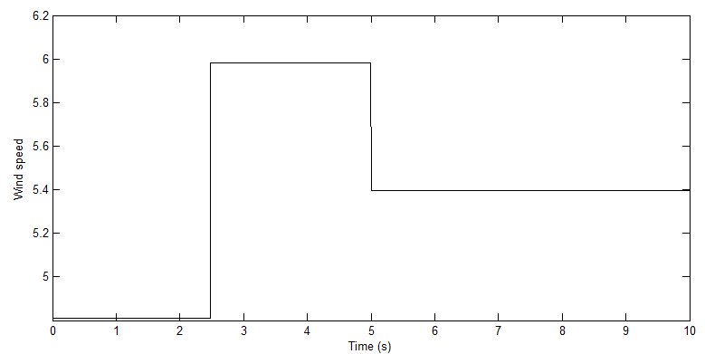
Fig.5 Wind speed

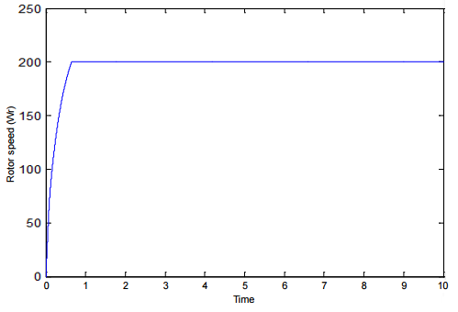
Fig.6 Rotor speed

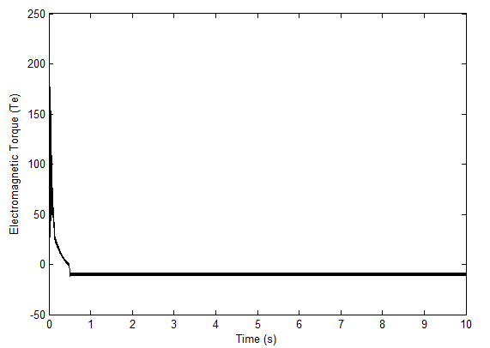
Fig.7 Electromagnetic torque
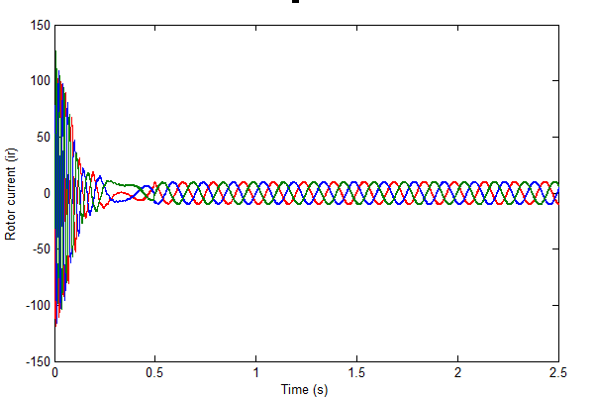
Fig.8 Rotor current without ANN control
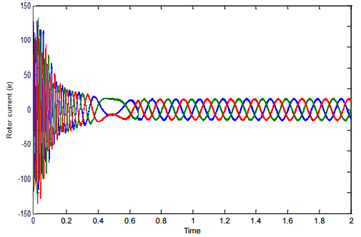
Fig.9 Rotor current with ANN control

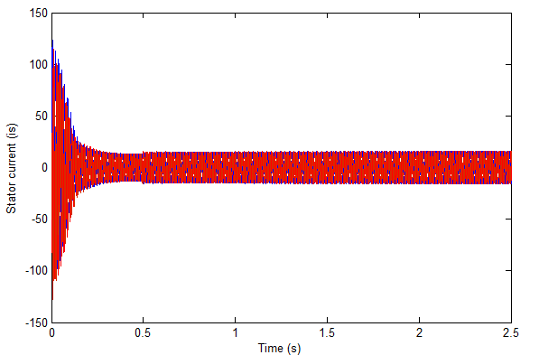
Fig.10 Stator current without ANN control

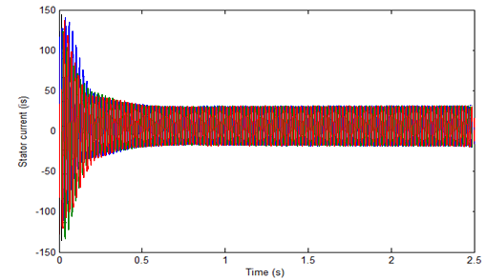
Fig.11 Stator current with ANN control

Fig 4 represents the wind speed. Fig 5 shows the rotor speed. Fig 6 represents the electromagnetic torque. Rotor current without ANN control is shown in Fig 7. Fig 8 represents the rotor current with the ANN control. It’s clear that the fluctuations caused in the rotor speed, the stator and rotor current and the electromagnetic torque become smooth after applying the ANN control, and we notice less oscillations.
- CONCLUSION
This paper has discussed the improvement of doubly fed induction generator with artificial neuron network and has emphasize the importance of system’s stabilization.

References
- “Global wind energy outlook 2008”, Global Wind Energy Council, Oct.J. Breckling, Ed., The Analysis of Directional Time Series: Applications to Wind Speed and Direction, ser. Lecture Notes in Statistics. Berlin, Germany: Springer, 1989, vol. 61.
- “ANN-Based Optimal Energy Control of Induction Motor Drive in Pumping Applications,” Osama S. Ebrahim, Member, IEEE, Mohamed A. Badr, Ali S. Elgendy, and Praveen K. Jain, Fellow, IEEE.M. Wegmuller, J. P. von der Weid, P. Oberson, and N. Gisin, “High resolution fiber distributed measurements with coherent OFDR,” in Proc. ECOC’00, 2000, paper 11.3.4, p. 109.
- “A Neural-Network-Based Space-Vector PWM Controller for a Three-Level Voltage-Fed Inverter Induction Motor Drive,” Subrata K. Mondal, Member, IEEE, João O. P. Pinto, Student Member, IEEE, and Bimal K. Bose, Life Fellow, IEEE.
- Sayouti, Y.; Abbou, A.; Akherraz, M.; Mahmoudi, H., "Real-time DSP implementation of DTC neural networkbased for induction motor drive," Power Electronics, Machines and Drives (PEMD 2010), 5th IET International Conference on, vol., no., pp.1, 5, 19-21 April 2010.
- B.K. BOSE, « Artificial neuronal network applications in power electronics », The 27th Annual Conference of the IEEE Industrial Electronics Society, IECON’01, pp. 1631-1638, September 2000.
- Kh.Benyahiya,L.Boumediene, A.Mezouar,M.Moussaoui. ‘’A robust control of doubly fed induction generator using in wind energy conversion system’’.2eme conférence internationale des energies renouvelables CIER 2014.
- J.N.razafinjaka, A.Tsiory Patrick,‘’Model reference adaptive control based on fuzzy logic for a doubly fed induction generator used in a chain of wind power’’
- Heikki N.Koivo,‘’Neural networks: basics using Matlab Neural network’’2008
- M.Sharawy, N.Abdel-Rahim, Adel A.Shaltout, ‘’Modeling and control of stand-alone doubly fed induction generator used in wind energy conversion system’’ Recent trends in energy systems conference (RTES) 2015

