**INVOICE LETTER FOR AFRICAINS**

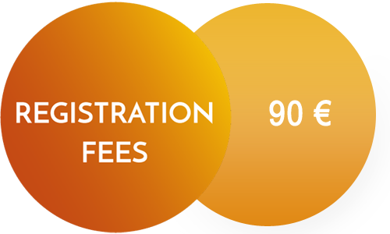



**This registration form has to be made before 30 November**

**If you have any query please write to us on**

**workshops.inscription@gmail.com**

It covers: Admission to all sessions, Lunch and an Official Certificate of Attendance.

**Payment Procedure:**

* Payment could be made by **Cash** on the conference desk or **by Bank Transfer or by purchased order forms**:

**Tax Number:** 1285992 / M / N / C / 000

**Account Holder:** Rahma Abdallah “INT.PUB & CO”

**Bank Name:** ZITOUNA BANK, SOUSSE SENGHOR

**International Bank Account Number (IBAN):** TN59 25 005 000 0000110235 40

**Bank Identification Code (BIC):** BZITTNTTXXX

Please clearly indicate your name, the paper ID and the announcement: “Workshop TWP -2017″ on the payment receipt.